- Recognizable imagery: Pop art utilised images and icons from popular media and products. ...
- Bright colours: Pop art is characterized by vibrant, bright colours. ...
- Irony and satire: Humour was one of the main components of Pop art.

Above are definitions of Pop art ( among other things)
Richard Hamilton was a British Pop Artist working in the 1950’s, 60’s and 70’s
He is known for his mixed up drawing and collage faces using magazines and pen or pencils and bright colour in pen or paint.
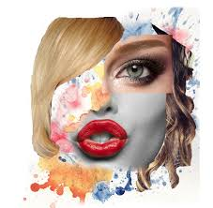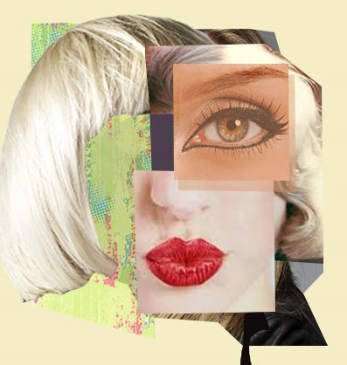His work could be humorous or funny at times

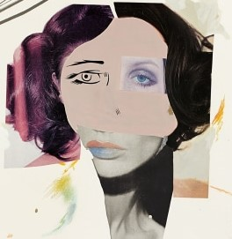

TASK
Create your own version of these Richard Hamilton inspired faces. Use whatever you have at hand ( and are allowed to cut up!) Magazines and newspapers work well here. Also recycling packaging.

