MUSICAL MONDRIAN DRAWING
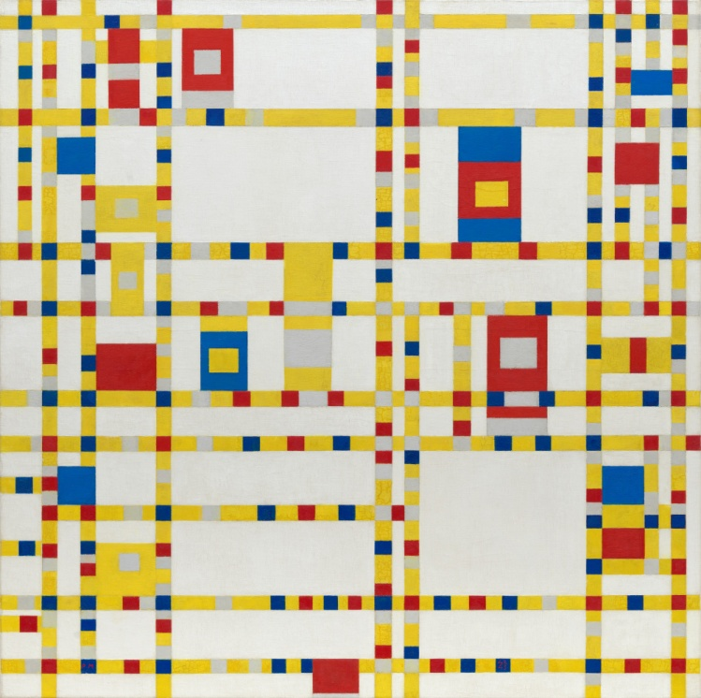
Piet Mondraian was a famous Dutch painter. His abstract paintings has inspired many people and companies over the years.
This painting is called Broadway Boogie Woogie painted in 1943.
It was inspired by the upbeat music of the time.
What music do you like to listen to?
If you were to draw your favourite song or style of music would it look a certain kind of way? Think pattern, shape, line , colour, rhythm, direction
And make a sketch of a song of your choosing In the square below or in your own square.

