Mirror Image
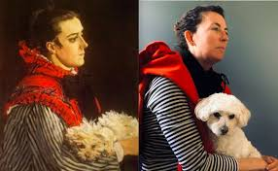You may have seen during lockdown that people have been recreating famous paintings by using whatever you have to hand in the house and taking a photo. Attached are a few examples
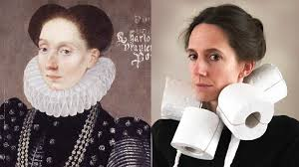

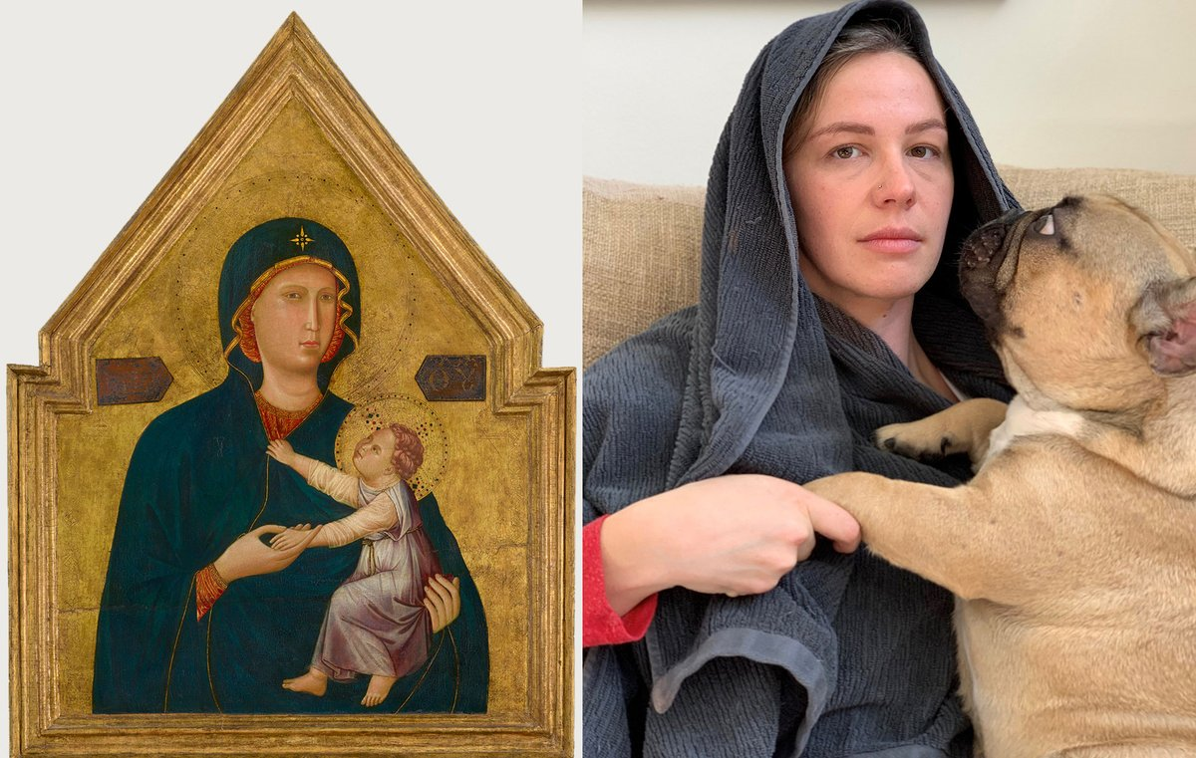
TASK
Go onto google and type in ‘famous paintings’
Choose any one that you think is achievable and ( maybe with the help of family members) try to recreate the painting in your own home as a photo!
It could be a bit of fun too! Send to SMH please

