Leger blind drawing portrait
Working in Paris during the height of Cubism, Fernand Léger’s iconic style, with its emphasis on primary colours and rounded, massive forms, become regarded as “Tubism. Leger has been described as a forerunner of Pop Art. Interested in modern innovation, industry and machines was further encouraged by the Italian Futurist painters, and by his military service for France during World War I. His paintings are sometimes very simple with bold coloured sections. They are a bit like doodles

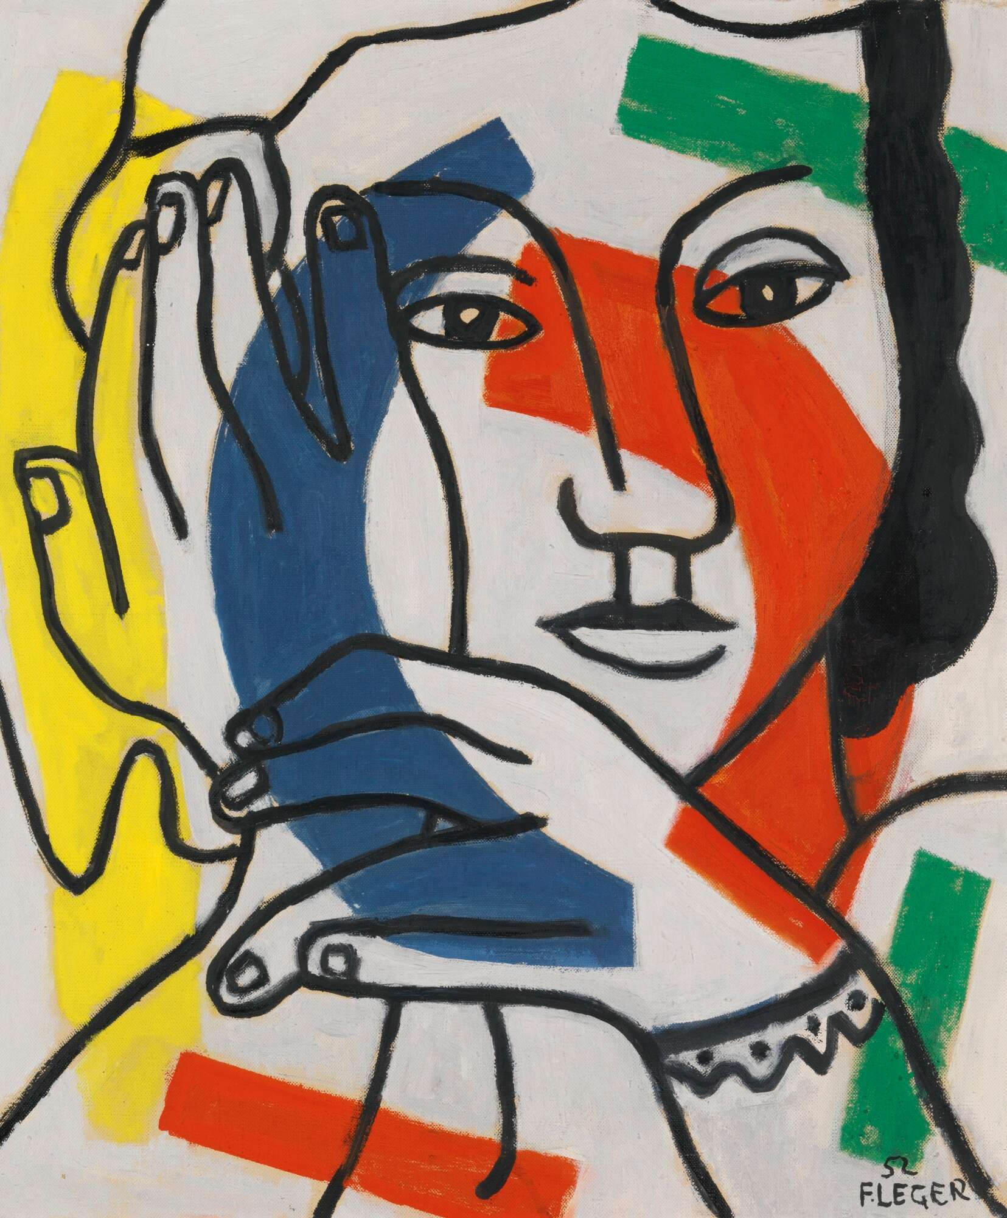
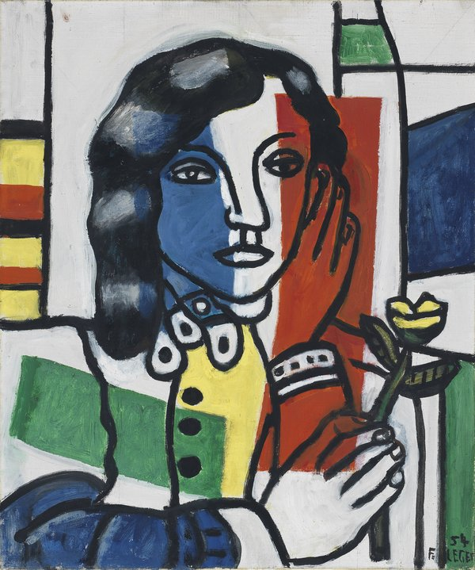

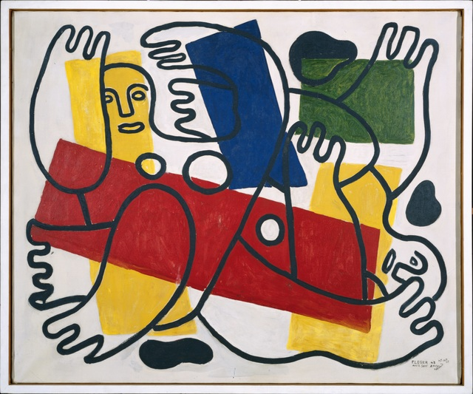

TASK
- Find some old collage material such as recycling paper or card from boxes. Glue or tape the card onto paper.
- Set up a mirror or your phone camera on reverse to see your own image.
- Draw a quick sketch of yourself over the coloured shapes without looking at the drawing!! Go over the drawing in bold black pen.
- Include all facial features and have your hand up at your face.

