Gustav Klimt was an Austrian artist born in 1862 and died in 1918
He is very famous for his glamorous paintings of women and his use of pattern.
He often used real gold leaf in his paintings. His famous paintings include’ the Kiss’ and ‘Portrait of Adele Bloch-Bauer 1’
Here are various examples.
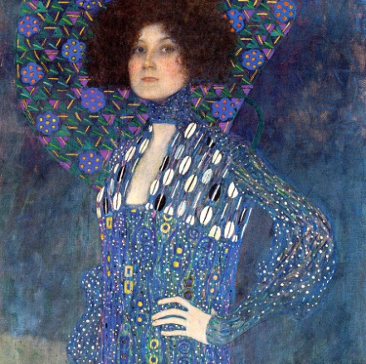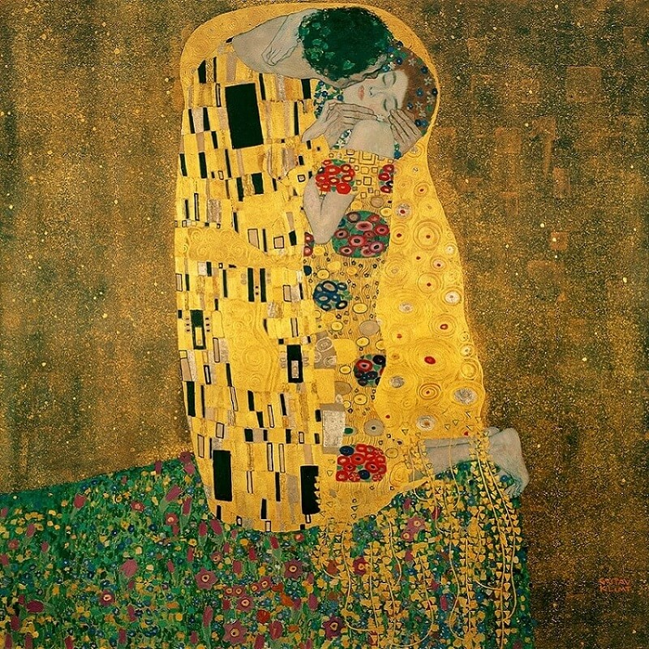
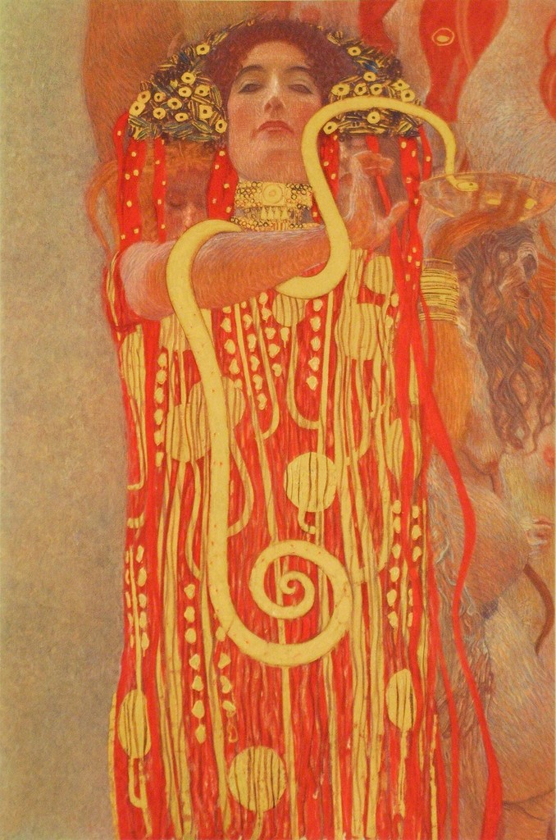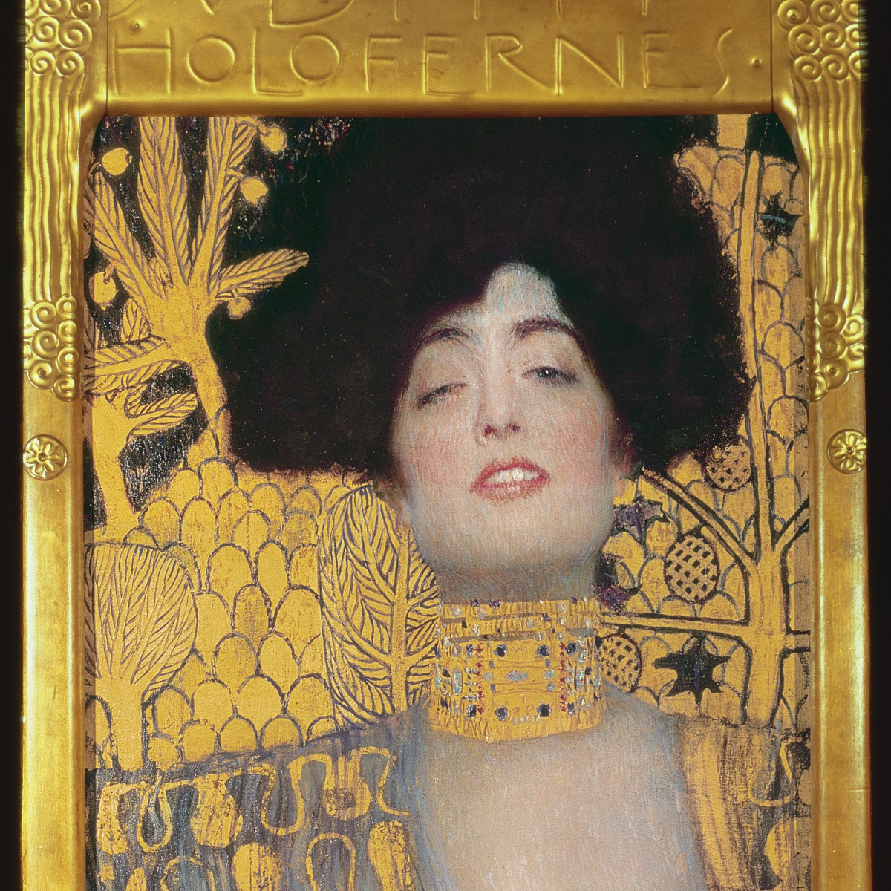

TASK
- Using the pdf file attached of Adele Boch-Bauer 1.
- Sketch the outline of the drawing.
- Use a magazine/ newspaper to get a face and hands photo that are facing a similar way to the original. Now stick or tape them on. Make sure the scale suits your drawing
- Now using any of the pattern in Klimts paintings or your own ideas ( perhaps a curtain or printed textile in the house) Add pattern and colour to your figure.

