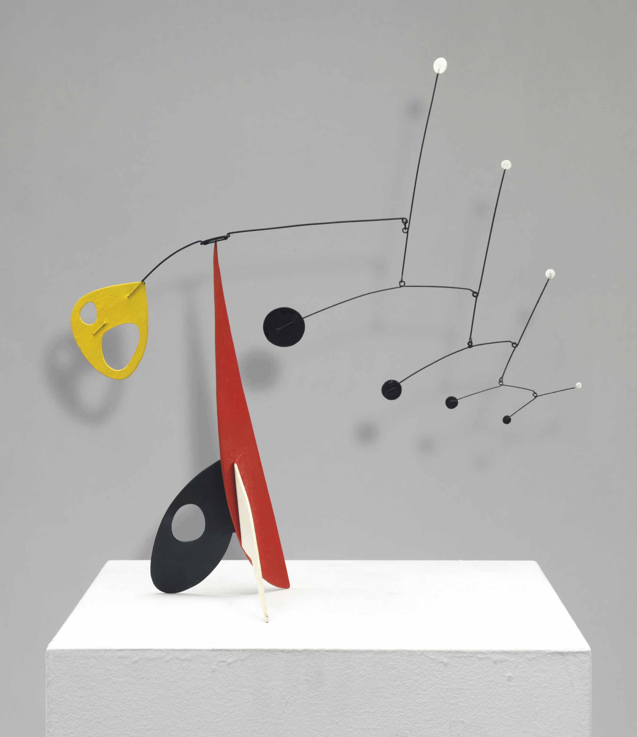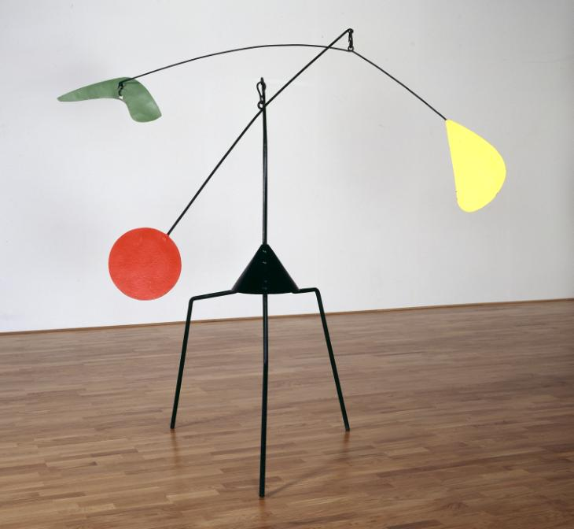Visual elements- FORM- These are sculptures by ALEXANDER CALDER. 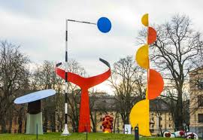Alexander Calder is known for inventing wire sculptures and the mobile (not phone), a type of kinetic art which relied on careful weighting to achieve balance and suspension in the air.

TASK
- Get an old cereal or recycled cardboard box
- Draw circles, arches, squares ( any geometric shapes really) and cut out.
- Cut slots half way into the shapes and join together, slot to slot. Wiggle around until the flat shapes stick out from each other.
- Continue to join shapes together in this way until your sculpture is bigger (6 +shapes)
- Add long thin slivers of card from the box and wedge into any slot or cut new slots to do this
- Use string or thread to tie your sculpture to the ceiling in a corner (tape should hold it )
- Take a photo with a torch light to make shadows. Your sculpture will spin and look different from different angles

SEE PICTURE SHEET BELOW FOR MORE CLARITY

