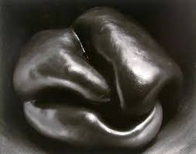Edward Weston was a famous American Photographer. He was well known for a series of photos of peppers. He made his photos black and white and lit and turned the peppers in such a way as they didn’t seem like what they were anymore. They looked more like fleshy lumps or parts of a body!
TASK
Can you take 3 photos of objects in your house on your smartphone try to….
turn/ partially hide/ light in a different way / photograph in black and white mode
to make them seem strange or like something else??
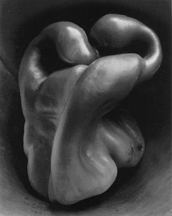Send to SMH please

