CIRCLE ART
Robert Delaunay lived from 1885-1941 and was from France. He was one of the first people to paint fully abstract art of pure circles and colours and along with his wife Sonia a type of Art known as Orphism. His work is now very famous across the world.

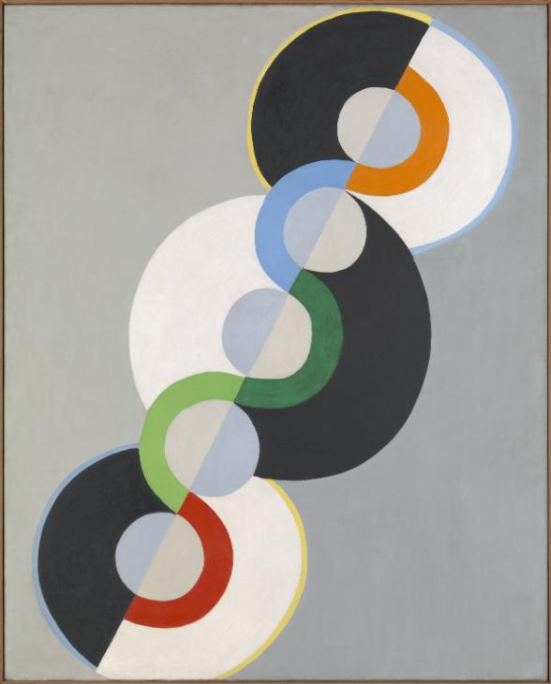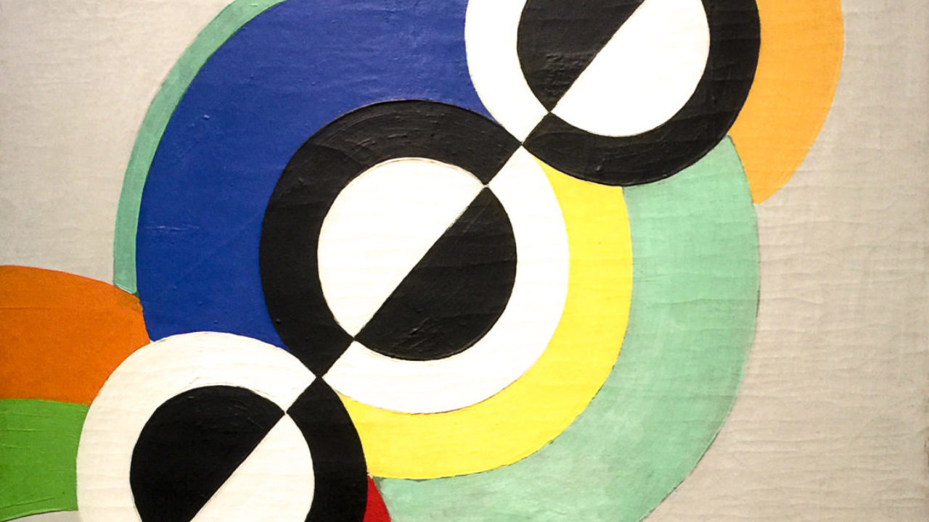

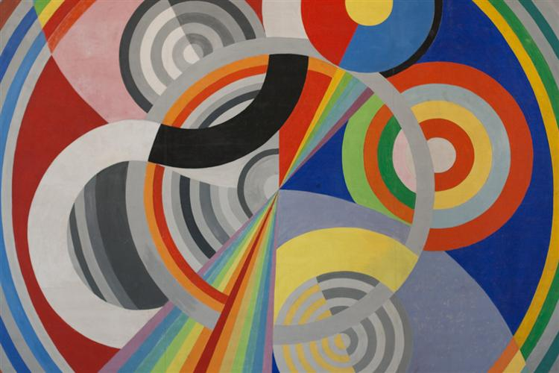

Try Task A or B
TASK A
Find circular objects of different sizes around the house. On paper, draw parts or all of the circles on your square and try to get a similar arrangement or composition as Delaunay’s examples. Use black and white and colour to complete
TASK B
You need a fidget spinner for this task and it is a bit tricky but all the instructions are on this video li https://www.youtube.com/watch?v=B3QCJNJo_XA&t=550snk.
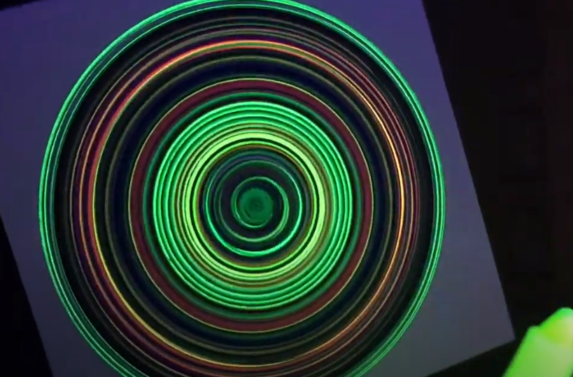The results are really bold and precise!