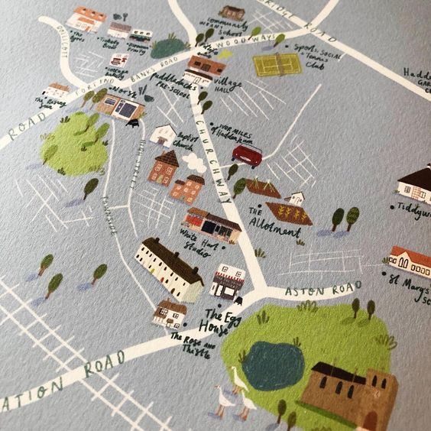
Design your own map of your town/ village
Being a map designer gives many challenges. Accuracy has to work with interest and ease of understanding in a place.
Look at the examples of map style below. Can you design your own map of your town or village?
Put on the important places to you, streets and other features that are interesting.
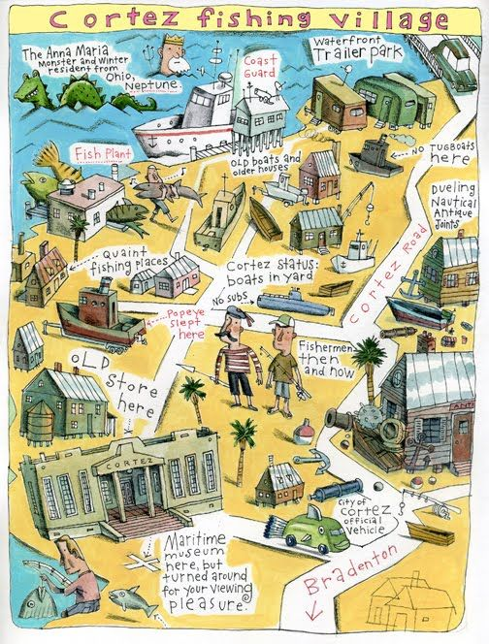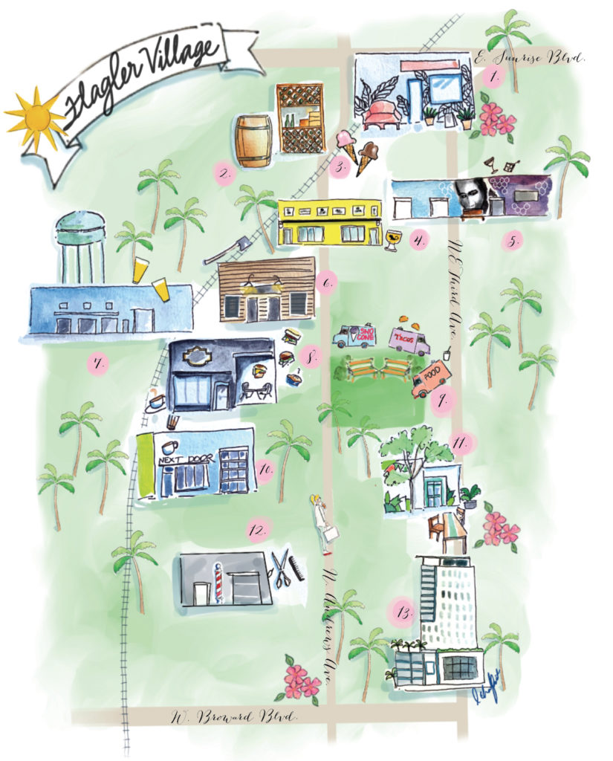Remember to add a key to let us know what certain things are!
