Emoji Design
Can you design 3 new emojis that don’t exist already?
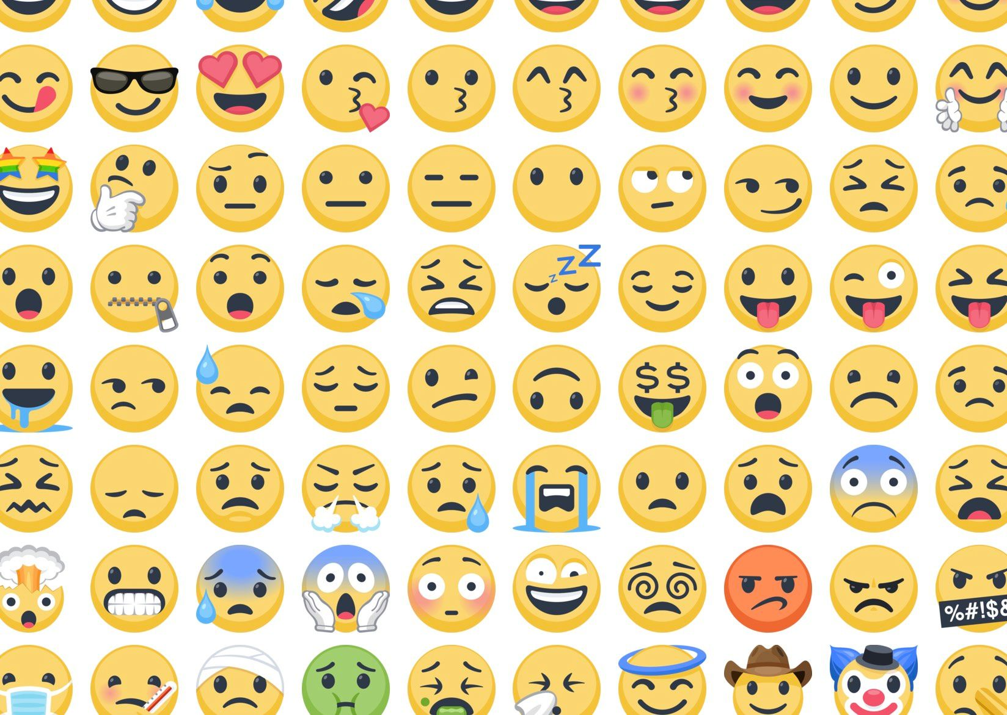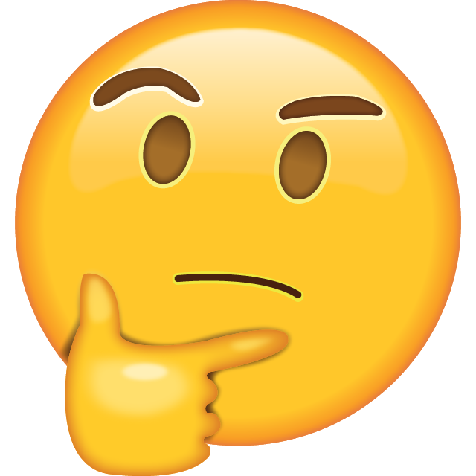Think what they represent. Ask family members to help. You can have hands and props in your emojis to better represent your feeling/ thought/ emotion creations.
Send pics to smh please. Thanks folks

