Dragons Den Invention
Have you ever thought of a great idea for a product that you’ve never seen before?
Maybe you always had a problem with something and never had a good solution?
I want you to invent a new product that will be a big hit and earn an investment from dragons den
Be as wild and wonderful as you like or perhaps its just simple and straight forward.

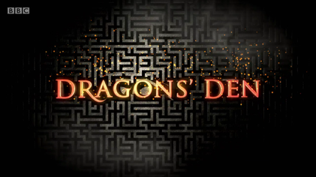

Check out the ideas below for inspiration
https://brightside.me/inspiration-tips-and-tricks/28-design-ideas-that-gave-a-second-chance-to-ordinary-things-418310//
Sketch the final design with notes and some colour if you can please and send to SMH
Good Luck

