Design my own garden
Whether you have or don’t have a garden at the moment doesn’t matter for this task.
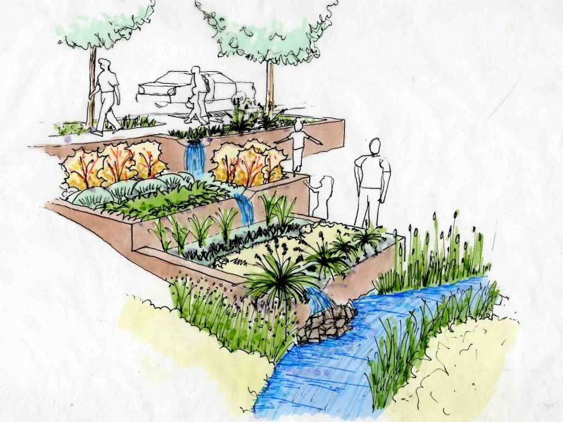 I want you to imagine creating your own garden just how you would like it.
Garden design is a big industry and you can see much of this in garden design tv shows.
Look at the link below from the Garden Ninja to see how he sketches garden designs
https://www.youtube.com/watch?v=3zO_pA7JLWU
You can add all sorts of different areas, have your own pool, juice bar or even a sumo suit wrestling area! Don’t forget paths and plants though and colour areas to suit as well as label what is what!!
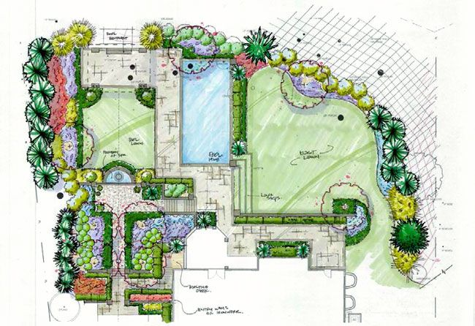Looking forward to see what you come up with! 