S3- Low level Photography
Watch the video first
https://www.youtube.com/watch?v=QS8QaCtGKKA
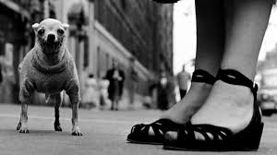
TASK
Take 3 inside and 3 outside low level photographs
Think about distance and depth in your photo and what is in the fore, middle and back ground to make a pleasing shot.
Send to gw07mcgregoreuan@glow.sch.uk

