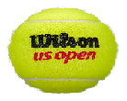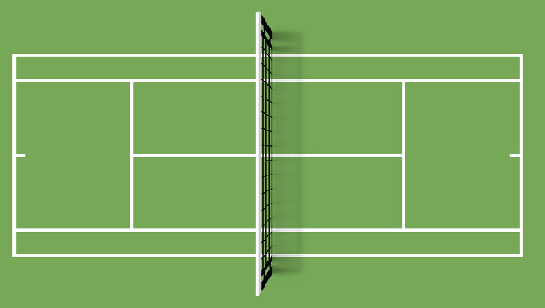[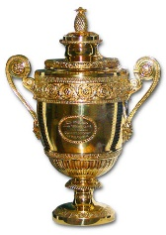](https://www.google.co.uk/url?sa=i&url=https://www.edco.com/wimbledon-cup-trophy&psig=AOvVaw26c55ec8xVg8iCAGQ_aTOL&ust=1585307929612000&source=images&cd=vfe&ved=0CAIQjRxqFwoTCKj64rOCuOgCFQAAAAAdAAAAABAJ)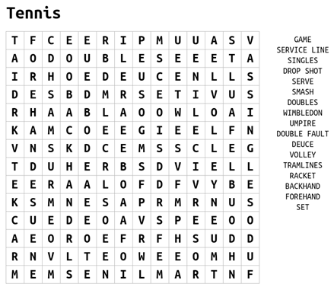

Tennis

**Challenge-**

Name 5 ways to win a point in tennis



**Challenge-**

**1. Label the key parts of a tennis court**

**2. How many balls have landed with the singles court?**

**Can you name the last 5 Wimbledon champions?**

**FEMALE Male**

**2015-**

**2016-**

**2017-**

**2018-**

**2019-**

Tennis Challenges

Challenge 3

Rally against a wall!

How many times can you hit the ball against the wall in succession? The ball can only bounce once.

[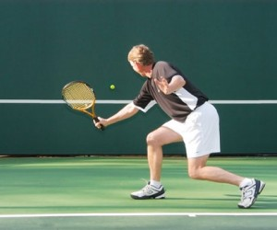](https://www.google.co.uk/url?sa=i&url=http://www.rallymasterbackboards.com/index.php/archives/tag/tennis-wall&psig=AOvVaw0SdG1vLvKNqV2S8Wd2yLMB&ust=1585312403474000&source=images&cd=vfe&ved=0CAIQjRxqFwoTCLimgImTuOgCFQAAAAAdAAAAABAG)

Challenge 4

Watch this video of Rodger Federer and practice your forehand technique against a wall.

<https://www.youtube.com/watch?v=KLzaaln6Rf0>

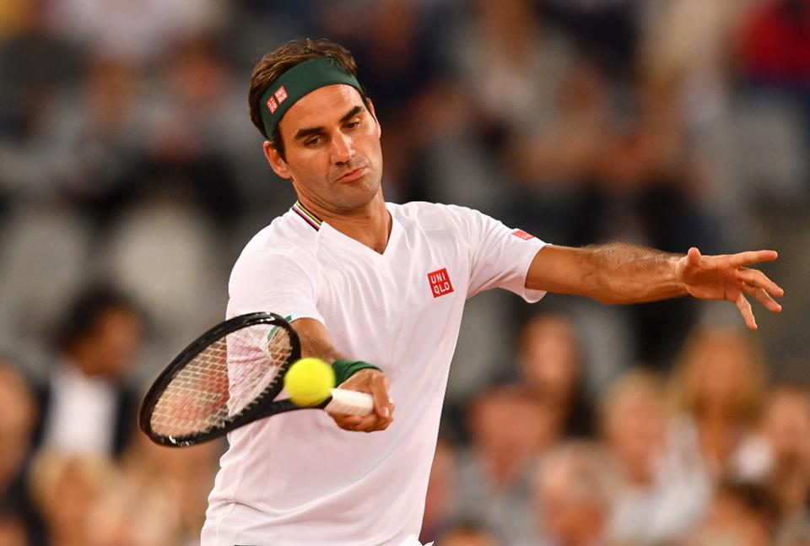

Challenge 2

Can you hit a bottle / object using a serving action?

How many shots does it take?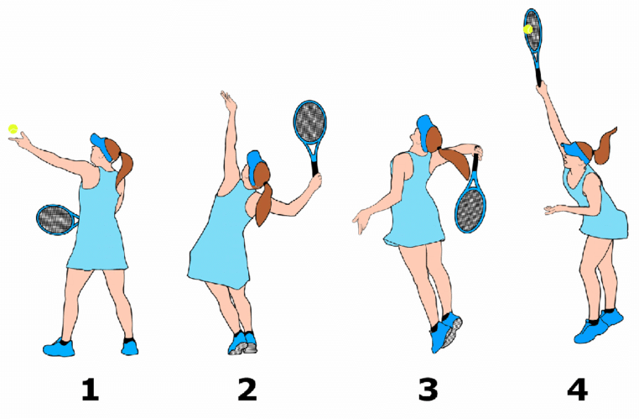

Challenge 1

How many times can you keep the ball up? The ball must go higher than your shoulders.

Make it harder….. Try using both forehand and backhand.

