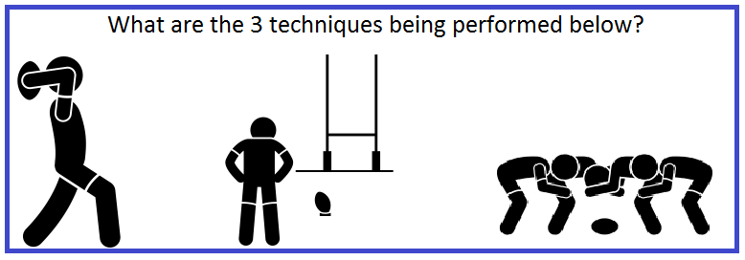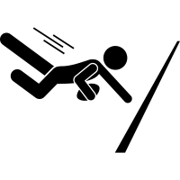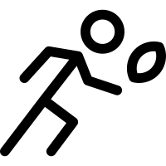**Rugby Union**

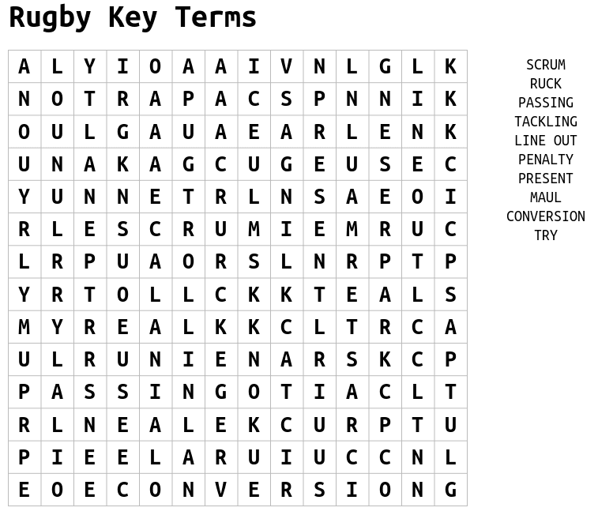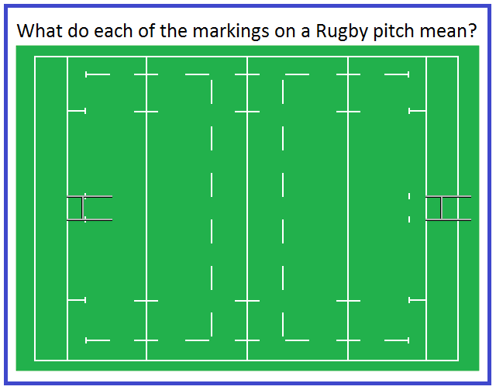

How many Points do you get for scoring the following?

1. Try

2. Conversion

3. Penalty

4. Drop Goal

How many players are there on a Rugby Union team and what number would a Hooker and Fly half wear?

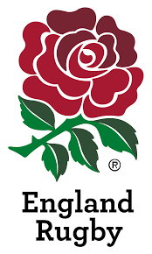



|  |  |
| --- | --- |
| **Challenge 1**  Find out what a ‘grubber kick’ is and attempt this over 5/8/10m  +Attempt with non-dominant foot  https://static.thenounproject.com/png/2744745-200.png | **Challenge 2**  Perform 30 seconds of lateral passing with a partner in both directions (left & right)  + Increase the distance  https://static.thenounproject.com/png/2744752-200.png |
| **Challenge 3**  https://static.thenounproject.com/png/2744749-200.png  Practise your try scoring technique. You must apply downward pressure on the ball  +Research Chris Ashton’s famous try scoring technique on YouTube | **Challenge 4**  Dustbin Drop Goal  Research how to perform a drop goal and attempt this from 5m.  +Increase distance to 7/9m and attempt with non-dominant foot |
| **Challenge 5**  Identify who these famous England payers are and what position they play. Look up footage of them on YouTube | **Challenge 6**  Get pictured completing any challenge and tweet @jhighHWB |

**Rugby Union Challenges**