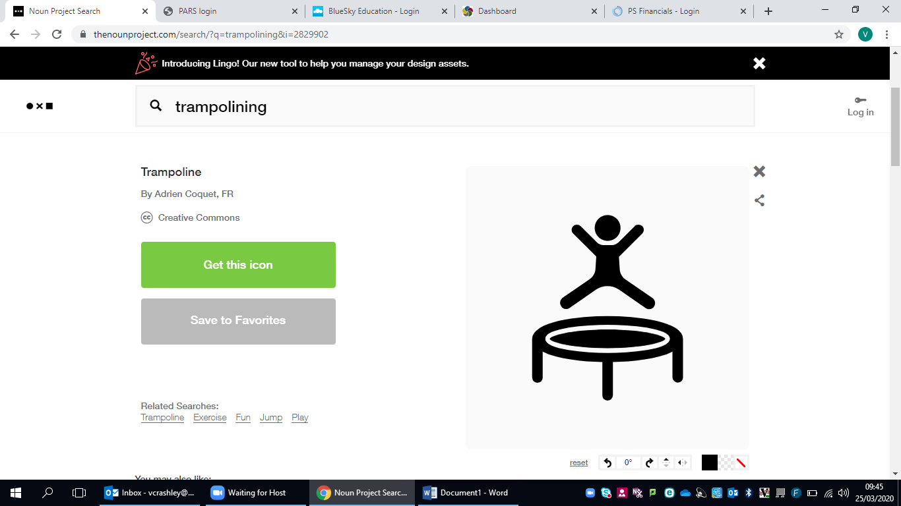

**Trampolining**

**Challenge 1:**

Complete the following word search with trampolining specific terms:

|  |  |  |  |  |  |  |  |  |  |  |  |  |  |  |
| --- | --- | --- | --- | --- | --- | --- | --- | --- | --- | --- | --- | --- | --- | --- |
| Q | F | A | S | T | T | A | M | H | S | A | R | C | V | M |
| W | G | S | O | W | P | S | E | Q | A | S | W | E | E | T |
| E | H | D | M | G | I | F | L | O | O | R | M | A | T | K |
| R | J | T | E | H | K | V | A | W | F | A | W | R | R | A |
| T | K | S | R | J | E | F | E | E | G | E | S | E | D | R |
| Y | L | I | S | K | P | R | S | L | H | D | D | T | F | E |
| U | Z | W | A | L | O | T | T | D | H | F | F | T | G | P |
| I | X | T | U | O | I | Y | H | F | I | I | G | O | H | O |
| O | C | F | L | J | U | U | E | G | I | G | P | P | E | R |
| P | V | L | T | U | C | K | T | T | T | H | E | S | E | D |
| A | B | A | F | M | Y | I | I | Y | E | J | G | A | G | T |
| S | N | H | G | P | T | K | C | U | S | K | H | A | H | A |
| T | H | G | I | A | R | T | S | T | R | A | D | D | L | E |
| D | M | E | C | N | A | M | R | O | F | R | E | P | G | S |

Pike

What skill is being performed here? 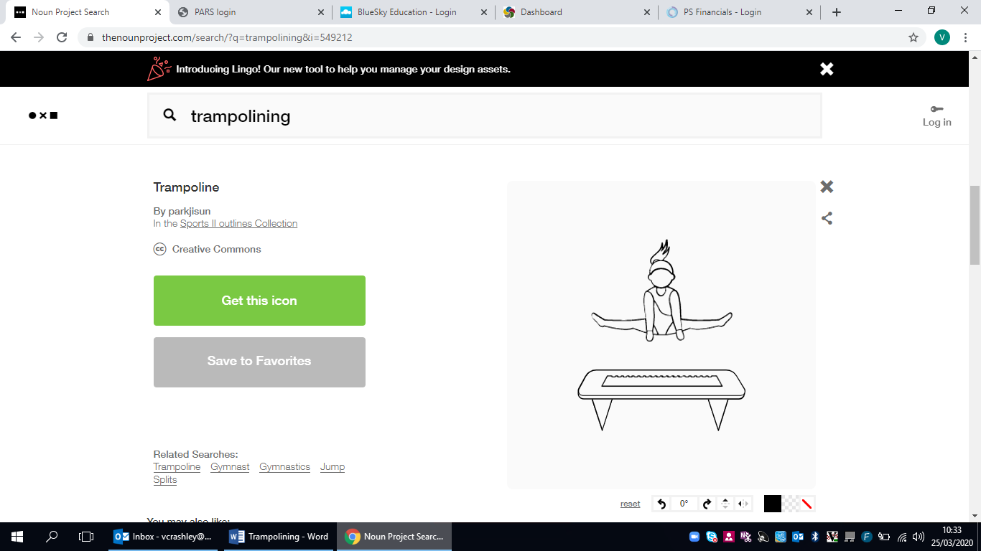

Tuck

Straddle

Seat Drop

Half Twist

Swivel Hips

Spotter

Somersault

Jump

Straight

Floor Mat

Crash Mat

Aesthetics

Performance

**Challenge 2:**

Using the following skills, please create a written 10 bounce routine (remember not every skill only classes as one bounce).

* Straight Jump, Tuck Jump, Straddle Jump, Pike Jump, Half Turn, Full Turn, Front Drop, Back Drop, Swivel Hips, Front Somersault, Back Somersault.

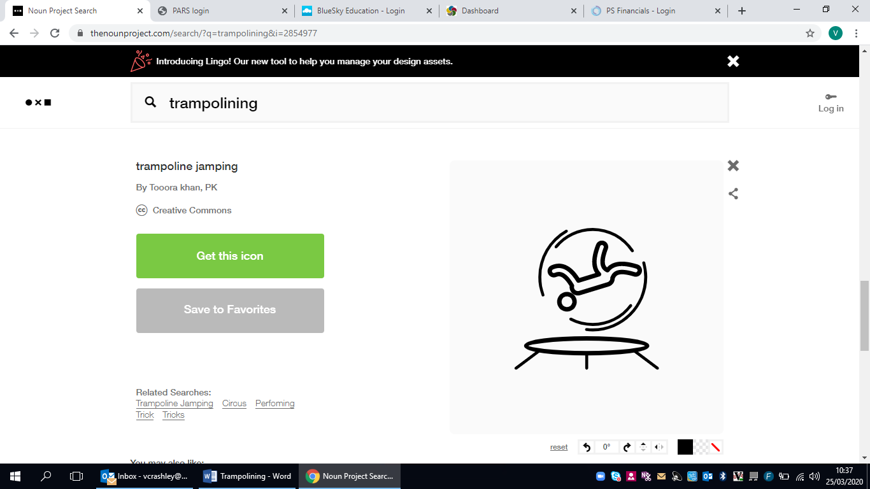

**Challenge 3:**

Select *TWO* of the following skills ‘Front Drop, Back Drop, Swivel Hips, Front Somersault, Back Somersault’, pretend you are a coach. Research the progressions for these skills recording your findings below.

Skill 2:

Skill 1:

**Let’s Practice Some Skills**

**Jump Challenge:**

1. Set your timer for 1 minute.
2. How many jumps can you complete in this time?
3. Repeat this 3 times to try to improve your score!

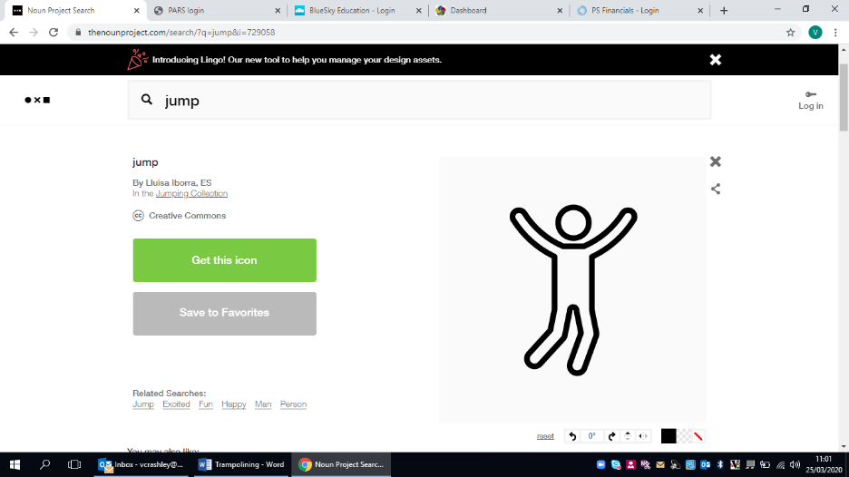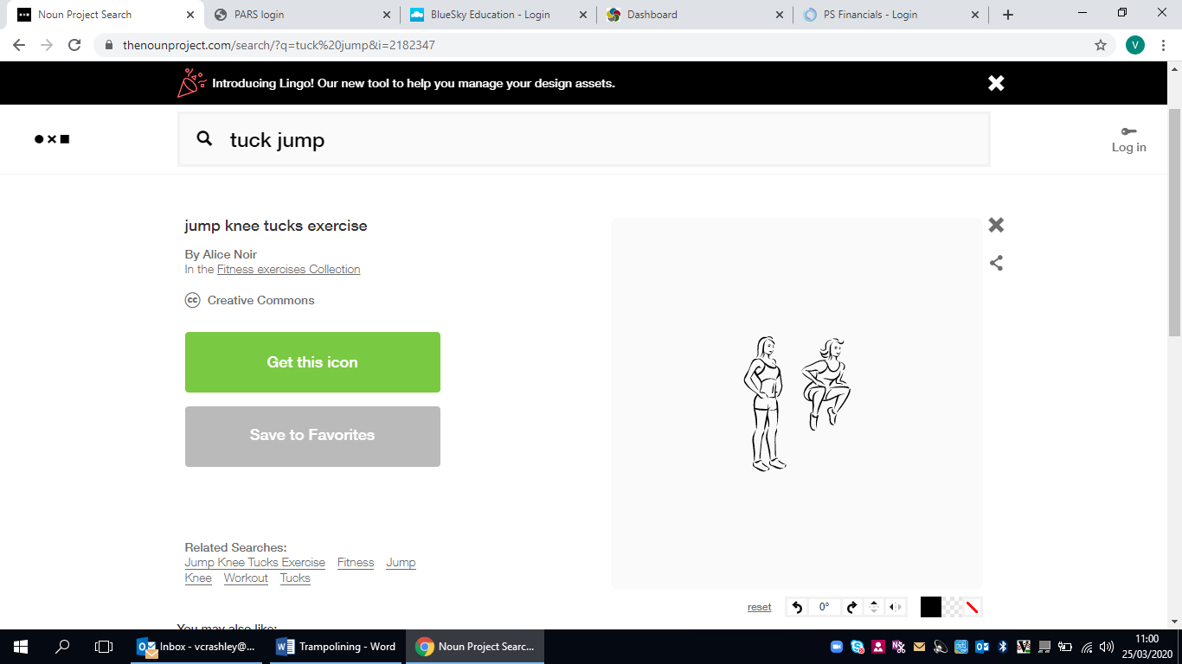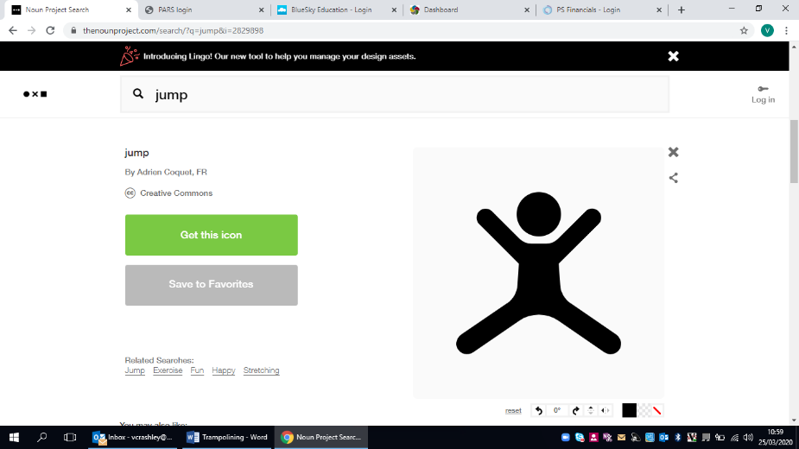

***Straddle*** ***Tuck*** ***Straight***

Repeat the circuit 2 times.

Finally… ENJOY!

Complete the following circuit, spending 30 seconds on each exercise.

***Flexibility*** is needed to improve your performance on the trampoline.

