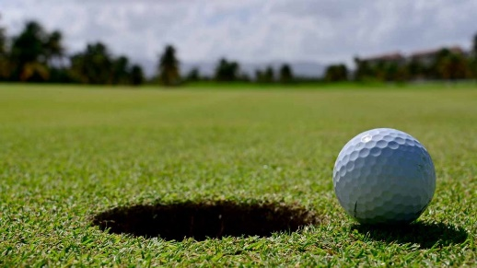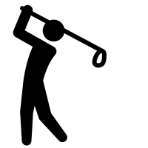

**Golf**

**Challenge 1**: Find the key golf terminology in the word search below.

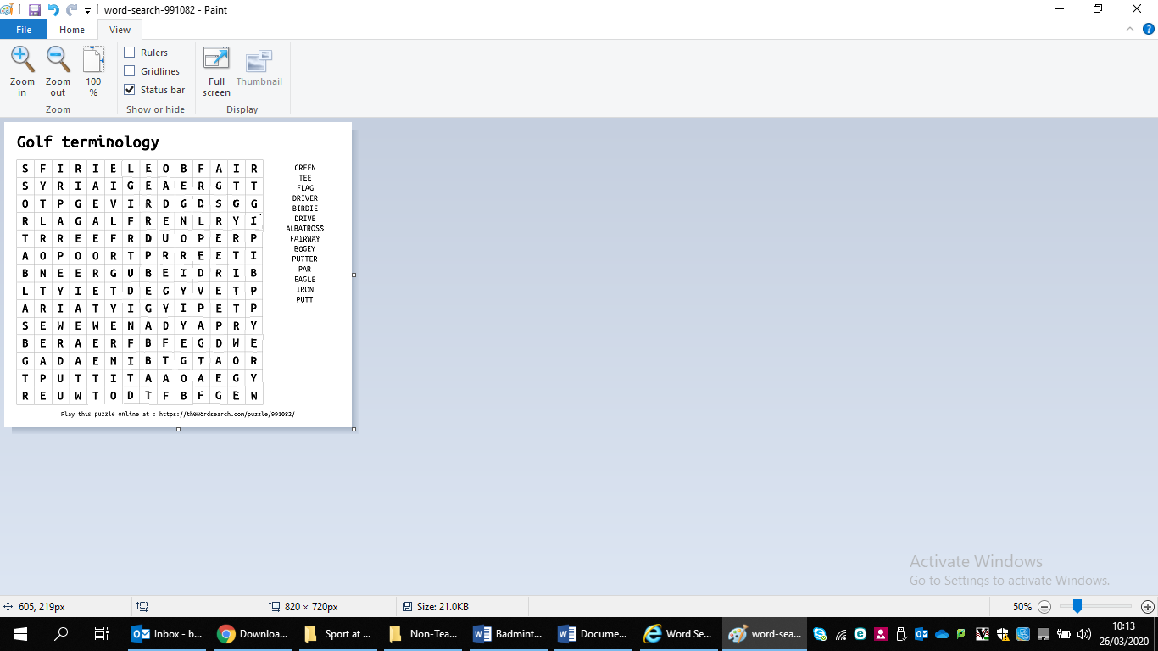

**Challenge 3**: There are 4 major golf tournaments (The Masters/The US Open/The Open Championship/The PGA Championship). For each, name 2 golfers that have won the major.

1. The Masters
2. The US Open
3. The Open Championship
4. The PGA Championship

**Challenge 2**: For each of the terms below, write how many under par or over par a player would score on a par-5 hole

Remember, ‘Par’ is the expected number of shots taken.

* Birdie
* Bogey
* Eagle
* Albatross
* Double bogey
* Triple bogey
* Hole-in-one

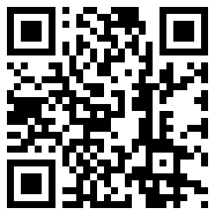

**Golf Challenges**

|  |  |
| --- | --- |
| Image result for golf keepy up  **Challenge 1 – Keepy up**  See how many times you can bounce the ball on the golf club head without letting it bounce | **Challenge 2 – Chipping**  Practice chipping balls into a designated area, for example into a hoop, trying to hit a football or into a plant pot.  Image result for golf chipping |
| https://static.thenounproject.com/png/3052499-200.png  **Challenge 3 - Putting**  Using a target as the hole (tin of beans/a football) attempt to make a putt from the greatest distance. | Image result for phil mickelsonImage result for tiger woodsImage result for rory mcilroy  **Challenge 4 - Faces**  Using the internet or your own knowledge, identify the 3 famous golf players below.  ___________ ____________ ____________ |
| Image result for ian poulter medinah  **Challenge 5 - Celebrations**  Using Youtube, watch some videos from the Ryder Cup – The Miracle of Medinah. Picture yourself recreating some of the famous celebrations on show. | **Challenge 6 – Smile!**  Get pictured completing any golf challenge and tweet @jhighHWB |