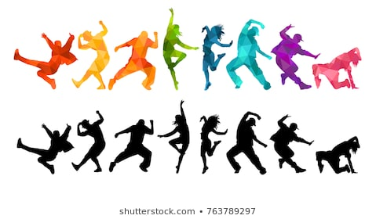

**DANCE**

# CHALLENGE 1:

# Find the dance keywords in the word search.

|  |  |  |  |  |  |  |  |  |  |  |  |  |  |  |
| --- | --- | --- | --- | --- | --- | --- | --- | --- | --- | --- | --- | --- | --- | --- |
| J | S | S | B | L | S | W | K | F | V | O | P | X | G | Z |
| M | D | C | B | T | I | C | X | C | S | V | B | U | S | D |
| M | J | L | V | R | H | C | I | L | I | T | Q | P | C | V |
| S | I | U | X | D | J | H | E | M | R | K | A | B | R | P |
| D | O | F | A | A | V | O | T | A | A | C | H | H | A | L |
| J | Q | N | V | N | B | R | V | B | E | N | U | N | S | S |
| O | N | X | Z | C | O | E | W | W | I | W | Y | D | N | S |
| S | A | M | N | E | L | O | P | R | A | H | S | D | O | W |
| F | M | R | S | L | Y | G | L | E | V | E | L | S | I | Y |
| A | U | O | I | O | N | R | W | A | J | Z | R | K | T | V |
| T | E | N | O | I | T | A | M | R | O | F | T | T | C | P |
| P | G | J | W | T | L | P | W | V | Q | P | A | K | A | S |
| X | V | O | L | O | H | H | Z | A | U | A | U | I | T | K |
| W | L | Q | P | V | D | Y | N | G | E | E | I | O | P | F |
| F | D | M | U | W | Z | Y | R | R | D | L | Y | R | X | Z |

|  |
| --- |
|  |
| ACTIONS | CHOREOGRAPHY | DANCE |
| DYNAMICS | FLOWING | FORMATION |
| KICK | LEAP | LEVELS |
| SHARP | SMOOTH | SPACE |

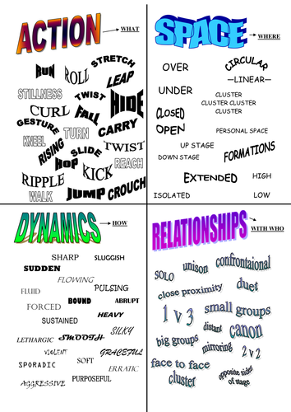



# CHALLENGE 2:

# Actions are what you do.

# Dynamic are how you do it.

# Space is where you do it.

# Relationships are interactions with another dancer.

# Plan your own routine outlining 6 actions, dynamics and space. This is a solo dance so no dance relationships will be included.

|  |  |  |  |
| --- | --- | --- | --- |
|  | ACTIONS | DYNAMICS | SPACE |
| Example | Turn on one leg, arms parallel upwards | Fast and sharp | Turn to the left |
| 1 |  |  |  |
| 2 |  |  |  |
| 3 |  |  |  |
| 4 |  |  |  |
| 5 |  |  |  |
| 6 |  |  |  |

# Now practice your routine to some music.

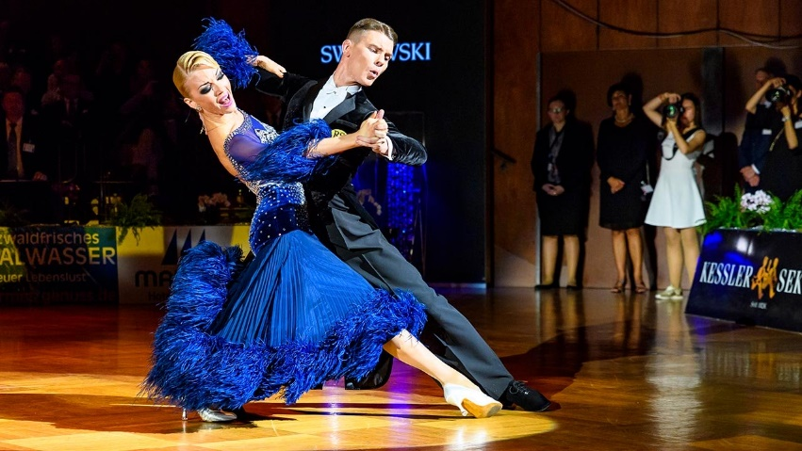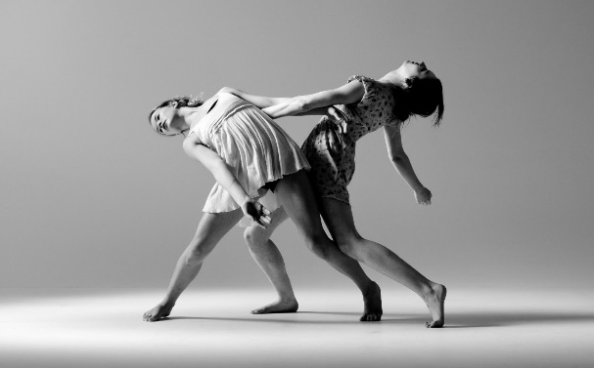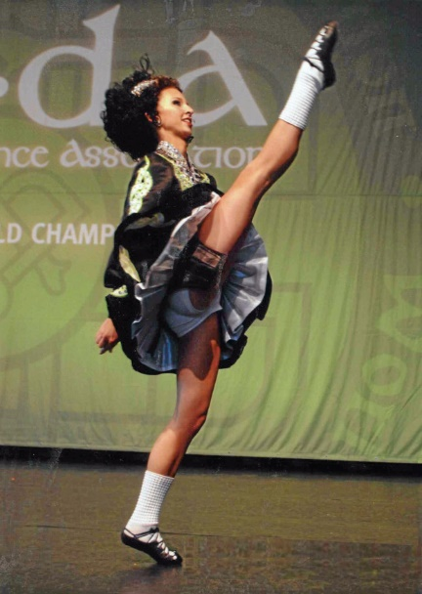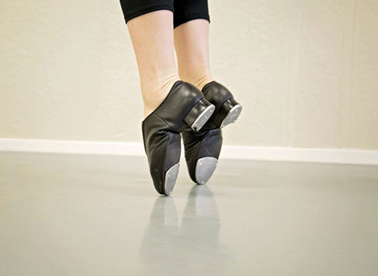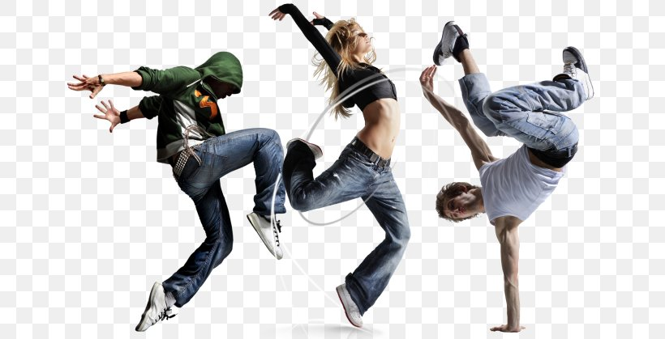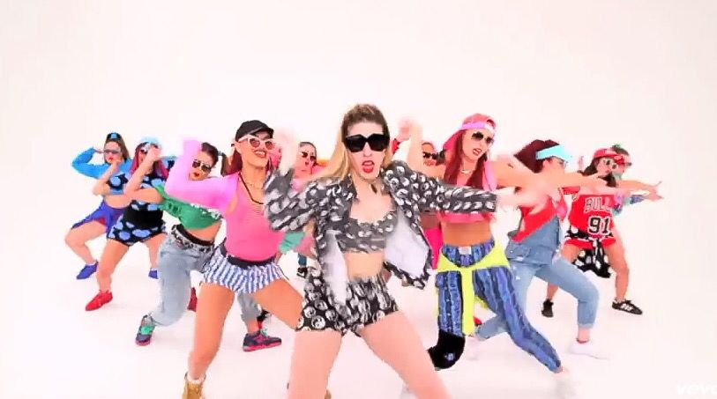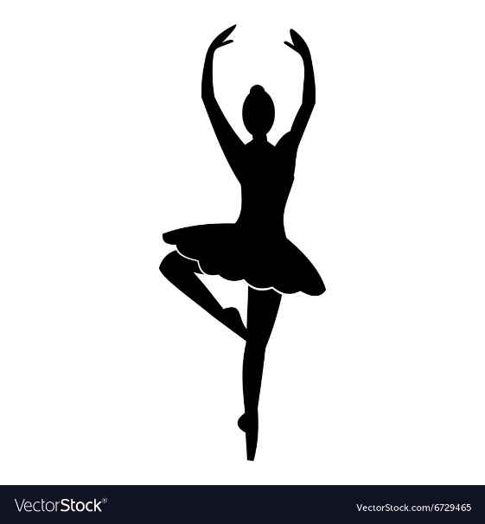

# CHALLENGE 3:

# Can you name the dance styles shown in the images below? Write the name of the style next to the image.

# Now note down any actions, dynamics, space and relationships you would see in these dance styles.

# CHALLENGE 4:

# A stimulus is a choreographer’s starting point for a dance. Choreography is created based on that stimulus.

# Using the image below as your stimulus, choreograph 16 counts of dance. Use the space around the image to plan your dance.

# Image result for rainbow



Shapes/ patterns created in space by dancers.

The range of movement in the joints.

The ability to make the unique qualities of the accompaniment evident in performance.

Two or more dancers performing the same movement at the same time.

The art of creating dance.

Ability to maintain physical and mental energy over periods of time.

Lengthening one or more muscles or limbs.

The way the body is held.

Muscular power.

When the same movements overlap in time.

CHOREOGRAPHY

POSTURE

STRENGTH

STAMINA

FLEXIBILTY

UNSION

CANON

EXTENSION

MUSICALITY

FORMATION

# CHALLENGE 5:

# Link the definition to the key word.