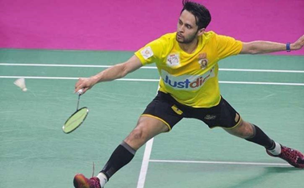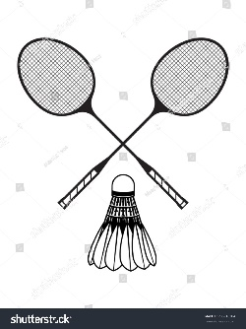

**Badminton**

**Challenge 1**: Find the key terminology in the word search below.

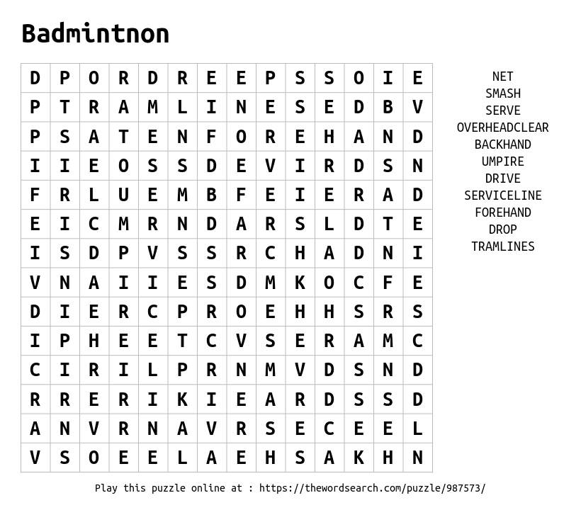

**Challenge 2:** State all the different ways in which you can score a point in badminton.



**Challenge 4:**

**A**: Label the court markings on the picture below

(Service line/side tramlines/back tramlines/net/centre line).

**B**: State the court dimensions

**Challenge 3:** On the diagram below, shade in the areas in which you can score in a game of singles and doubles. Remember, these are slightly different (Singles is the top half of the court, doubles is the bottom)

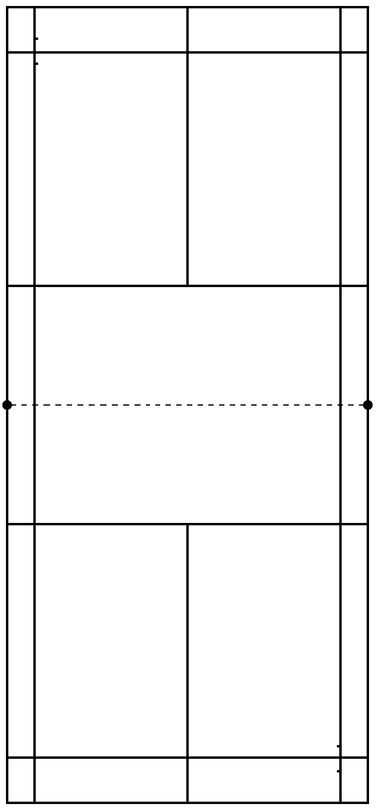

Doubles

Singles

**Let’s Practice Some Skills**

|  |  |
| --- | --- |
| Challenge 1 – Wall rally  See how many times you can hit the shuttle (or small/light object) against a wall without letting it hit the ground. | Challenge 2 – Agility  Place 5 items (plant pots/stones/footballs) 3 meters apart in any shape you chose. Get somebody to time you touching each item as quick as possible.  To make it harder, make the shape bigger and complete it more than once per go |
| C:\Users\bmassey\AppData\Local\Microsoft\Windows\INetCache\Content.MSO\D447EB69.tmpImage result for chris adcock  ------------ ----------- | Image result for badminton playerImage result for gabby adcock  **Challenge 3**  **Identify these 4 badminton players. Use YouTube and Google to help you.**  ------------ ------------ |
| Image result for skipping  Challenge 4 – Skipping  To practice those quick feet, design a skipping circuit using the different kinds of skips (research if you need to) and carry it out. | Challenge 5 – Smile!  Get pictured completing any badminton challenge and tweet @jhighHWB |