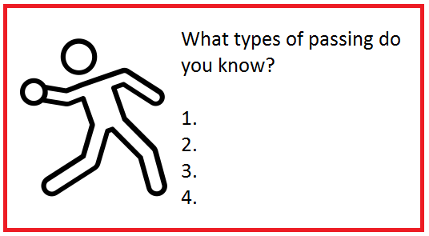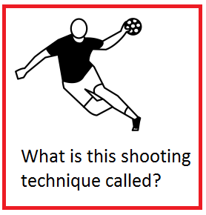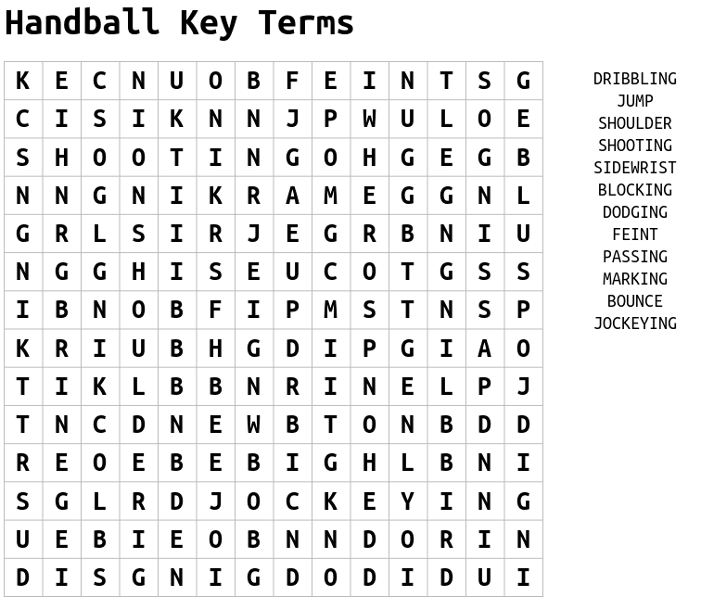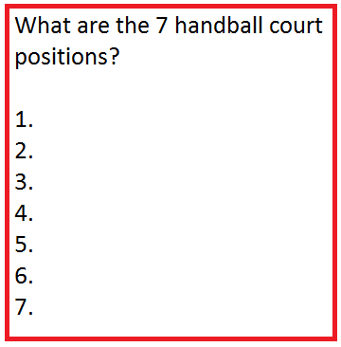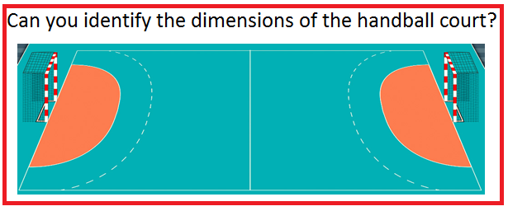

**Handball**

|  |  |
| --- | --- |
| **Challenge 1**  Choose one type of pass and see how many successful passes you can make in 30 seconds (5m apart).  + Increase distance to 8m | **Challenge 2**  What is the furthest distance you can perform a jump shot from and hit a target? |
| **Challenge 3**  Set this up in your garden, time yourself how long it takes to dribble in and out of the obstacles.  + Use your non-dominant hand | **Challenge 4**    Plant Pot Target  How many can you hit from 5m?  + Use non dominant hand/increase distance to 7m |
| https://static.thenounproject.com/png/3209607-200.png**Challenge 5**  Reaction Test – Using a wall complete 10 passes from 5m away and attempt to catch all of them  +Each time you are successful decrease the distance by 1m  How close can you go?! | **Challenge 6**  Make up your own handball challenge and tweet @jhighHWB  when you complete it! |