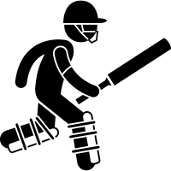 **Cricket**

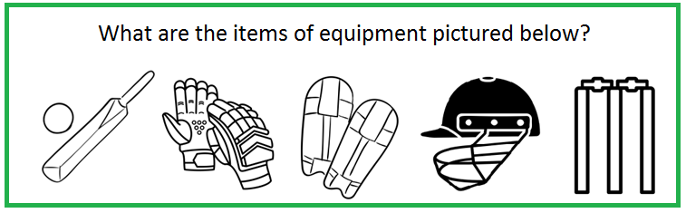

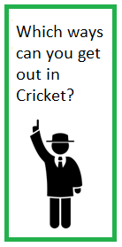



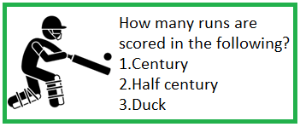

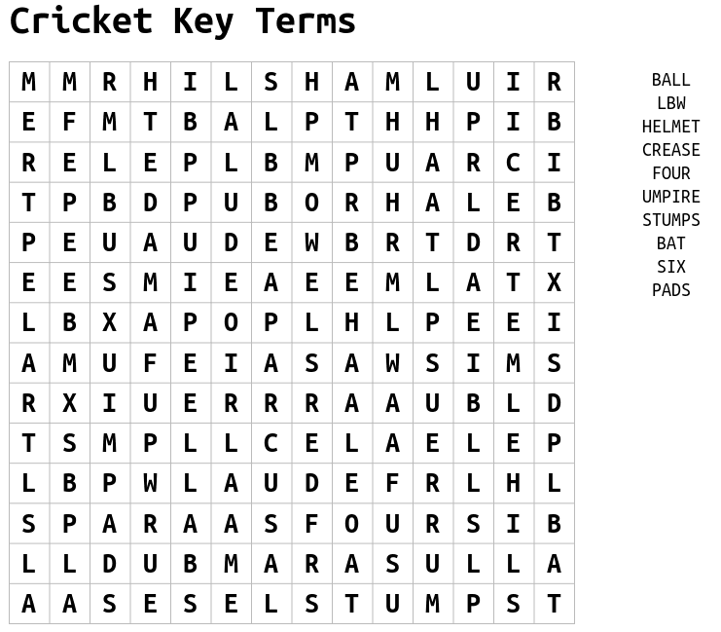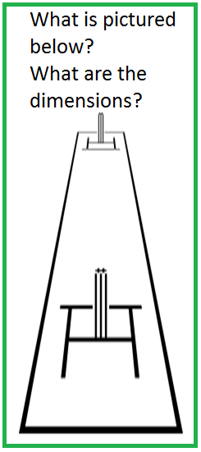

**Cricket Challenges**

|  |  |
| --- | --- |
| **Challenge 1**  QRCode  Wall Toss Test  This will test your co-ordination which is vital in Cricket.  Scan the QR code and follow the instructions in the video. | **Challenge 2**  Dustbin Stump Shy  Take 10 attempts to hit the dustbin from 5m and record your results.  +Increase the distance and use a smaller target  ++ Use non-dominant hand |
| **Challenge 3**  Practise your diving catches. Start off at 2m and try to increase the distance after each successful catch.  +Use non-dominant hand | **Challenge 4**  Garden Fork Bowling. Bowl one over (6 Balls) and see how many times you hit the fork from 10m. Increase distance to 15m if possible. |
| **Challenge 5**  Take a look at England bowling their super over in the 2019 World Cup Final.  Would you have held your nerve?!  QRCode | **Challenge 6**  Picture yourself completing one of the Cricket challenges and tweet @jhighHWB  with the image/video! |