

**Basketball** 

**Challenge 2 Numeracy;**

How many points are awarded for a;

- free throw

- basket inside the semi-circle

- basket outside the semi-circle

How many players in a basketball team?

How many teams are there in each conference (league) in the NBA?

**Challenge 1 Literacy;**

Complete the following word search with basketball specific terms:

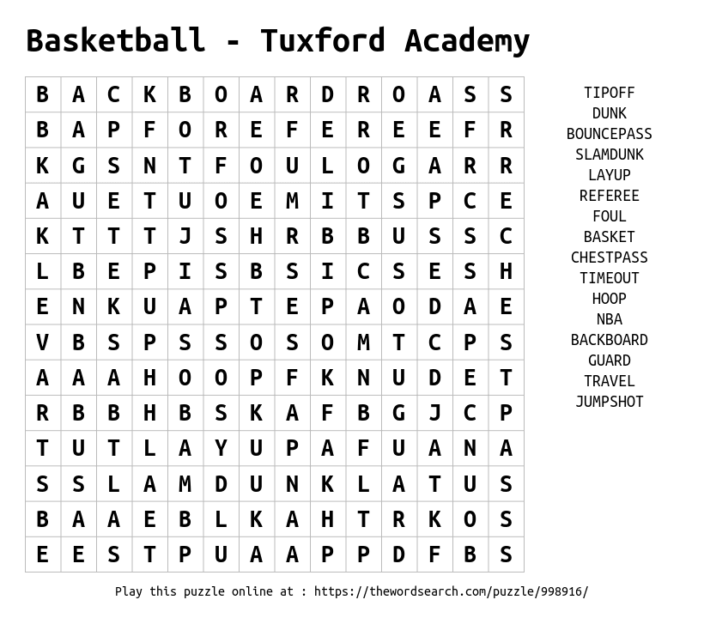

**Challenge 3 Rules;**

Describe what is meant by the rule ‘backcourt violation’

Explain how a player could break the double dribble rule.

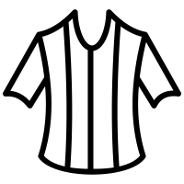



**Challenge 4 The court;**

Complete the basketball court with the correct markings

**Challenge 5 Geography;**

What are the two conferences (divisions) called in the American NBA competition?

Which NBA team are located at the most western point in America?

Which NBA team are located at the most eastern point in America?

|  |  |
| --- | --- |
| **Challenge 1 - Art**  - Research an NBA team of your choice and on a plain piece of A4 paper draw and colour their kit.  - Design your own Johnstone High basketball kit. | **Challenge 2**  Find a spot 5 metres away from a wall;  How many chest passes can you perform in one minute without the ball touching the floor?  (If you don’t have a basketball use any ball)  https://static.thenounproject.com/png/2112101-200.pnghttps://static.thenounproject.com/png/1277502-200.png |
| **Challenge 3**  C:\Users\clongmore\AppData\Local\Microsoft\Windows\INetCache\Content.MSO\B9764380.tmp  How many times can you rotate the ball around your;  -head  -waist  -knees  Time one minute for each task (3 minutes in total) | **Challenge 4**  If you have a hoop at home, great.  If not find a target which you can use e.g. bin or ask a family member to hold a bag open.  Take 10 shots 3 metres away and record the score.  https://static.thenounproject.com/png/1461812-200.png  https://static.thenounproject.com/png/199029-200.png |
| **Challenge 5**  Maya Moore is listed (or ranked) 1 on the list Famous Female Basketball Players C:\Users\clongmore\AppData\Local\Microsoft\Windows\INetCache\Content.MSO\88D45F82.tmp  **WHO AM I?**  C:\Users\clongmore\AppData\Local\Microsoft\Windows\INetCache\Content.MSO\EBC2362C.tmp C:\Users\clongmore\AppData\Local\Microsoft\Windows\INetCache\Content.MSO\6C050253.tmp | **Challenge 6**  Get pictured completing any challenge and tweet @jhighHWB  C:\Users\clongmore\AppData\Local\Microsoft\Windows\INetCache\Content.MSO\69673A5D.tmp |