**Athletics**

Complete the following challenges to enhance your knowledge of athletics.

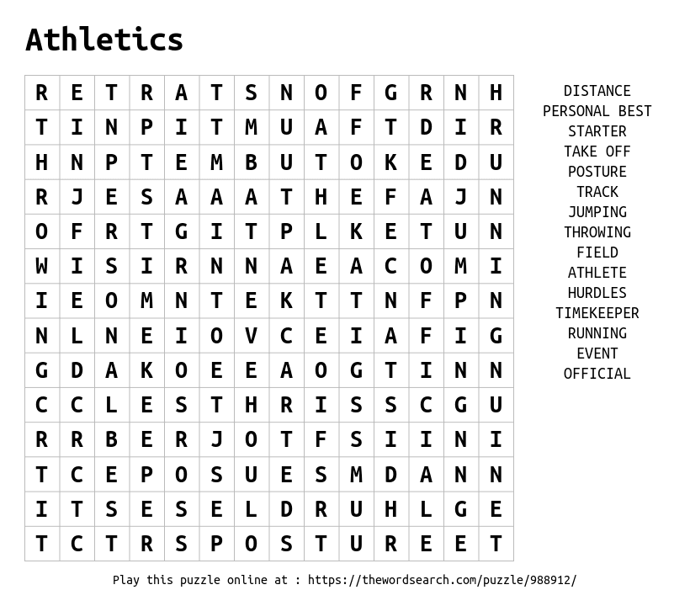

**What events are in a Heptathlon?**

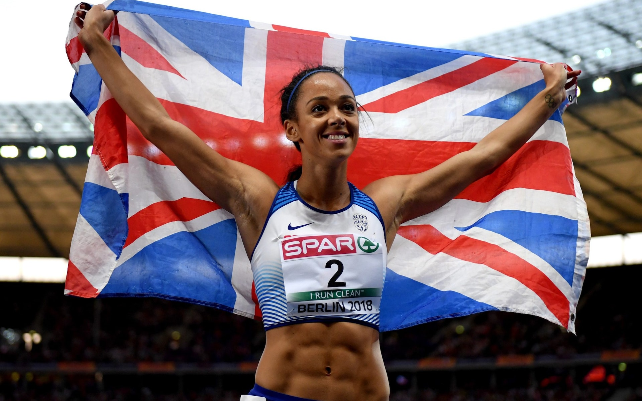

1.

2.

3.

4.

5.

6.

7.

How many players are there on a Rugby Union team and what number would a Hooker and Fly half wear?

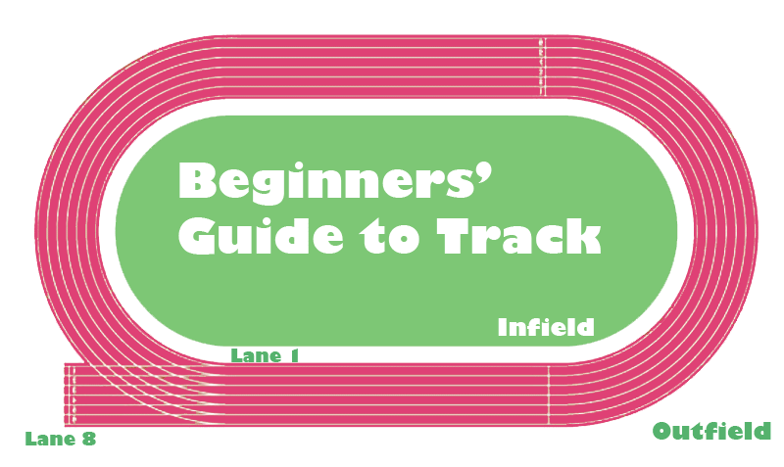 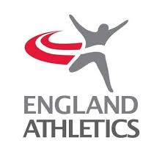 

**Identify them on the track**

**Where do the following events start and finish on the track?**

**100m**

**200m**

**400m**

**1500m**

**Find your PB**

Challenge 1 – Speed Bounce Challlenge 2 – Standing Long Jump

Measure how far you can jump from a standing start.

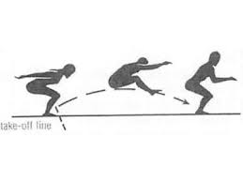

1:

2:

3:

Personal Best:

Count how many repetitions of the speed bounce you can complete in 60secs.

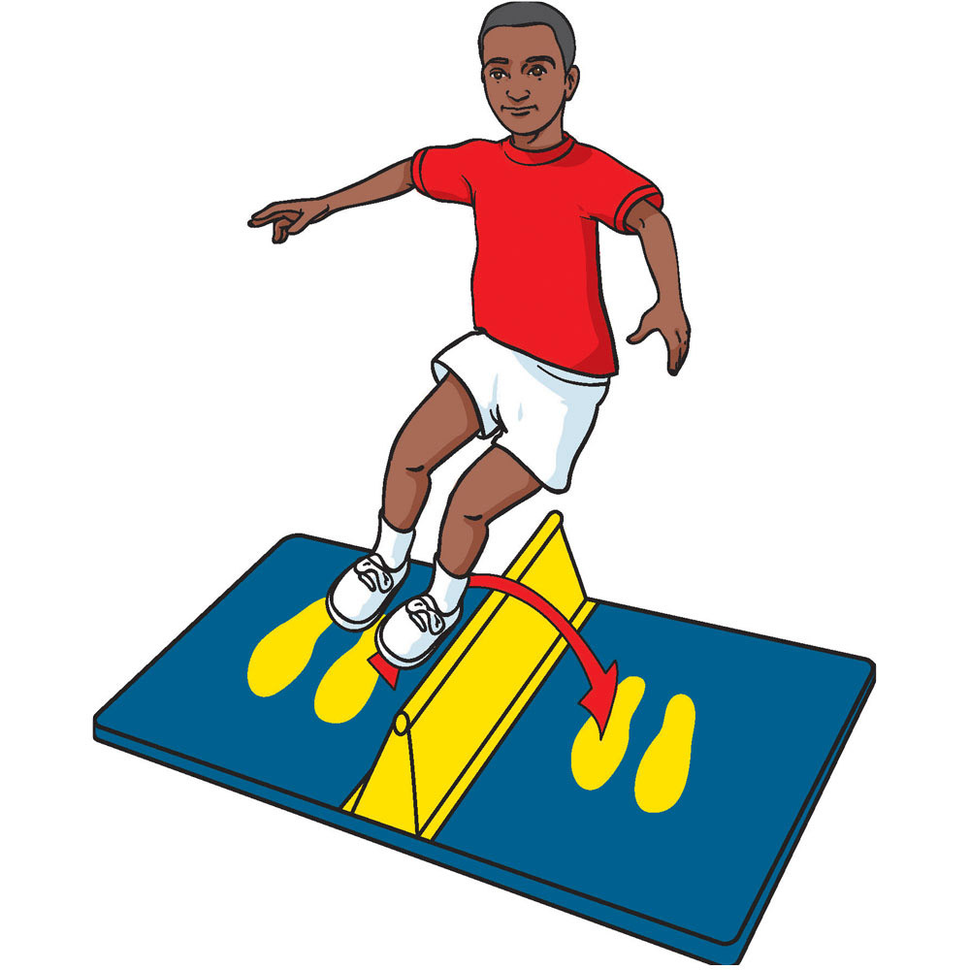

1:

2:

3:

Personal Best:

Challenge 3 – Chest Push Challenge 4 - High Knees

Using a ball (football, netball or medicine ball). Perform the chest push and measure how far you can throw it.

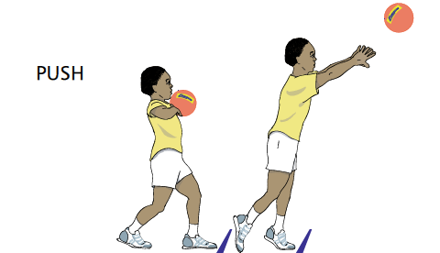

Calculate your PB after three attempts.

1.

2.

3.

Personal Best:

Complete as many high knees on the spot for 60 secs.

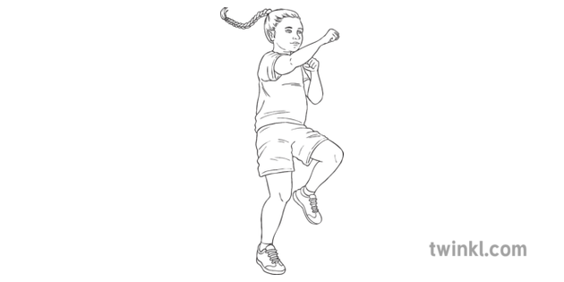

1.

2.

3.

Personal Best: