

**Association Football** 

**Challenge 1 Literacy;**

Complete the following word search with football specific terms:

**Challenge 2 Numeracy;**

How many points are awarded for a;

- win

- draw

- loss

How many players in a football team?

How many substitutes are permitted to be made each game?

Carlisle United v Plymouth Argyle – what is the **round distance** the Plymouth team would travel?

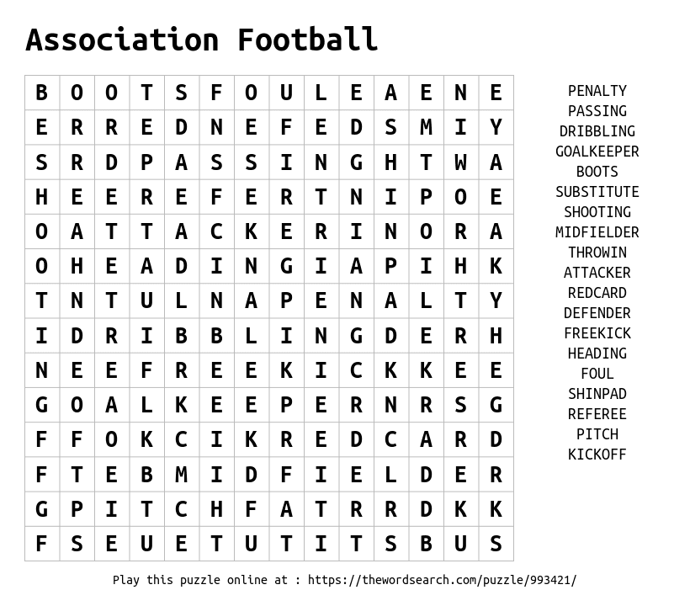

**Challenge 3 Laws & Respect;**

Give one example of good sportsmanship in the game of football.

Describe one scenario when a red card might be awarded in the game of football





**Challenge 4 The pitch;**

Complete the football pitch with the correct markings

**Challenge 5 Geography and History;**

Which professional football team plays its games closest to Johnstone High School?

What do the counties of Cornwall, Herefordshire and Durham all have in common?

Which local football club is the oldest in England and when was it founded?

In what season did the Women’s Super League turn professional?

|  |  |
| --- | --- |
| **Challenge 1**  How many kick ups can you do without the ball touching the floor?  https://static.thenounproject.com/png/642584-200.png | **Challenge 2**  Find a spot 5 metres away from a wall;  Using one touch pass the ball against the wall using alternate feet.  Record your best score in 1 minute.  https://static.thenounproject.com/png/1751398-200.png |
| **Challenge 3**  https://static.thenounproject.com/png/1118484-200.png  If you have access to Netflix watch;  The English Game  History of Football | **Challenge 4**  Grab a family member  Grab a ball  How many keepy up headers can you do?  https://static.thenounproject.com/png/688848-200.png  https://static.thenounproject.com/png/2742311-200.png |
| **Challenge 5**    Name the players and recreate their famous goal celebrations | **Challenge 6**  Get pictured completing any challenge and tweet @jhighHWB  C:\Users\clongmore\AppData\Local\Microsoft\Windows\INetCache\Content.MSO\C2BFE741.tmp |