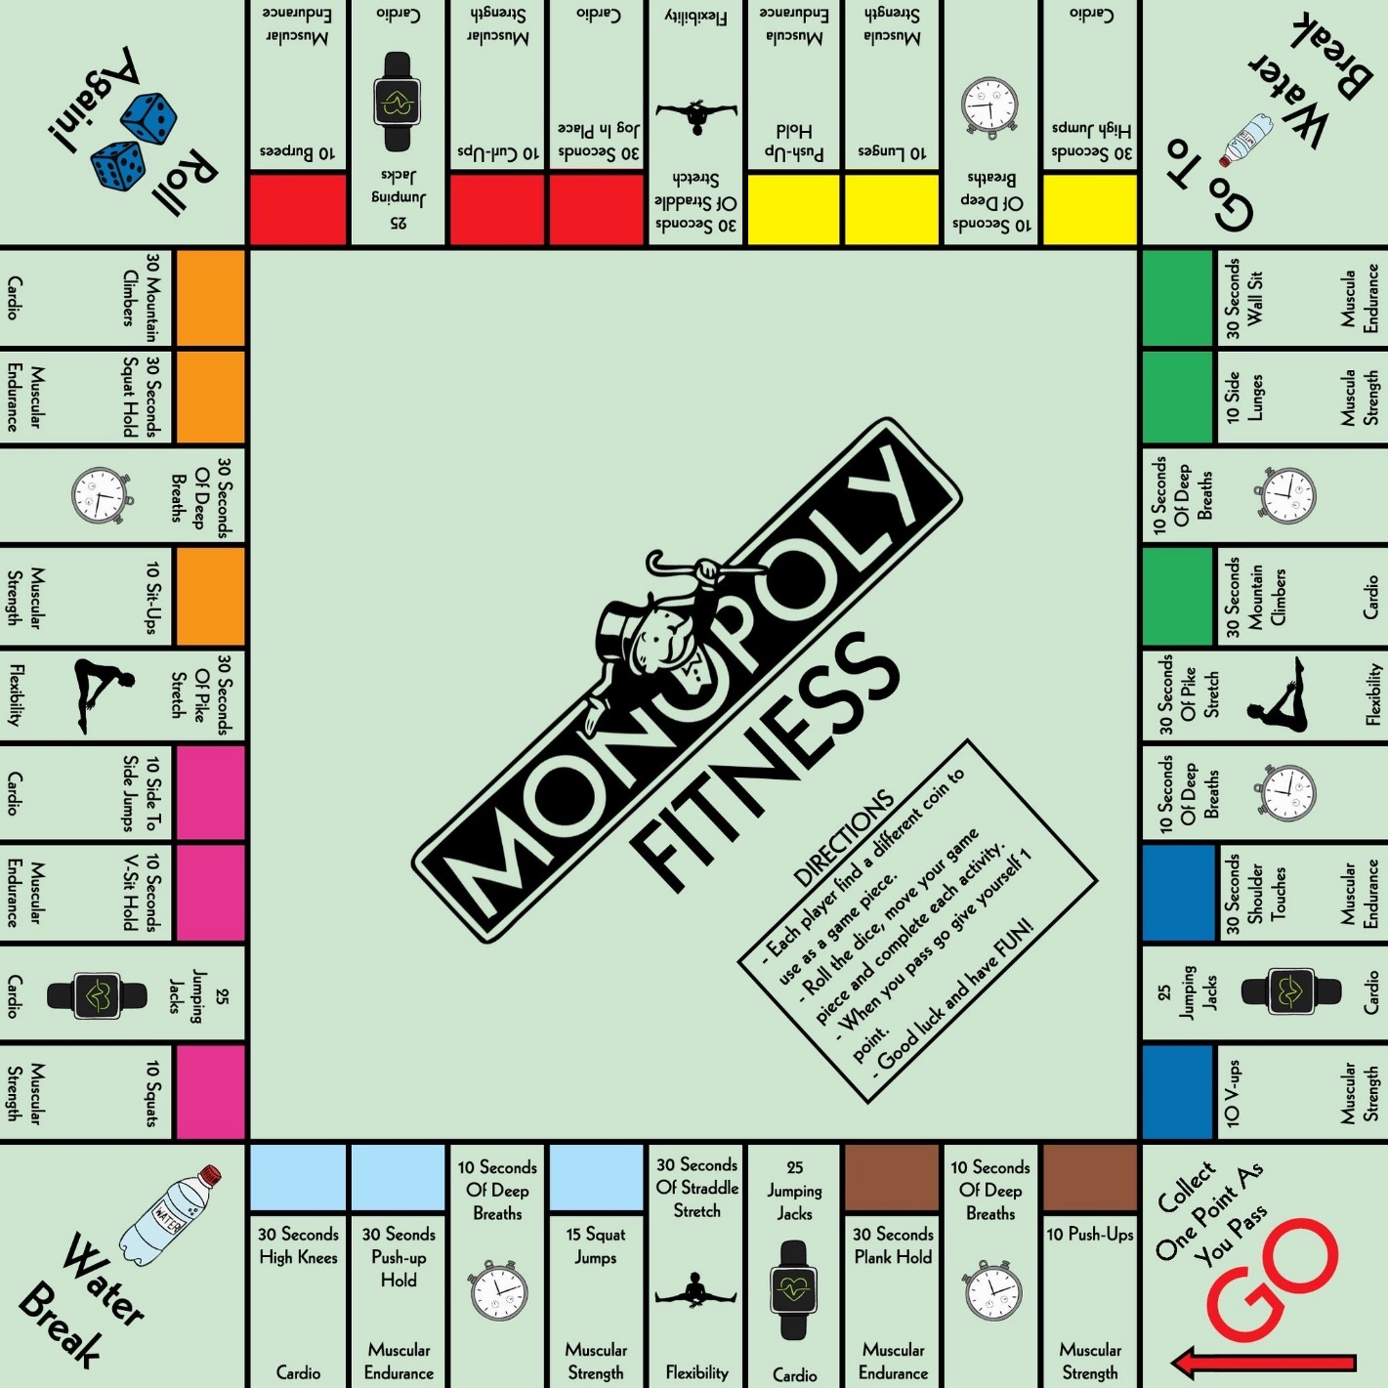**Monopoly Fitness**

Tips to play at home

* Use ‘freeonlinedice.com’ if you don’t have a dice
* When playing in a group, decide the winning number of points (first player to receive 10 points wins)
* You could play individually and count the number of points you get in a set playing time (e.g. 20 mins) and try to improve that next time

Choose your level

* Bronze – use reps on board
* Silver – add 5 extra reps/seconds to every exercise
* Gold – add 10 extra reps/seconds to every exercise