BGE Challenge:
JHigh – Ayr Beach
This week’s BGE Challenge is to cover the total distance from Johnstone High School > Ayr Beach
- Total distance is: 35 miles
- You have 3 options:
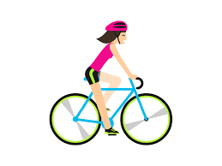
- You can walk your distance
- You can jog your distance
- You can cycle your distance
Efforts can be individually recorded, or you can collectively combine your totals with members of your family.
Plan how much distance you will cover each day, you have 7 days to complete this challenge!
Record your distance on your watch/phone using a free app to track it.
You have 7 days to complete the challenge
- Starts Monday 8th June
- Finishes Sunday 14th June
Remember to update you progress to your teacher on SMHW or let us know on Twitter via @jhighHWB.

GOOD LUCK!!

