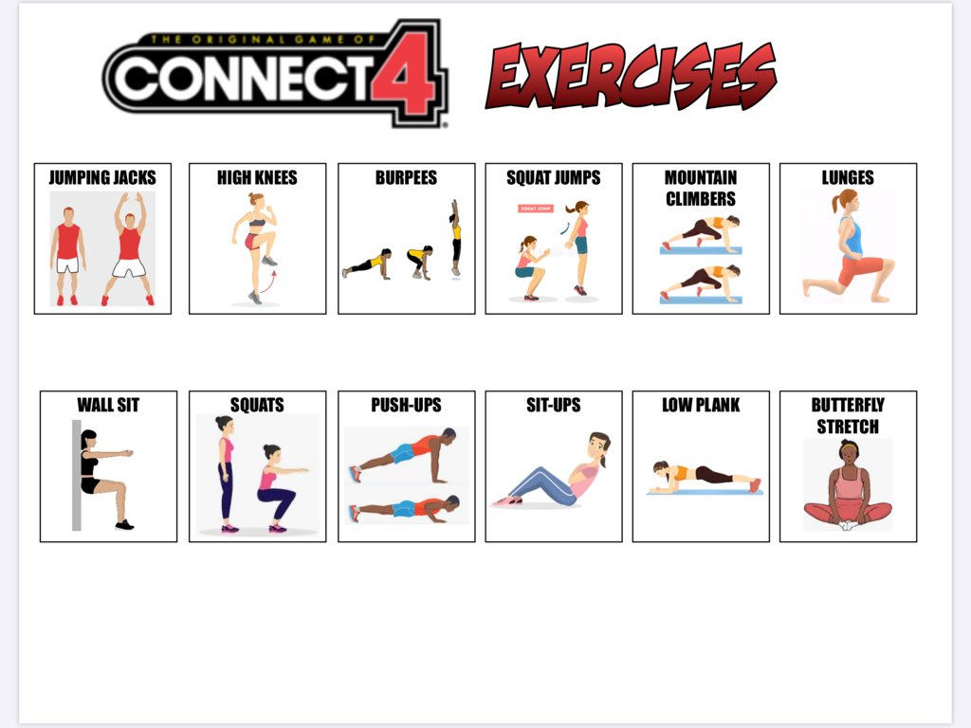

**FLIP FITNESS**

|  |  |  |  |  |  |
| --- | --- | --- | --- | --- | --- |
| Flip 1 | Flip 2 | Flip 3 | Flip 4 | Flip 5 | Flip 6 |

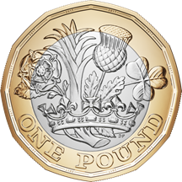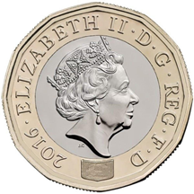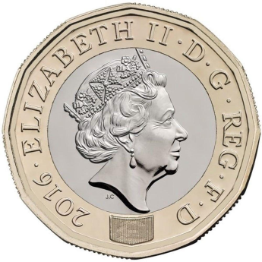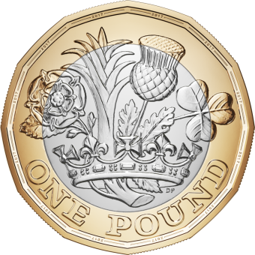

**40 secs**

**40 secs**

**40 secs**

**30secs**

**25secs**

**15secs**

**30 secs**

**30**

**40**

**20**

Flip a coin fitness. Compete against an opponent or play on your own to improve your fitness. There is 6 rounds, complete the challenge for heads or tails depending on how the coin lands.