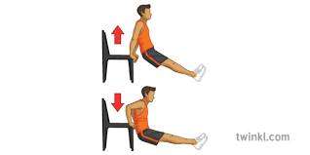
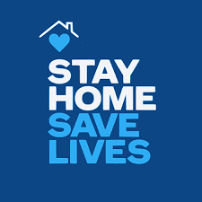
BGE – STAY HOME Challenge
S
- Squats x15
T
- Triceps Dips (on chair or sofa) x15
A
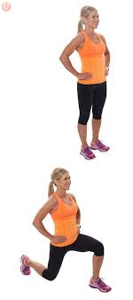
- Alternate Reverse Lunge x20
Y
- Y Jumps x15
H
- High Knees x20
O
- Overhead shoulder circles X20
M
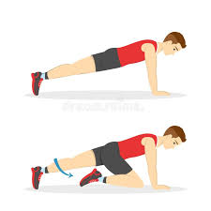
- Mountain climbers x20
E
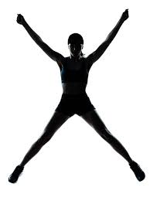
- Explosive Star Jumps X15

