BGE PE Challenge Week (26/5/2020)
Over the course of the coming week test yourself against the teachers to see how many of each exercise you can do in 30s. Record this in the table below and send it back via SMH by the end of the week.
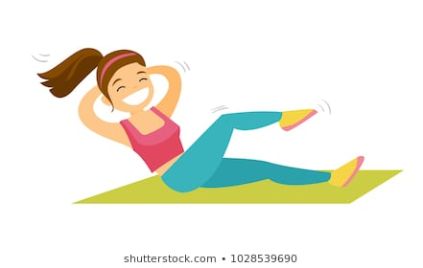
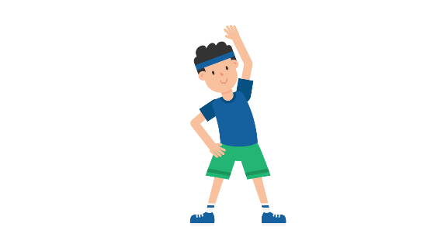
Exercise | Miss Ashmole’s Score | Your Score
Press Ups | 24
Sit Ups | 17
Squats | 26
Star Jumps | 36
Mountain Climbers | 28
Keepy Uppies (If you have a ball and appropriate space) | 4
Plank (How long can you hold for) | 30 seconds

