Alphabet Fitness Challenge

A: 10 sit ups Q: 5 jumps squats
B: 5 squats R: 20 star jumps
C: 15 arm circles S: 5 lunges each leg
D: 10 mountain climbers T: 5 jump squats
E: 10 high knees U: 10 push ups
F: 5 burpees V: 10 mountain climbers
G: 5 lunges each leg W: 20 high knees
H: 30 second plank X: 30 second plank
I: 5 jumps squats Y: 20 Star jumps
J: 10 bicycle crunches Z: 10 push ups
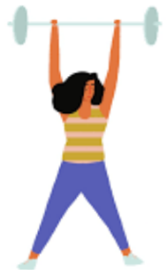
K: 10 star jumps
L: 10 mountain climbers
M: 10 push ups
N: 20 high knees
O: 10 sits up
P: 15 arm circles
Challenge 1: Complete FIRST NAME
Challenge 2: Your age - complete that number of BURPEES
Challenge 3: Complete LAST NAME
Challenge 4: Complete your STREET NAMES of where you live
*If you’re unsure of any exercises then use google to research the moves*

