Full Name: Class:
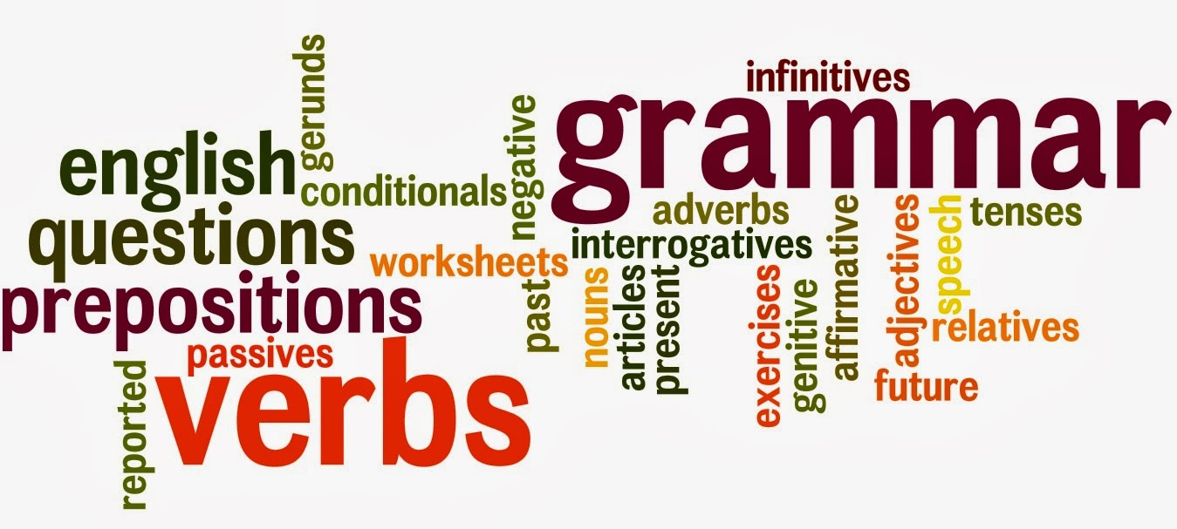
S1 Language Booklet
Glossary of terms for Section 1:
Adjective: adjectives describe nouns and are often found before the noun (or before another adjective if more than one adjective is being used).
i.e. “the red, crumbling brick wall.”
Adverb: a word which modifies a verb in some way.
i.e. “He ran quickly.” Quickly tells us more about the verb ‘ran’.
Noun: a word which names things. There are different types of noun:
Proper nouns give the names of actual places or persons [e.g. “Glasgow” & “Kylie Minogue.”]
Common nouns refer to objects, [e.g. “desks”, “floors”, “rivers”]
Collective nouns define groups of things [e.g. “herd”, “class”] and
Abstract nouns define qualities [“wisdom”, “kindness”]
Pronoun: a pronoun is a word which replaces a noun.
i.e. “he”, “she”, “it”, “they”.
Verb: a verb is often referred to as a ‘doing word’ and if you know what this means you know what a verb is; it is the word which tells us the action.
i.e. “run”, “cry”, “hope”, “love” and “shout”.
Conjunction: a word that links or joins together two words or phrases.
i.e. “and” “but”.

SECTION 1

Week 1: Nouns
You will have looked at nouns in primary school. Nouns are sometimes described as naming words. However, there are different types of nouns. There are definitions in the glossary at the end.

Task 1: Common and Proper Nouns. Can you highlight the proper nouns in the list below?

water | Aldi | sock | Paisley
hen | music | Everest | toe
France | bacon | Ann | Foxbar Road
park | horse | Henry | Lord Watson
July | Barshaw Park | pencil | Gleniffer High

Collective Noun conundrums. Now complete the following:
A pack of ______________
A bouquet of ______________
A pride of _______________
A flock of _______________
A coven of_________________
A__________________ of geese.
A _________________of crows.
A__________________ of elephants.
A__________________ of ants.
A__________________ of bees.

Can you find other examples of collective nouns? Write down at least two.

Consolidating task: Your job is to look at the list in the box below and try to put them into the correct section in the table. A first example has been put in each section to help.

- pack
- tree
- love
- gaggle
- London
- Charles Dickens
- girls
- regret
- swarm
- kindness
- High Street
- happiness
- knife
- bottle
- flock
- Australia
- elephants
- courage
- December
- team
- audience
- holiday
- jealousy
- Wednesday
- apple
- road
- Christmas
- River Amazon
- bunch
- army
- hate
- Mount Everest
- chair
- The Titanic
- train

COMMON  (ordinary things) | ABSTRACT  (names an idea)
book | hope
PROPER  (a specific name of person/thing) | COLLECTIVE  (groups of objects/ people/ things)
Paisley | flock

Week 2: Verbs

Verbs are doing words. They are words used for action. The following extract is taken from the fantastic book Northern Lights by Philip Pullman which is part of the His Dark Materials trilogy. In the passage below there are ten verb errors. Underline the mistakes for ten marks. Next, write in the correct tense of verb in the numbered spaces below for another ten marks.
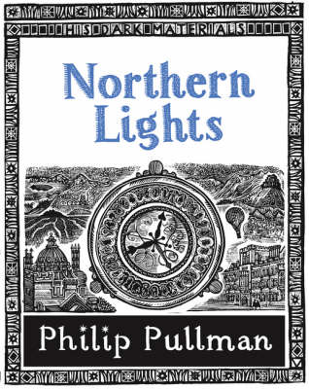
Farder Coram standing by the gate and called:
"Iorek Bymison!"
The bear stopped ate. As far as they could tell, he was looked at them directly, but it was impossible to read any expression on his face.
"Iorek Byrnison," said Farder Coram again. "May I spoke to you?"
Lyra's heart was thumped hard, because something in the bear’s presence make her feel close to coldness, danger, brutal power, but a power controlled by intelligence; and not a human intelligence, nothing like a human, because of course bears had no daemons. This strange hulking presence gnawed its meat was like nothing she had ever imagined, and she feel a profound admiration and pity for the lonely creature.
He dropped the reindeer leg in the dirt and slumping on all fours to the gate. Then he reared up massively, ten feet or higher, as if to show how mighty he was, to remind them how useless the gate would be as a barrier, and he speaking to them from that height.

1.__________ 2. __________3. __________ 4. __________ 5.__________

6.__________ 7. __________8. __________ 9. __________ 10.__________
Identify whether the verb in each sentence below is past, present or future tense.
- The rats were biting the ankles of the walkers.
- I am living in a top floor flat.
- I shall speak to you tomorrow.
- The mirror cracked from side to side.
- I have not seen you for many years.
Week 3: Adjectives
Underline all the adjectives you can find.
- The little girl had a squeaky voice.
- James Bond is tall, brave and handsome.
- The teachers are strict but fair.
- The wood was cool and shady.
- I love cool, fresh lemonade.
- We were caught in a heavy shower.
- The bride wore a long white dress and a beautiful veil.
- The teacher has a loud, shrill voice.
- The pizza was delicious.
- We walked along a dimly-lit street.
- The sea was blue and calm.
- The sun was a big, yellow, shiny ball in the sky.

Highlight/ underline all of the adjectives in the following extract from “The Giver” by Lois Lowry.
It was almost December, and Jonas was beginning to be frightened. No. Wrong word, Jonas thought. Frightened meant that deep, sickening feeling of something terrible about to happen. Frightened was the way he had felt a year ago when an unidentified aircraft had overflown the community twice. He had seen it both times. Squinting toward the sky, he had seen the sleek jet, almost a blur at its high speed, go past, and a second later heard the blast of sound that followed. Then one more time, a moment later, from the opposite direction, the same plane.
Write down possible adjectives to change these basic sentences:

- The teacher spoke________________ to the boy.

- She walked ______________to the venue.

- He slept_____________ in the chair.

- She danced____________ on the stage.

Week 4. Adverbs
An adverb is a word used to give more information about a verb.
Choose a suitable adverb from the box to complete each of the sentences.
generously meticulously greedily defiantly
joyfully patiently proudly meticulously
carefully happily calmly quickly

- Abigail _______ snatched the last biscuit from the plate.
- “I’m not going to tidy my room!” Chloe shouted _______ at her mother.
- The gentle nurse _______ helped the helped the old man back to bed.
- He gave _______ to the collection in aid of the RSPCC.
- The school choir sang _______ at the Christmas Concert.
- The boy ___________ accepted the trophy after winning the race.
- She _________________ planned and organised the event.
- He ___________ sprinted towards the front of the queue.

“How” adverbs
Some adverbs tell how something is done. They usually end in “ly” and are formed by adding “ly” to the end of adjectives.
Examples: clever – cleverly, true – truly, stupid – stupidly
Add “how” adverbs to the following sentences. Try to choose an interesting adverb which adds something significant.
- The prisoner walked ___________ into the interview room.
- As he sat in the hospital bed, he watched the sick woman ___________.
- The boy’s parents waited ______________ for the headmaster to speak.
- She looked _____________ at the stranger standing on the doorstep.
- He picked up the letter _____________ and began to read it.
Further types of adverb:
Adverbs of place – tell you where the verb is happening. (“Put it there.”)
Adverbs of time – tell you when the verb is happening. (“I will stop soon”)
Adverbs of degree – tell you how much. (“I quite liked him”)
Write beside the word in bold which type of adverb is used in each of the sentences below.
How? Where? When? How Much?
- I shall talk to her later.
- The fisherman nearly caught a fish.
- We can meet here.
- He scowled fiercely.
- I posted the letter yesterday.
Week 5. Conjunctions
If all the words we have looked at so far- nouns, verbs and adjectives are the building bricks of our language, then conjunctions are the cement. We use conjunctions to join together:
two single words: two nouns- ‘bread and butter’
two adjectives: ‘black or white’, ‘naughty but nice’
two adverbs: slowly but surely
two pronouns: you before me
Conjunctions can also join phrases:
Red roses or blue violets
Going outside before having lunch
More importantly, conjunctions are used to link together clauses and simple sentences in order to build longer and more interesting ones. We call these complex sentences.
Simple Conjunctions
and or but so because since If
although unless when while before after as
where whereas yet whenever despite

Other Conjunctions (Conjunctions can be more than one word)
As soon as in order that as well as as long as
As far as as if provided that in spite of

Account 1: The dog barked at us. We were waiting in a queue. A police car went past. It stopped. The policeman got out. He wanted to take the stray dog away.
Look at how much more sophisticated the same information sounds just by adding a few conjunctions!
Account 2: The dog barked at us while we were waiting in a queue. A police car went past and stopped. The policeman got out because he wanted to take the stray dog away.
Use the conjunctions listed in the boxes to link these complex sentences:
- I got absolutely soaking wet ________ I left my jacket at home.
- The weather forecast was for rain _____ the sun shone all day.
- I cleaned my room __________ I went to meet my friends.
- You could buy a new car _____________ you have the deposit.
- We should go to the cinema _________you have a better idea.

Read the following extract taken from ‘The Lion, the Witch and the Wardrobe’ by C.S. Lewis. Underline all of the words you believe to be conjunctions.
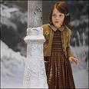
‘Lucy felt a little frightened, but she felt very inquisitive and excited as well. She looked back over her shoulder and there, between the dark tree trunks, she could see the open doorway of the wardrobe and even catch a glimpse of the empty room from which she had set out…
In about ten minutes she reached it and found it was a lamp-post. As she stood looking at it, wondering why there was a lamp-post in the middle of the wood and wondering what to do next, she heard a pitter patter of feet coming towards her.’
Write 3 sentences in the space below using conjunctions from the boxes.
1.

2.

3.
Week 6: Tenses
For a sentence to make sense, the noun (naming word) must agree with the verb (doing word).
(N) (V) (N) (V)
The bat hangs from the roof of the cave. The bats flutter their wings.

sang wakes gives make takes eat sings

Choose a verb from the box above to put into these sentences. When you have finished, check your sentences carefully to make sure they make sense.
- Gemma _________ the dog for a long walk on the beach.
- When Graham ________ you can tell he has a lovely voice.
- The sun ________ you up in the morning as it streams through the window.
- I did not ________ the last cream cake; it must have just vanished!
- As the nightingale _________ a mournful tune, the other birds perched on the branches of the tree and listened in silence.
- She _______ the cat a saucer of cream as a special treat.
- The waves ________ a crashing sound as they smash against the jagged rocks.

Complete these sentences. What happens to the verbs when the nouns change? Underline the noun (or nouns) and insert the correct verb. Make sure it agrees with the noun! The first one is done for you.
- Gemma and Leanne take the dog for a long walk on the beach.
- When Graham and Ashley ________ you can tell they have lovely voices.
- The rays of light ________ you up in the morning as they stream through the window.
- They ______ the cat a saucer of cream as a special treat.
- The wave ______ a crashing sound as it smashed against the jagged rocks.

