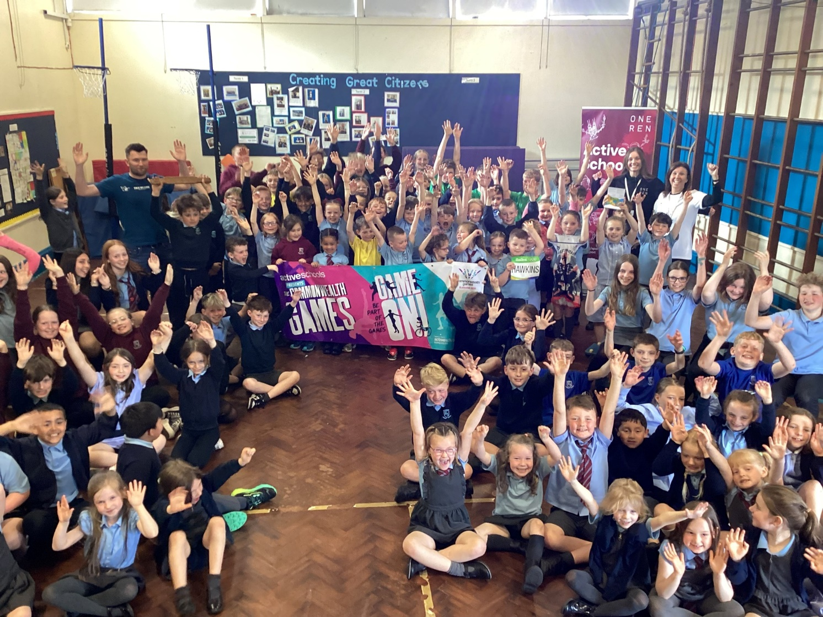
HOWWOOD PRIMARY SCHOOL
STANDARDS AND QUALITY REPORT JUNE 2026

This report will inform you of the school’s progress and achievements in the last session and let you know about our plans for 2026-2027. I hope that you find it helpful and informative.

Shirley Ormond
Head Teacher
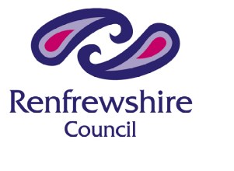

OUR SCHOOL


Howwood Primary is a non-denominational school based in the village of Howwood. The current school role is 109 which includes some inbound placing requests. The majority of our pupils live in Howwood and the surrounding areas and we benefit from a supportive wider school community.
The current school was built in 1963 and has accommodation for six classes.
There is an active Parent Council within the school . Parents are incredibly supportive, both in terms of educational engagement and attendance at school events. Pupil attendance is above the national average.
Although we are a small school, we offer excellent facilities and a learning and teaching experience which encourages pupils to be confident individuals, responsible citizens, effective contributors and successful learners. We have high standards in all we do and have achieved awards in Renfrewshire Nurturing Schools Approach, Reading Schools, Renfrewshire Netball and Rights Respecting Schools, reflecting the emphasis that we put on each child's well-being.
We are very fortunate to have beautiful school grounds which have been enhanced through the installation of a new, bright and welcoming friendship bench and the addition of an outside multi use gym area, from which the children have benefited, giving them the opportunity to support each other and enjoy outside play during all weathers.
At Howwood Primary School we aim to empower pupils to be great citizens. Our school values of Kindness, Respect, Ambition and Fun, underpin our whole school ethos and are reflected in all our actions and attitudes towards others.

Shirley Ormond
Headteacher

OUR VISION, VALUES AND AIMS
Our vision at Howwood Primary School is to Create Great Citizens. Pupils describe a Great Citizen as someone who is:
Helpful A good friend Supportive Welcoming
Volunteers Stand up for others Shares Has good manners
Tries their best Helpful in the local community
We celebrate all of our Great Citizen achievements together.
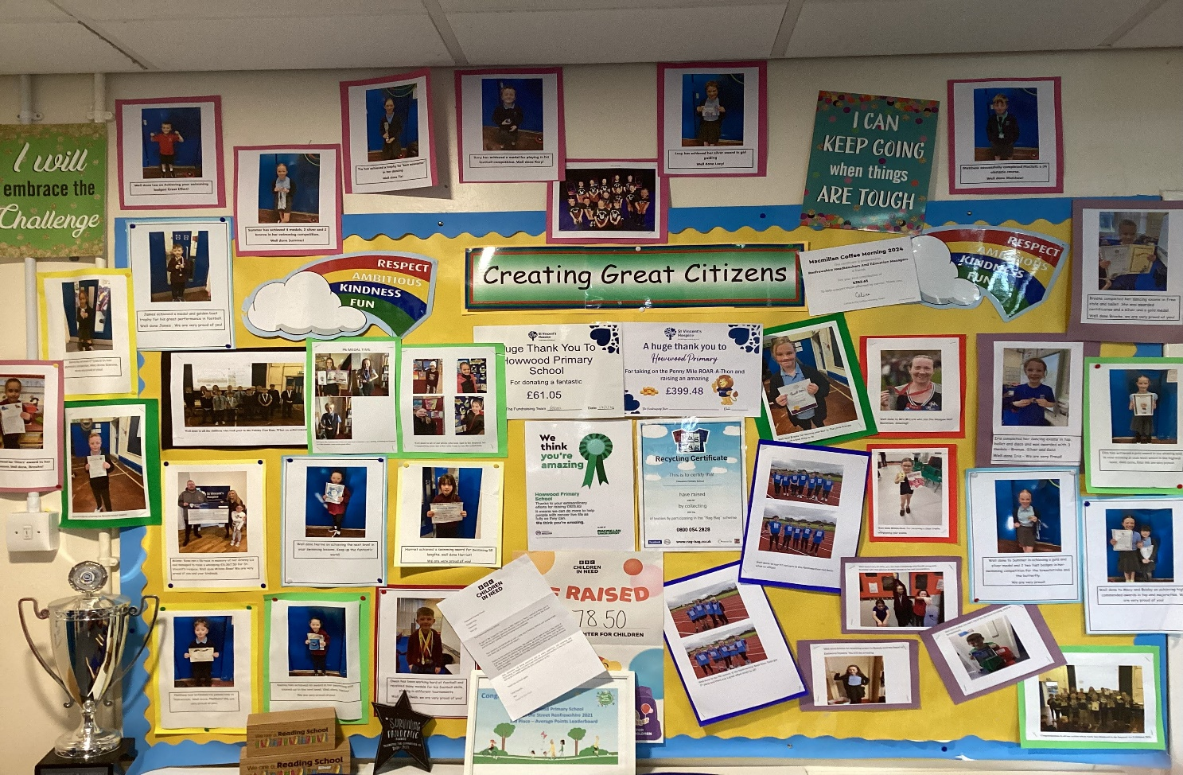

Our school values have now been in place for 7 years and support the ethos and attitude of the whole school community. They are:
Respect
Kindness
Ambition
Fun

All children will tell you that Kindness is the most important

SUCCESSES AND ACHIEVEMENTS


- This year we held a child led celebration for our Gold Nurture Award. There were friendly walks around the village, gold outfits and a special gold cupcake for everyone. We continue to review and adapt our nurture strategies and school ethos to maintain our gold status.

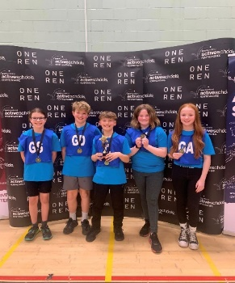
Our various sports teams have taken part in a range of competitions within the community and across the authority over the year including football, netball, running and dodgeball. Our children demonstrated respectful behaviour and great teamwork, maintaining the positive school reputation.

The netball team were the Renfrewshire champions this year.

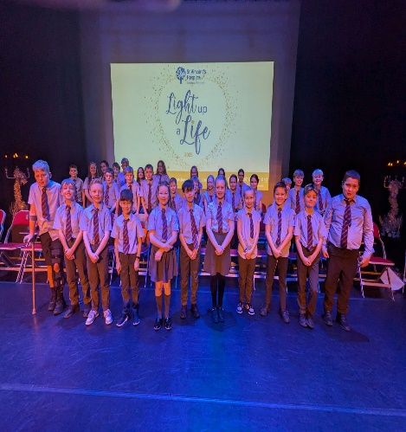
- This year we continued to support the local community with attendance at St. Vincent’s Light up a Life ceremony and visits to the local Winter Warmers group. Pupils also supported the Village Clean Up. We continue to work closely with the community council to support local initiatives. We continued with our charity work with our annual fundraising for Macmillan, Comic relief, St. Vincent’s and the Foodbank.

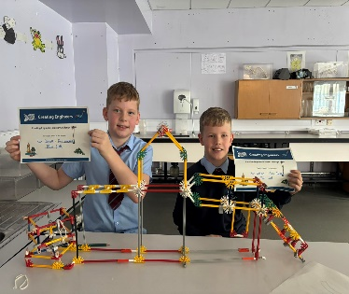
- Two of our P6 pupils won the cluster challenge for the K’nex Creating Engineers competition. They went on to represent Johnstone at the regional finals.

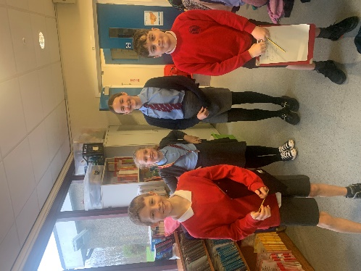
- Six of ourP6 pupils took part in the Young Leaders of Learning programme promoted through Education Scotland. Pupils teamed up with Bridge of Weir Primary to share the strengths of their schools. Howwood demonstrated their strength in digital technology to pupils from Bridge of Weir Primary.

- We were delighted to be the Summer Reading Champions in September 2026 as part of the Renfrewshire Summer Reading Challenge. The majority of pupils took part, ensuring that reading for enjoyment carried on through the school break.
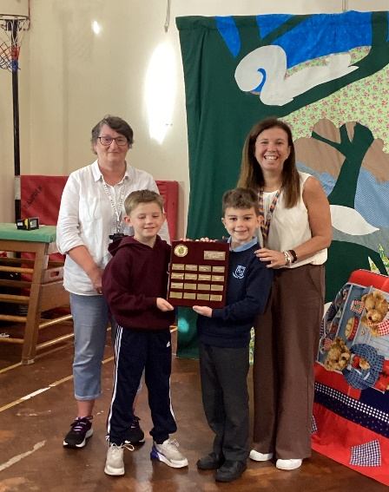

- We came first in the overall average category for Johnstone and the Villages Beat the streets competition this year. Pupils and their families demonstrated a determination to get their steps in and the whole school worked together to get healthier and beat our previous attempt when we got third place. The school received a £150 Decathlon voucher as a reward.
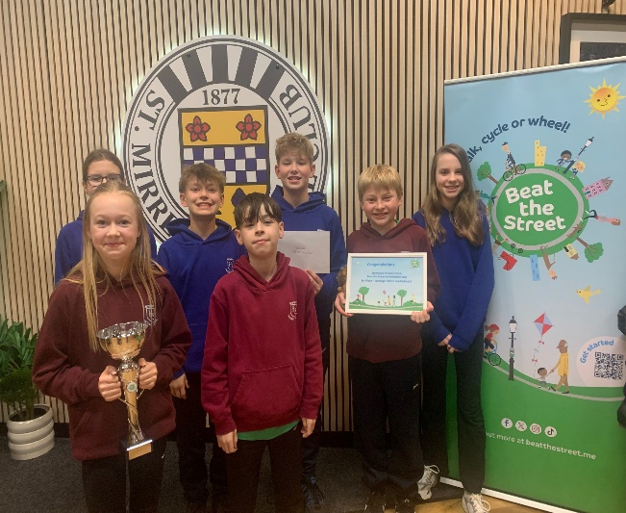

- Throughout the year we have supported a variety of initiatives such as Mental Health week, Maths week, Languages week, Scottish Book Week and Eco Day. The focus on these initiatives has expanded pupils’ wider experiences along with knowledge and understanding of the differing concepts. Pupils thrived with opportunities to be involved in planning and leading these initiatives.

- The Parent council continue to provide great support to the school both financially and on a consultative basis. This year they raised an impressive amount of money to begin the creation of our outdoor areas. Ground works have been completed and work is about to begin to make the area ready to be used.

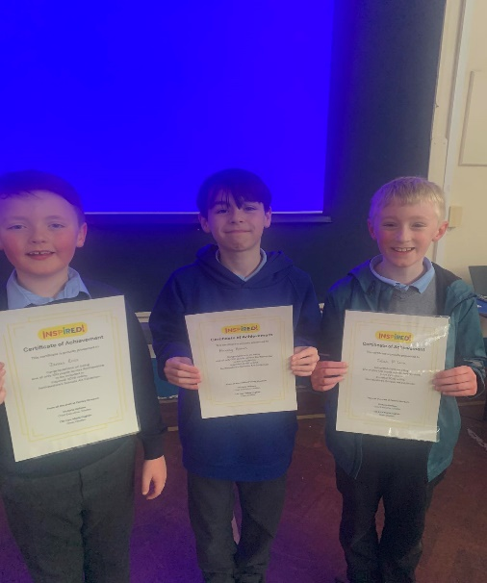
- Three of our pupils appeared in the top 100 art creations for Renfrewshire. They had their artwork displayed in the Inspired Art Competition.

- All of our Primary 6 pupils took part in and completed Bikeability Level 1 & 2 training. They demonstrated resilience and perseverance over the weeks and were able to follow instructions safely in and out of the school.

- Many pupils shared their outside achievements with us.

- 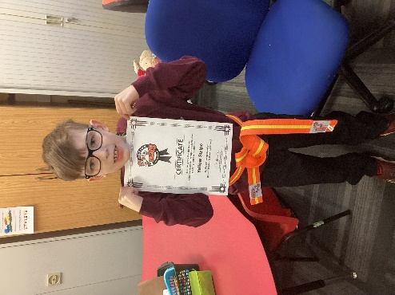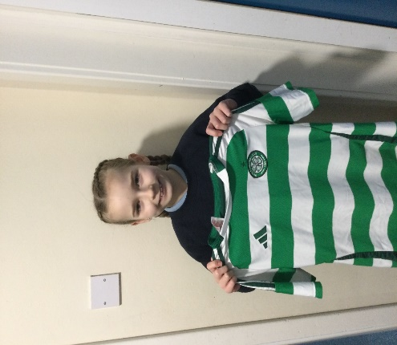

HOW SUCCESSFUL HAVE WE BEEN IN IMPROVING OUR SCHOOL?

Last session, we identified three key improvement priorities for our school –

Improvement Priority 1 – To review and develop our vision, value and aims, ensuring these are appropriate for our school community and intrinsic in all areas of school life.

We implemented the following interventions-
We consulted with the whole school community: pupils, staff, partners, parents and carers. Results clearly identified that the existing values and vision continue to be relevant to the school and this current cohort of pupils and their families.

In line with our respect value, we refreshed our Respect policy .

Impact of our Interventions
As a result of consultation, it was decided that the school vision of ‘Creating Great Citizens’ and the values of kindness, respect, ambition and fun should remain at the forefront of all we do.

In refreshing our Respect Policy, we have now created Howwood Primary’s Nurturing Relationship Policy. This will be the basis for all interactions throughout the school community and provide clear guidelines of expectations for all. The policy will be available on the school website.
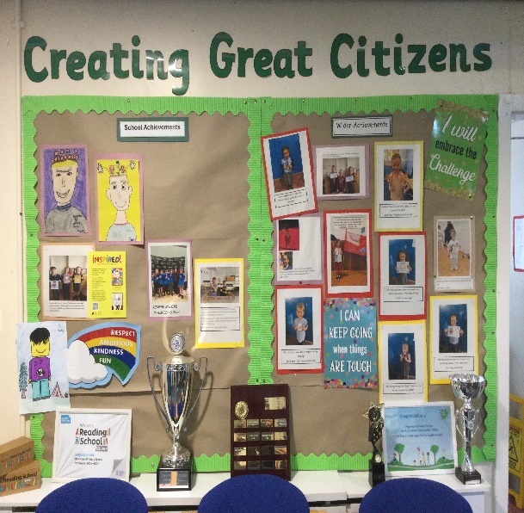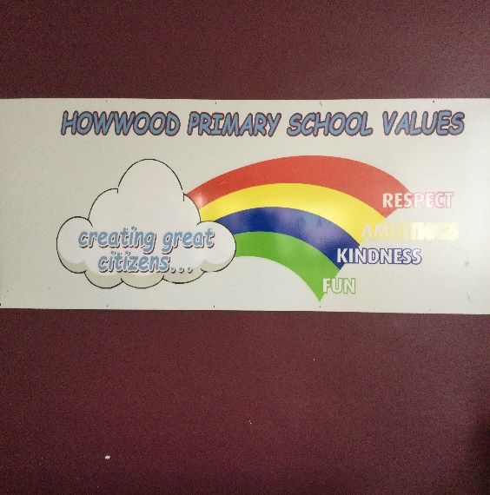

Improvement Priority 2 Improve the quality and consistency of learning and teaching throughout the curriculum through learners leading the learning.

We implemented the following interventions-
Staff refreshed the social studies programme and created child friendly outcomes. Pupils chose their topics around the outcomes which they were given and designed how and what to learn.
Pupil journeys were recorded in class on walls and floor books, demonstrating how pupil voice had helped to steer learning and create motivational ways to learn.

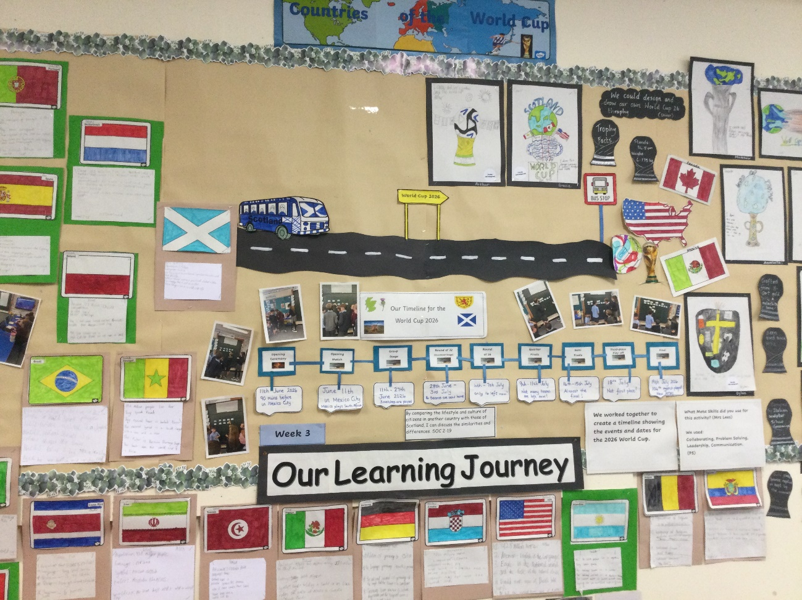

The P6 Young Leaders of Learning group paired up with Bridge of weir Primary to share ideas on digital learning and Leading the Learning. They also visited St. Margaret’s Primary School to observe pupils self-direction in skills based learning.
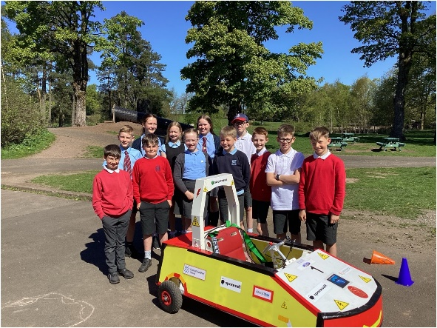

Questionnaires from staff and pupils evidenced an increase understanding and involvement in leading the learning in some areas of the curriculum.

P5 and P6 pupils were involved in creating their own personal projects which they chose, planned and implemented. Learning had to have a clear success criteria.
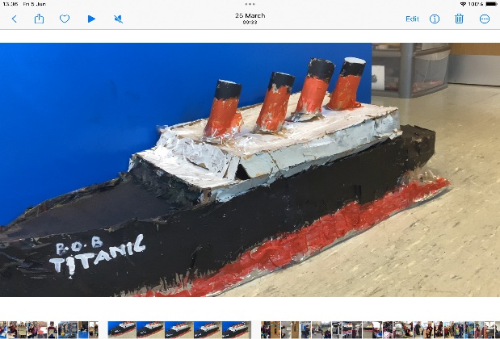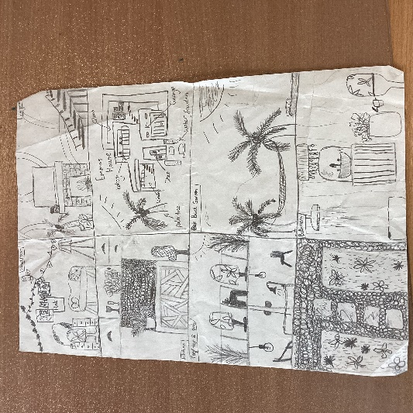
Impact of our interventions-
Pupils reported that they were increasingly motivated to learn when given the opportunity to choose their own class social studies topic. P6 and P5 pupils felt that their personal projects were successful and they were very proud of what they achieved. Teachers reported that pupils were focussed and engaged in their topics, both class and personal and were keen to contribute to the planning process at all times.

The Young Leaders partnership with Bridge of weir provided the opportunity for our P6 leaders to showcase their school and the digital learning that is embedded within. The children created their own presentation and were astute when showing the Bridge Of Wier pupils around the school. On our returning visit we could see the impact that our showcase had in Bridge Of Weir Primary. We also picked up some good digital ideas to move forward with.

Surveys clearly identified the next steps for pupils to lead their own learning and these form the basis for the School Improvement Plan.

PRIORITY 3-Improve the quality and consistency of pupil learning experiences throughout the curriculum through adopting and embedding meta skills.

We implemented the following interventions-
Staff training took place on the Meta skills framework and Meta land and whole school pupil lessons were delivered using Tree of Knowledge assembly packs.

We created a partnership with Fordbank PS and Lochwinnoch PS to share good practice, resources and plans for profiling within the learning of meta-skills.

P4-P7 introduced twice weekly meta-skills sessions where small mixed groups explored and experienced opportunities to identify and improve their twelve meta-skills.
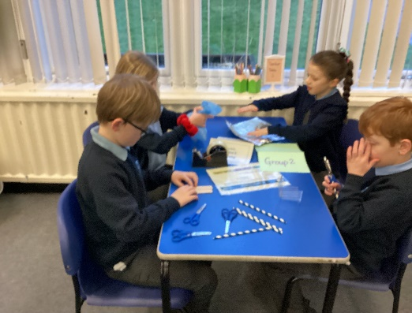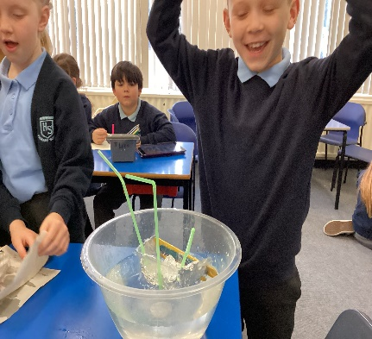

P1-P3 adapted their current play pedagogy to identify and incorporate opportunities for the Meta land characters to be the focus of their play activities.

Parents attended a meta-skills session to observe the P4-P7 meta-skills sessions. A Parent information Sway was shared through weekly bulletins.

Impact of our interventions
Pupil and staff surveys demonstrate a significant increase in the knowledge and understanding of meta-skills. Almost all pupils can identify the meta-skills that they are using during meta-skills sessions and throughout a variety of learning opportunities.

Staff report an increased confidence in the planning and resourcing of lessons and are looking forward to the next steps of embedding the language and skills throughout other curricular areas.

PUPIL EQUITY FUNDING
- At Howwood, Primary we have used Pupil Equity Funding (PEF) to support pupils in reading and numeracy. The school run learning clubs with a focus on reading and numeracy before and after school. The clubs were planned by teaching staff and implemented by support staff. The clubs have been the main focus for PEF for 5 years and have proven to make the required impact for almost all pupils who attend.
- Pupils are chosen from tracking meetings which identify pupil SIMD/CG/FME and progress. Those not on track or on track with support will attend the clubs for either reading or numeracy. The clubs provide opportunities for a small group of children to consolidate learning from class and to build confidence, ability, attitude and motivation.
Self-evaluation from pupils and parents for session 2025-2026 demonstrated the following.
Pupils survey on attending the club
60% increased confident
60% increased ability
53% increased enjoyment of learning
60% increased growth mindset towards curricular area

Comments from pupils included “Maths club makes me smarter!” and “ It helps to do a job before we do it in class.”

Parents survey on their child attending club
86% increased confidence
71% increased ability
42% increased motivation
42% increased wellbeing

Comments from Parents included “ XXXXXX now has confidence in maths and therefore enjoys it more” and “She enjoys it and comes out with satisfaction with herself that she has completed her tasks.

Teachers of pupils who attend the learning clubs report an increased ability in the chosen subject along with growing confidence in this area. Comments include “Sessions are very productive, providing targeted support for a small group of pupils”.

KEY STRENGTHS OF THE SCHOOL

- Our school has a strong, nurturing ethos where the health and wellbeing of our pupils and their families is a priority. We promote positive relationships at all times and work together to ensure that pupils have a safe and positive experience in their education and at home if support is required.
- Digital learning experiences are embedded in many areas of the curriculum and pupil skills are very good. We have a wide range of high-quality digital resources which are utilised by pupils throughout the whole school.
- Teaching and Learning provides support and challenge appropriately; pupil voice is evident in the planning and implementation of learning as well as helping to drive change in the school.
- Pupil attainment in literacy and numeracy is very good.
- School values underpin the ethos, teaching and learning and success of the school. We always celebrate achievements and achieve very well within the Local Authority competitive opportunities.

OUR NEXT STEPS – PRIORITIES FOR 2026-27

We have made very good progress during session 2025-26 and we will use the improvement priorities listed below to build on this progress moving forward.

- Improve the support and nurture of children and families, creating an increasingly inclusive environment through embedding the RNRA principle of ‘all behaviour is communication’ and developing anti-racism education.
- Raise attainment and enhance learning and teaching in an inclusive environment through learners increasingly leading the learning.
- Create the best possible learning estate to allow children and young people to thrive through embedding meta-skills within learning and teaching.

Full details of the school’s improvement priorities and actions are detailed on the school improvement plan which can be accessed on our website or by contacting the school office.

School Name Howwood Primary School  School Address Sempleview Howwood PA9 1BT  Phone 03003000160  Fax  Website https://blogs.glowscotland.org.uk/re/howwoodprimary/  Twitter/Facebook | HAVE YOUR SAY!  Please take the opportunity to share your thoughts with us as we use feedback to help us make improvements to the school. You can do this by speaking to staff, participating in Parent Council meetings, responding to questionnaires/surveys and by completing evaluations at school events.

