Howwood Primary School
Standards and Quality Report June 2023
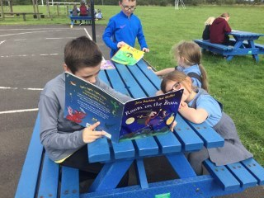 CREATING GREAT CITIZENS

Our School
Howwood Primary is a non-denominational school based in the village of Howwood. The current school role is 125 which includes some inbound placing requests. The majority of our pupils live in Howwood and the surrounding areas and we benefit from a supportive wider school community.
The current school was built in 1963 and has accommodation for six classes. There are a range of amenities in Howwood including a village hall, a church, green spaces, a shop, hotels, restaurants and a small number of other businesses.
There is an active Parent Council within the school . Parents are very supportive both in terms of educational engagement and attendance at school events. Pupil attendance is above the national average.
Although we are a small school, we offer excellent facilities and an excellent learning and teaching experience. We have high standards in all we do and have achieved awards in nurture and Rights Respecting Schools, reflecting the emphasis that we put on each child's well-being.
We are very fortunate to have beautiful school grounds which have been enhanced through the installation of a new, bright and welcoming friendship bench and the addition of an outside multi use gym area, from which the children have benefited greatly, giving them the opportunity to support each other and enjoy outside play during all weathers.
At Howwood Primary School we aim to develop children as rounded individuals and great citizens, supporting and challenging them as appropriate. Our school values of Kindness, Respect, Ambition and Fun, underpin our whole school ethos and are reflected in all our actions and attitudes towards others.

Shirley Ormond
Headteacher

Our vision and aim is to Create Great Citizens
Our values are Kindness, Respect, Ambition and Fun
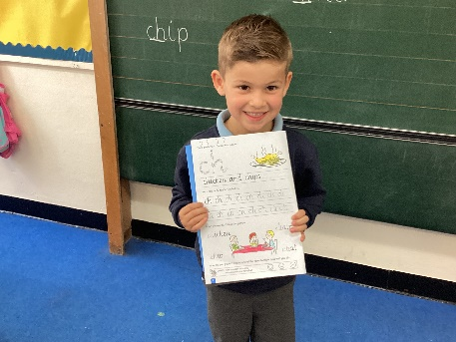 AMBITIOUS 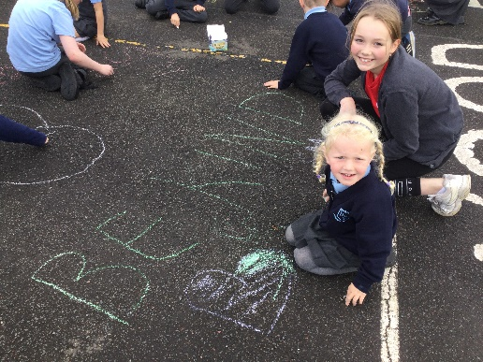
KINDNESS
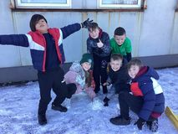 FUN 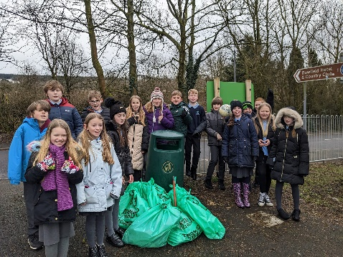
RESPECT

Successes and Achievements
· Pupils engaged extremely well with the summer reading challenge, with almost all pupils now members of the library and receiving certificates for participation. We achieved second in Renfrewshire for participation and highest performing school statistics. This reflects our goals as a reading school.
· Pupils participated in sporting competitions for netball, junior NBA, long distance running, track and field and dodgeball. The school netball team were the winners of the Johnstone and Linwood League and performed very well at the Renfrewshire finals. We had a winner at the long distance running for the first time! Pupils use these opportunities to develop a strong team spirit and are ambitious for themselves and their team throughout.
· The school achieved the Silver Rights Respecting Schools award, reflecting the work which has been done by the Respect committee to ensure that knowledge and understanding of the Rights of the Child are embedded across the school and families.
· Pupils have been volunteering this year as their extensive charity work was put on hold, recognising that the cost-of-living crisis would be affecting all households at this time. P4 pupils worked with pupils from Corseford school to support projects throughout the year whilst P6 helped clean up the village. P7 held a Macmillan coffee morning, inviting elderly residents from the village, and the school choir have been singing at local events. We continued to raise money for some charities with a walk for St.Vincent's Hospice, Comic Relief, Lochwinnoch foodbank and Macmillan Cancer charities all benefitting.
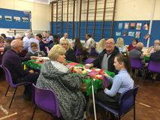Macmillan Coffee Morning
Silver RRS Award
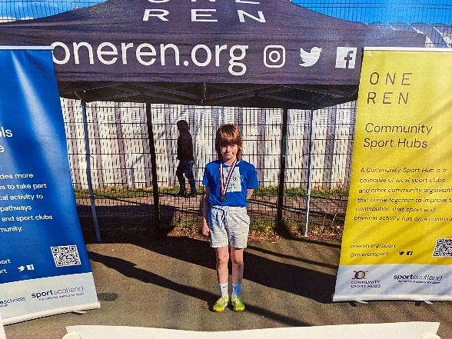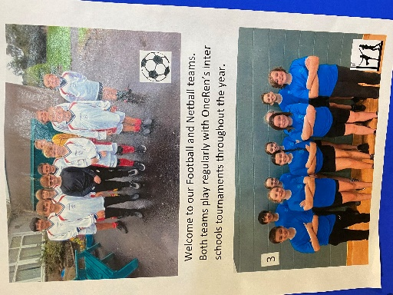

Individual and team sporting achievements.

School Leadership
Leadership is a shared role at Howwood Primary where all members of the school community have a valuable contribution to make. The foundation of this lies in the positive ethos of the school with kindness and respect at the forefront of all we do. Values are embedded amongst staff, pupils, parents and carers as well as those who we work closely with in the local community. Improvement in leadership this year has focused on returning to routines and expectations from before the pandemic whilst introducing further strategies to ensure leadership roles and responsibilities are available to all.

· Teaching staff were able to effectively take forward their curricular leadership role once again. Each staff member has made improvements in their designated role; notably a Silver RRS award, digital learning training, new Renfrewshire maths planners, volunteering opportunities and nurture champion training. Initiatives and events have been organised and driven throughout the year by teaching staff who have been given protected time to ensure that their role has a positive impact on the whole school.
· Pupil voice in the school is very strong and pupils believe that their voice is heard and can bring about change. Primary 7 pupils had increased opportunities for leadership with Eco Champion and Digital Leader roles being introduced this year. Whole class committees and the Pupil Council continue to be effective with the introduction of a Leadership of Change Committee. This addresses particular areas of school improvement and takes action to address issues with pupils or the wider community.
· The school Parent Council continues to play a pivotal role in school improvement with regular PTA meetings addressing curricular discussions and the School Improvement Plan. They continue to support the school financially and have secured funding for an all-weather Multi Use Gym Area in the playground. This is a huge achievement which the school, and the whole village, will enjoy.
· The Headteacher created a Small School Learning Set to share thoughts and good practice in many aspects of small school life. The Principal Teacher created a cluster learning set for PTs and DHTs and has found this hugely beneficial, introducing to the school many aspects of good practice shared by cluster colleagues.
.SMT consult with staff regularly on their own health and wellbeing and endeavour to support the whole staff team to feel fully supported and valued. A recent consultation reported that all staff felt fully supported at this time. Staff attendance is excellent.
· Pupils looked for volunteering opportunities with P4 working alongside Corseford school and P6 taking part in the village clean up. This has encouraged pupils to be valued members of society as well as understanding the difficulties that others may face and how to be supportive in these situations.
· Pupils lead learning through the school reading buddy system, the P7 buddy system and the pupil council. This involves older pupils supporting younger ones in a variety of learning tasks. The pupil council consults with other pupils around the opportunities provided for learning experiences. Pupils also take part in regular self-evaluation during assemblies or class observations.
.Family consultations regularly inform our next steps and parents are given clear feedback and actions regarding these. A recent survey of families concluded that families were confident that their child's health and wellbeing was being supported very well at school.
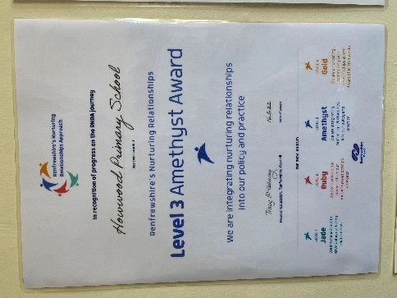 Nurture Awards 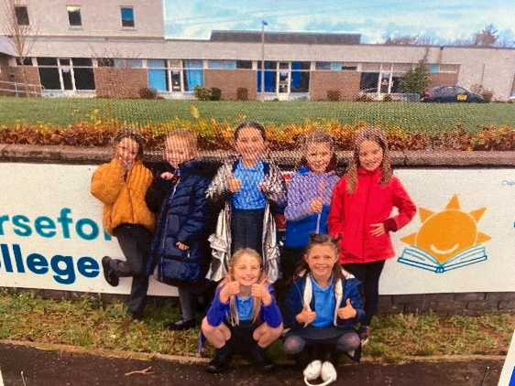

Volunteering at Corseford

Teacher Professionalism
Staff at Howwood are committed to their professional development and this is closely linked to the school Improvement Plan, Leadership roles and the school values.
All staff actively engage in professional learning and dialogue in order to ensure our knowledge and skills are up to date and enable us to meet the needs of our children. Training this year has included:
Whole school staff training in nurture, embedding all nurture principals consistently cross the whole school and working towards a Gold Nurture Award.
Talk for Writing training, a professionally researched approach to writing, has given staff the tools to support attainment and promote engagement in writing across the whole school. Digital training has taken place within and out with school and staff are developing their skills to provide a high-quality digital learning experience for pupils.
Support staff attended Renfrewshire Classroom Assistant training sessions and completed this course. All classroom assistants have now completed the Renfrewshire support staff course and have used their new skills and knowledge to support individuals and groups in class and during Pupil Equity Funded support groups.

Parental Engagement
Parents play an integral role in the success of the school. They are supportive, share a mutual respect and engage in their child’s education. During a year without restrictions, we have reinstated previous practice which encourages parents and carers to be a physical presence in the school again.

· Staff further improved parental communication through digital communication for homework and increased sharing of class learning and events on the school Facebook page. Parents reported a positive response to having homework on the school app, finding it accessible and an effective way of communication. Parents also engage well with the school Facebook page and share in the success of all pupils.
· Parents once again attended Open Afternoons to share the learning with their child. Parents are involved in World Book days/weeks, Maths week and sharing World of Work information. Having parents and carers back in school has allowed staff relationships with families to foster in a deeper way and for parents to experience their child’s learning first hand.
· Parents have been regularly consulted on many issues throughout the year, reporting positively on our homework and Health and Wellbeing consultations. Parental consultations always help to inform improvement needs and feedback is always provided, ensuring that parents feel that their views are valued.
· The Parent Council secured a large grant which has allowed the school to install an all weather outdoor play area in the school grounds - a great achievement and resource for all involved. This will allow pupils to use another section of the playground-even when the grass is too muddy to play on!
· The school is always looking for ways to be involved in the local community and have enjoyed being part of events for the elderly in the community as well as hosting a Macmillan coffee morning for grandparents and elderly members of the Howwood community. They have taken part in the village clean up and visiting local schools. This promotes the ‘great citizen’ message to our pupils who are becoming increasingly aware of their role in their local community and wider society.
· The Headteacher engaged with Renfrewshire Supporting Parental Engagement Initiative to share good practice. This allowed the head of the PTA and Headteacher to work with other schools and share good ideas on how to move forward successfully. It also reinforced to both parent and Headteacher the advantages to the positive ethos between families and school at Howwood Primary.
· Parents are fully involved in transition events for pupils in nursery and high school, attending information evenings and play dates for younger pupils. Due to electronic registration, parents are no longer attending school to enrol. As a cluster we felt strongly that parents should be given this opportunity and created a ‘meet your school’ event in January. As a result of this parents felt informed and settled about the transition ahead.
· All parents and carers of children with support needs are in integral part of supporting and planning for their child. All families and children have input to the child’s plan and actively work with the class teacher and SMT to ensure a successful outcome for their child. Working together on planning has ensured that staff have the support of parents and know the pupils in their class as well as possible.
The school supports many parents to volunteer on a regular basis. This can lead to future educational roles for some as well as school improvement in areas such as the school library or play in P1.
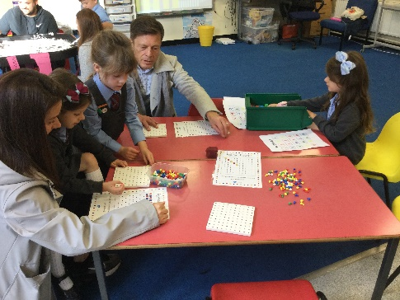 Parents getting involved in class activities.
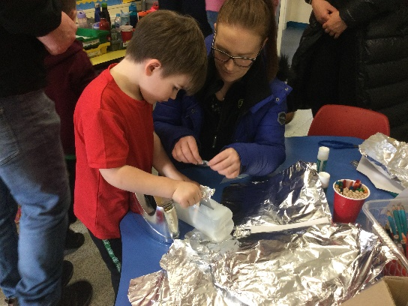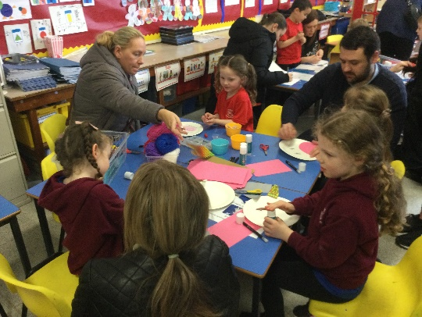

Open Afternoons and Maths week activites.

Assessment of Children’s Progress
Pupils attain well with almost all pupils on track in reading, writing, listening and talking, and numeracy, with a group of pupils in each class ahead of target in reading, writing and numeracy. The school performs well against comparative schools, with P1, P4 and P7 results above or similar in reading, writing, listening and talking and numeracy.
Staff have a wealth of information in order to support pupil learning and plan next steps. Summative assessment is embedded into the school calendar, and this is an integral part of planning next steps. There continues to be robust monitoring and tracking of pupil progress.
· Moderation with the Johnstone cluster schools and within school has once again focused on the assessment of writing. As a result of these professional discussions good practice has been shared and staff have made effective relationships to support their teaching. We are also committed to creating a new assessment tool for writing to support further, effective moderation.
· Pupils continue to focus on the learning intentions in order to contribute to the creation of the success criteria and to allow for effective self-assessment, thus giving them clear next steps for attainment.
· Pupil assessment of their own health and well-being is an embedded practice throughout the school, with P3-P7 focusing on the Glasgow Health and Well-being assessment tool and P1-P2 using the SHANARRI indicators to report on their well-being. This helps staff to quickly identify needs for individuals and any concerns within a class or the whole school. At this time results are overwhelmingly positive.
School attendance continues to be above the local authority average and exclusion data clearly identifies that inclusion is a priority in school, with a 0% exclusion rate.
Pupil Equity Funding is directed towards targeted intervention for support in literacy, numeracy and emotional and social needs for pupils. This is enabled through funding for classroom assistants’ support. This has resulted in pupils making increased progress in learning and an increase in engagement in class learning.

School Improvement
Planning for improvement is collegiate and self-evaluation is embedded in this.
· As a result of professional dialogue through target setting meetings, Pupil Equity Funding money was used to employ a classroom assistant to support individual pupils and groups. As a result of this pupils have been given opportunities for small group and one-to-one working to enhance their daily experience and support progress.
· Pupil Equity Funding money has also supported extra Learning Clubs for identified pupils using teacher feedback and tracking data. The impact of the clubs has been carefully measured and we have had very positive feedback from pupils, staff and parents around supporting pupil confidence and attainment.
· The school continues to look for external support for pupils which helps to ensure an inclusive environment for all.
· All teaching staff have been trained in a new writing programme, Talk for Writing. This has been delivered in class and staff are beginning to identify the positive outcomes from this. We will be building upon these successes next year to embed these writing strategies for further success.
· The school’s focus for nurture training was transitions and staff training has highlighted the importance of appropriate strategies for all transitions in school. A small focus group of pupils who had an enhanced transition felt that this was helpful for them to settle into their new stage. Pupils' understanding of their emotions and the importance of the SHANARRI indicators continues to be embedded in school. Teachers reported that they felt further empowered to make a positive difference to pupils’ experiences in school and to have a greater impact on their well-being.
The school has been awarded the Silver Award for the UNICEF Rights Respecting School programme. This is a fundamental part of teaching and learning within the school and the whole school community understand that the rights are understood and practised in the school. This year we have focused learning on how to make a difference to those children who are denied the rights of the child.
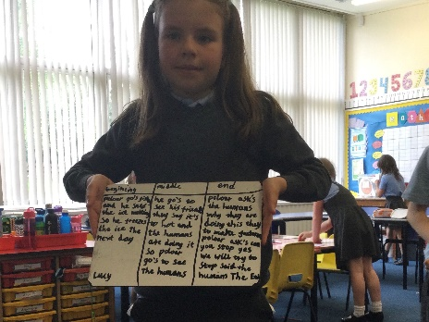 Talk for Writing in action.
Performance Information
Almost all pupils remain ahead of or on target in numeracy, writing , reading and talking and listening.
We continue to address aspects of writing which suffered most from lockdown, addressing these through Pupil Equity Funding staff allocation and teacher professionalism. To further ensure attainment in this area we have introduced a new teaching approach which is initially showing positive signs for improvement.
Triangulated systems are in place to measure and predict attainment. The use of comparative data and Local Authority support and the Quality Assurance Calendar has a positive impact on maintaining a rigorous overview of performance information.

CFE results for June 2023 are as follows:
Reading Writing Listening and Talking Numeracy
P1 June 22 93% 93% 93% - 93% 26 pupil
P4 June 22 92% 92% 100% 85% 13 pupils
P7 June 22 94% 100% 100% 100% 17 pupil

Pupil Equity Funding
Self-evaluation and professional dialogue during monitoring tracking and target setting meetings provided the rationale behind our decisions on the allocation of Pupil Equity Funding . A classroom assistant has been funded through PEF this year to support identified pupils in class through small group or one-to-one support.
Parents and staff were consulted on use of Pupil Equity Funding. Parents were keen for existing before and after school Learning Clubs to continue. Staff were keen for Learning Clubs to continue as they have been very effective in the past. Evaluation of the clubs has been very positive with staff, parents and pupils reporting an increased confidence and ability from almost all of those attending.

Strengths of the School
· Nurture Values -the whole school community recognises the importance of nurture and the principles behind it. All pupils know that wellbeing and relationships are of utmost importance in Howwood Primary School.
· School ethos- our school ethos is warm and welcoming.
· Parental Engagement -Parents and carers report very positively on their relationship with the school . Parents know that the school is approachable and will always do their best to address any concerns.
· Strong staff team-the staff team work well together to ensure that all pupils are having the best educational experience.
· Celebrating Success- the school always celebrates success for individuals, groups or classes of pupils. The school Facebook page and Creating Good Citizens wall in school promotes this. Celebrating success assemblies recognise pupil efforts on a regular basis.
· School values-Ambition, Kindness, Fun and Respect. These embody all we do at Howwood PS.
· Pupil voice- pupils know that they will be listened to at Howwood PS. They are regularly consulted on school issues and lead committees in areas of Health and Wellbeing, Eco school, Rights Respecting School and Reading Schools as well as having a Pupil Council and Leadership of Change group and regular meetings for pupil self-evaluation.
· Achievement-pupils are given many opportunities for achievement in sport, the arts and technology.
Our role in the community- the school has strong links with the local Community Council and supports events and charities in the local area.

OUR NEXT STEPS – PRIORITIES FOR 2023-24
We have made very good progress during session 2022-23 and we will use the improvement priorities listed below to build on this progress moving forward.

Improvement in attainment in writing through embedding the Talk for Writing programme throughout the school.
Improvement in attainment and lifelong skills for work through digital learning.

Full details of the school’s improvement priorities and actions are detailed on the school improvement plan which can be accessed on our website or by contacting the school office.

School Name Howwood Primary School
School Address Sempleview Howwood PA9 1BT
Phone 0300 300 0160
Fax
Website https://blogs.glowscotland.org.uk/re/howwoodprimary/
Twitter/Facebook closed Facebook page Howwood Primary parent council

HAVE YOUR SAY!
Please take the opportunity to share your thoughts with us as we use feedback to help us make improvements to the school. You can do this by speaking to staff, participating in Parent Council meetings, responding to questionnaires/surveys and by completing evaluations at school events.

