Problem Solving Friday – Secret Code Challenge

Task 1:
Can you work out the following problems using the secret code?
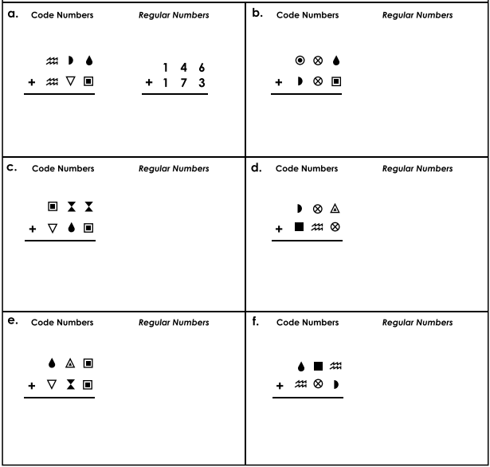

Task 2:
Can you make up your own secret code and challenge your teacher/members of your family to work out the calculations?

