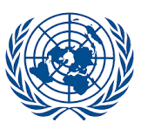
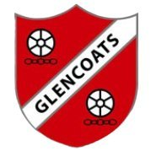
UNCRC Newsletter
by Primary 5

We learned about the United Nations Convention on the Rights of the Child (UNCRC) to understand children's rights, hold governments accountable for protecting us, and promote healthy development. Learning about the UNCRC empowers us and all young people to know their rights, and it teaches adults and institutions how to support and respect those rights, leading to improved behaviour, relationships, and a fair society.
The UNCRC outlines 54 articles that define children’s rights. These rights include civil, political, economic, social, and cultural rights, which are all interconnected and hold equal importance.
The UNCRC have created a child friendly version of these rights which are displayed in our classrooms as a reminder for everyone.
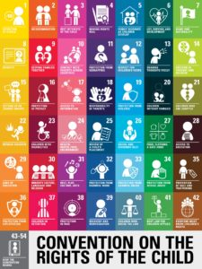
Every year in school, we will remind ourselves of our rights and create Class Charters to give all members of the class a voice and agree on a set of standards & expectations.

We choose which articles we want to focus on in class and
then sign the articles with our name or picture.

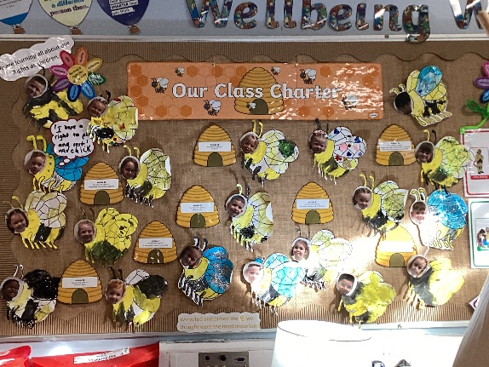
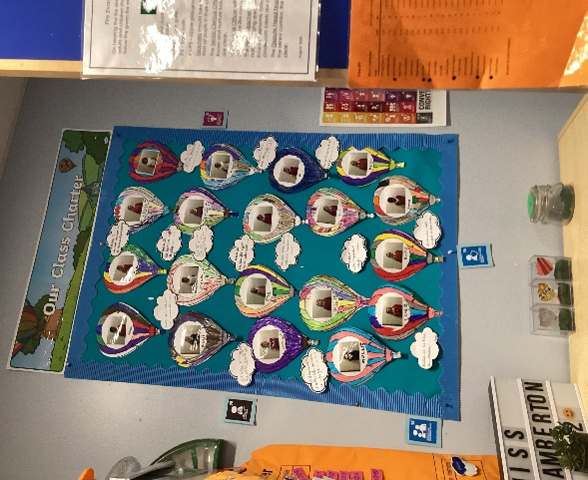
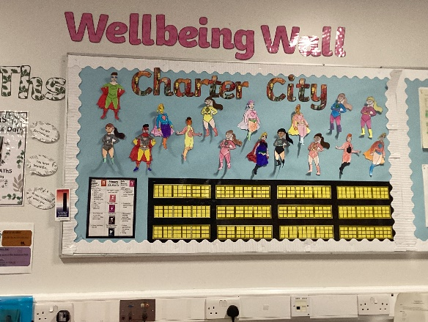
Primary 1
Primary 3
Primary 2

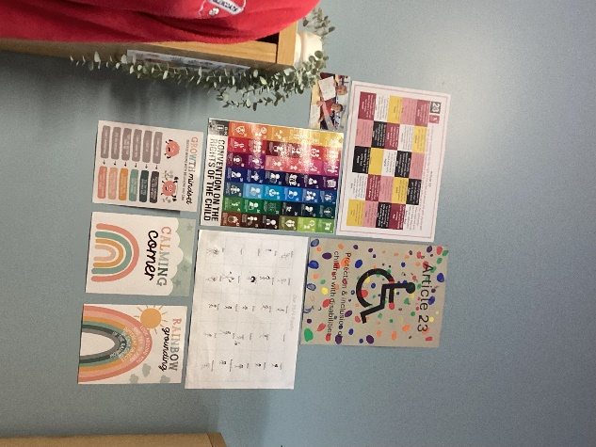
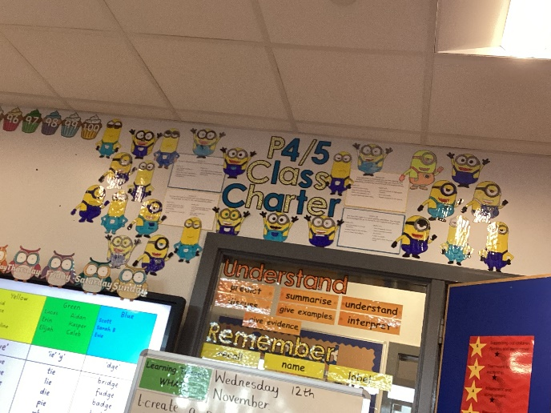
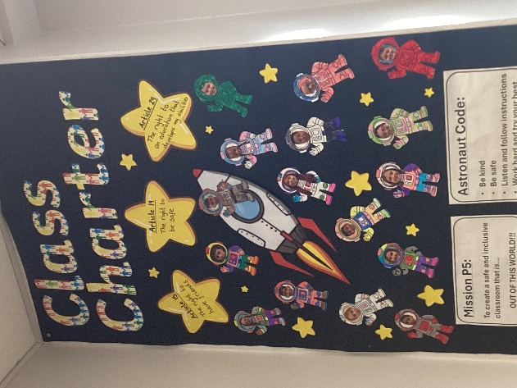
Primary 4/5

Primary 5

Primary 3/4

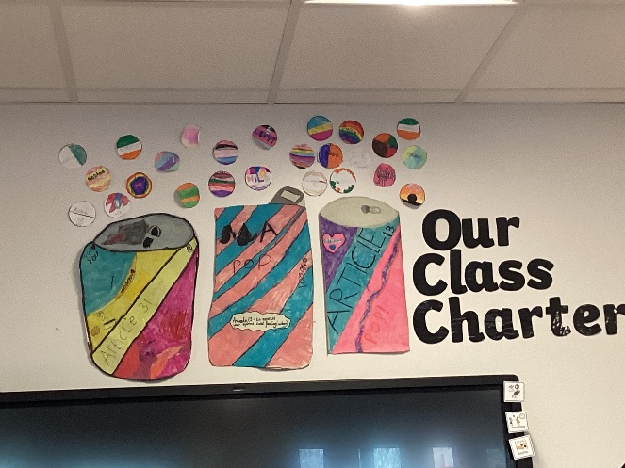
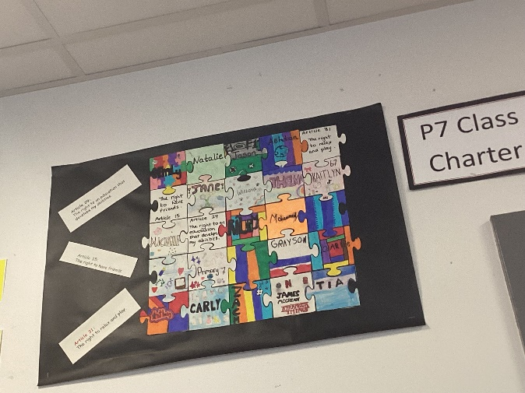

Primary 6

Primary 7

How families can help
Photos taken by
Lewis and Arwen P5
At home, you can support your child by:
- Talking about fairness, kindness and respect
- Asking your child which Rights they’ve learned about
- Listening to their ideas and opinions
- Encouraging them to think about how others feel
Together, we can make sure every child and young person feels respected, included and heard.
If you have any questions about UNCRC or our Rights Respecting School work, then please feel free to contact us.

