
NewsletterSep -Dec ‘25
Welcome to the new term at Ferguslie Early Learning and Childcare Centre. I would like to give a warm welcome to all the new children and parents and to welcome back everyone who had some time off over the summer. We hope that your time with us will be a pleasant and worthwhile experience and please don’t hesistate to speak to either myself or another member of the staff team if there is anything we can help you with.

Over the next few weeks we will be welcoming new staff to our team: Lee Brady will join us as an Early Learning and Childcare Officer and Jodie Kerr will move from her current role as Supply Support Worker to Early Learning and Childcare Officer, both will be based within the 3-5 playroom.

We will also be offering a placement experience to an HNC Childhood Practice student from West College Scotland. Courtney will be will us on a Monday and Tuesday with her placement commencing Monday 15th September.

To ensure the safety of all children please ensure the doors are closed securely behind you, after entering and leaving the building, and please be mindful not to hold the door open for anyone to enter the building that has not been buzzed in by staff.

There have been a few incidents recently within Renfrewshire Council early years establishments where children have taken seriously ill, and staff have been unaware that medicine has been administered at home. If medication has been administered to your child prior to the child arriving at nursery all parents/carers MUST ENSURE
this information is passed to a member of staff before you leave the building.



Parental engagement is going to play a big part of the session 2025-2026 and we are excited to share all the great opportunities for parents/carers we have planned. To hear more about how you can be involved in the life of centre and especially in your child’s learning journey please engage in the various oportunites availble to you over the coming weeks and months.
Coffee & Chat

Coffee & Chat sessions are now planned, and we hope that you all can attend. These informal get togethers enabled us to share with you information on our plans for the coming year and other aspects of the centre, that we will be taking forward in the coming year.

Tuesday 23rd September
1pm – 2pm

Thursday 25th September
9.30am – 10.30am

Are you interested in joining our Parents Committee? The next meeting is planned for

Tuesday 7th October 9am -10am


Parents Nights

Tuesday 4th November
Babies/2-3’s Playroom’s

Thursday 6th November
3-5 Playroom

A timetable of available slots will be offered out after the October break.

Please remember to log into your child’s Learning Journal to ensure you are up to date with their learning journey and achievements within the centre. If you are having any issue in accessing these please let us know and we can get this fixed.


Specially trained Dental Nurses or Hygienists employed by NHS GGC will visit the centre on 28th October to apply the varnish to all pre-school children’s teeth.

Boogbug is back with weekly sessions for you and your child to enjoy together.  These sessions will be held every Wednesday  9.15am – 10am  Please remember to leave a change of clothes at your child’s peg. Outdoor play is a huge part of our learning environments and children may require to be changed during the session. Also please remember with the changing weather children should be dressed appropriately e.g. jackets, hats, wellies.  Thank you. | We will be guaging parent opinions in further Bookbug sessions over the next few weeks regaring suitable times, dates etc, so please hand in your questionnaire when completed.    We have arranged for the photographer to be in the centre on  Tuesday  18th November  Time slots will be available nearer the time to enable siblings to be photographed together if preferred.  

PARENT VOLUNTEER’s
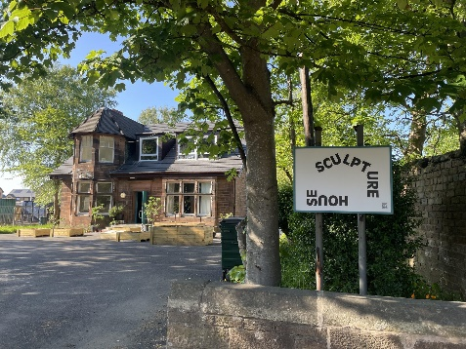
Our extra curricular groups to the forest, allotment and Scupture House will be starting very soon and the chil dren would love to share their learning with their families. If you would be interested in joining your child please inform a member of staff.

Improvement Plan
Each year we as a centre we are asked to devise a plan detailing our priority actions for the coming yearand our successes form the previous one. Thank you to all that were involvd in this process. Please feel free to read the copies on the wall in our entrance hall. More information regarding this will be discused at the abve Coffee & Chat sessions.

I am delighted to share that we now have our own link Speech & Language Therapist. Joanne Latimer will be our first point of contact if we have any concerns about any of the following:
- children’s speech, language or communication
- advice or strategies to support communication within the centre
- advice on signposting parents to the advice line
- direct referrals

Parent Pay
All parents have been issued with an activation code to enable them to log into their account. If you have still not completed this process, Doris ask’s that this is done at your earliest convenience, following the below instructions.
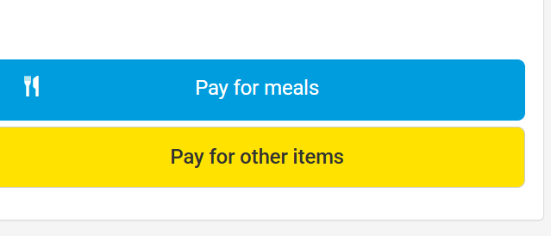 | - Please ensure when you log in that at this stage you click on the YELLOW BOX.  - After you have accessed the “pay for other items” section, please click PARENT CONTRIBUTION.

The centre is closed on the following days

September 26th & 27th | All children
October 13th -17th | Term time children only
October 20th | All children
December 1st | Term time children only

