

Renfrewshire Council Children’s Services

**Douglas Street ELCC**

**Improvement Plan**

**2021-2022**

##### Planning framework

As part of Children’s Services, Douglas Street ELCC has developed this establishment improvement plan which provides a framework for how we intend to achieve Children’s Services’ vision of *working together to get it right for children, families and communities – Protecting, learning, achieving and nurturing.*

**National Priorities**

We also have to take account of the Scottish Government’s national improvement framework which provides a vision for education in Scotland, namely to:

1. **improve attainment, particularly in literacy and numeracy.**
2. **close the attainment gap between the most and least disadvantaged pupils;**
3. **improve children’s health and wellbeing; and**
4. **improve children and young people’s employability skills so that they move into positive and sustained destinations.**

**Renfrewshire’s Education Priorities**

Our priorities will also align with the Renfrewshire Council Plan and Education Improvement Priorities listed on the next page.

**Our Establishment Plan**

The priorities and actions within this improvement plan address the needs of our establishment and articulate with local and national priorities.

**Renfrewshire’s Council Plan 2017-2027**

Working together for a thriving and connected Renfrewshire, creating opportunities for all

Reshaping our place, our economy, our future

Creating a sustainable Renfrewshire for all to enjoy

Building strong, safe and resilient communities

Working together to improve outcomes

Tackling inequality, ensuring opportunities for all

**Renfrewshire Council’s Values**

We are **fair**, we treat each other and everyone we deal with respectfully and work hard to build trust in Renfrewshire Council.

We are **helpful**, we care about getting things right and are always approachable.

We are great **collaborators**; we work as one team and with people who care about this place.

We value **learning** to help us innovate, improve and deliver better services.

**Children’s Services Vision**

Working together to get it right for children, families and communities – protecting, learning, achieving and nurturing

**Renfrewshire’s Education Improvement Plan Priorities**

Reduce inequalities and deliver improved health and wellbeing outcomes for children and young people

Develop high quality leadership to promote empowerment at all levels

Improve employability skills and support all of our young people to enter positive and sustained destinations

Develop high quality learning and teaching that leads to improved levels of attainment and achievement in all of our establishments

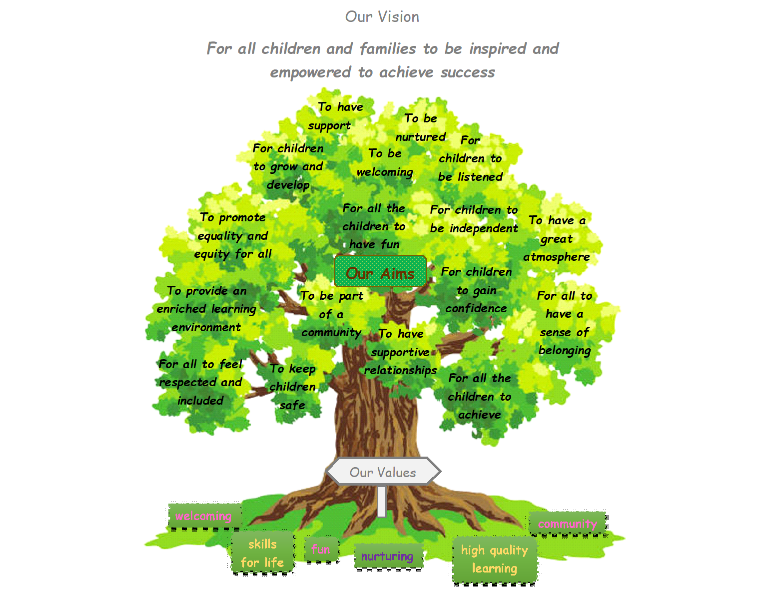

Who did we consult?

To identify our priorities for improvement, we sought the views of children, families, staff, community groups and all other professionals involved within the life of the centre. We used a variety of methods of getting the views of those who are involved in the life and work of Douglas Street Early Learning and Childcare Centre such as ongoing regular verbal discussion with all stakeholders, consultation questionnaires, pebble drops, parent groups, play and stay sessions, staff professional dialogue opportunities, staff training evaluations, comments sheets, keyworker updates and planning records.

We have also consulted with our partners across and out with the Council to assist us in the delivery of our priorities. Professional dialogue opportunities at meetings and training, sharing good practice, involvement in local community and charity initiatives and ongoing effective levels of communication with all outside agencies has enabled our team to reflect on practice.

All information gathered is collated and used to assist us to identify next steps and areas for improvement.

How we will know if we are achieving our aims?

We will measure and evaluate the progress we are making to achieve the key outcomes set out in this plan. We do this using quality assurance activities that include:

* A robust monitoring programme that monitors practice delivery, focussing on key priorities identified using challenge questions within How Good is Our Early Learning and Childcare. Book of improvement to support documenting Centre achievements.
* Monitoring and professional dialogue opportunities with Early Years Manager and Early years Development officer
* Staff PRD programme
* Regular consultations and communication with all children, families, staff and stakeholders.
* Robust training programme to be delivered – staff evaluations to be used to support maximum impact

Each year we also complete a standards and quality report and self-evaluation document which are monitored by Renfrewshire Council Children’s Services’ staff.

|  |  |  |  |  |
| --- | --- | --- | --- | --- |
| **Improvement Priority 1: Improve children, families, and staff wellbeing – COVID recovery** | | | | |
| **HGIOS/HGIOELC QIs**  **3.1,**  **2.1-2.4**  **2.7** | **NIF Priorities**   * Improvement in attainment, particularly in literacy and numeracy * Closing the attainment gap between the most and least disadvantaged children * Improvement in children's and young people’s health and wellbeing * Improvement in employability skills and sustained, positive school leaver destinations for all young people | | **NIF Drivers**   1. School Leadership 4. Assessment of Children’s Progress 2. Teacher Professionalism 5. School Improvement 3. Parental Engagement 6. Performance Information | |
| **Rationale for change** | **Outcome and Expected Impact** | **Measures** | | **Intervention** |
| COVID recovery Re-establishing routines and supporting the health and wellbeing of all children during the recovery period will be of paramount importance.  COVID recovery Re. Staff consultation has shown a need to establishing routine meetings that promote effective collaborative professional dialogue with staff is a priority as we move away from COVID restrictions that have hindered or prevented such activities. | By November 2021, all children will be settled back into nursery life. The centre will start to operate with reduced/removed restrictions gradually allowing parents into service and supporting effective relationships and community links.  By Jan 2022 RNRA action plan will be fully embedded and nursery will be ready to apply for accreditation demonstrating a continued increased focus on Nurture practice to support children, families and staff.  By Aug 2021 staff wellbeing supports, SMART targets and training needs will be agreed to ensure staff feel, valued, and supported in their role.  As restrictions allow All regular meeting arrangements will be back in place supporting effective and collaborative professional dialogue to support all staff in carrying out their roles and responsibilities to a high standard. | Practitioners’ planning will demonstrate the increased focus on mental health and wellbeing.  CLPL evaluations and staff meeting minutes evidence that staff understand and actively use the supports available to support children.  Data gathered from self-evaluation process will demonstrate parental physical engagement has increase and demonstrate effective relationships and parentships  Children’s plans and observations will demonstrate children are settled and engaged within the nursery environment and feel safe as restrictions ease.  Communication to parents/carers through virtual meetings, Facebook/Twitter/texts/website and leaflets, demonstrates that clear consistent messages are being provided.  RNRA plan will continue and demonstrate focus on wellbeing practice that support chosen principle “language is a vital means of communication”. RNRA award will be achieved to reflect this.  Discussion around staff wellbeing supports offered over last year will be evidenced within staff PRD notes – all PRDS will be completed by end of July 2021  Staff PRD SMART targets should demonstrate a solution focused approach to improving wellbeing as restrictions ease  Communication with staff will demonstrate staff are feeling supported and informed as restrictions and guidance changes  RNRA plan and book of improvement will continue to evidence an increased focus on staff wellbeing. Staff meeting minutes will evidence effective professional dialogue to support staff to link practice back to agreed centre Vision, Values and Aims  All meeting (room, staff, planning and wellbeing) minutes and staff training evaluations will demonstrate increased shared approach to supporting children and all aspects of service delivery.  Staff interim PRD reviews will demonstrate that staff continue to feel valued and respected within their roles and professional dialogue opportunities carried out in person (face/face) have increased as restrictions ease | | Planning will continue to provide greater curricular time for health and wellbeing activities (mental, emotional, and social, re-establishing routines, outdoor learning)  Social media/newsletters/ text service and feedback will continue to be used to share information with families as restrictions and guidance changes.  Learning observations (SMT and peer) will focus on health and wellbeing and engagement.  Self-evaluation consultations with families – pebble drop and survey 123  Settling procedure for new and returning children will continue to be flexible and offer outdoor visits in etc line with all current restrictions  Information re mental health supports available to children in ELCC and in the community will continue to be shared with all staff and families. Appropriate signage will be posted around the establishment. SMT will continue to link with support services when required for children and families e.g. LISN, ESRG, SW etc  Ferree Leavers training and knowledge will be used to support and record children’s level of engagement, wellbeing, and targeted supports  RNRA core group to be established at start of term – plan to apply for award in Jan 2022  RNRA training for all new staff  PRD programme – initial PRDS between May and July  Interim PRD review programme Jan-Feb 2022  Staff leadership skills and responsibilities to be agreed and displayed by Aug 2021  Smart target PRD tracker to be used by HOC/DHOC to support targets with agreed interventions, CLPL etc  Continue to update and share risk assessments, guidance with staff as restrictions and guidance change through pandemic – Kaizala, staff glow email and at meetings.  RNRA core group to be established and plan updated. Ensuring a continued focus on wellbeing for all.  Staff meetings plan for Year – Centre Vision, Values and Aims to be revisited during training and Inservice  SMT to continue to support wellbeing – share links, tips access to Time for Talk and open-door policy.  HOC/DHOC to continue to use council supporting guidance for all staff – e.g. supporting attendance.  Robust meeting plan to be agreed and shared as restrictions ease |

|  |  |  |  |  |
| --- | --- | --- | --- | --- |
| **Improvement Priority 2: close the attainment gap between the most and least disadvantaged pupils** | | | | |
| **HGIOS/HGIOELC QIs**  **QI 3.1, 2.1**  **QI 2.1-2.4** | **NIF Priorities**   * Improvement in attainment, particularly in literacy and numeracy * Closing the attainment gap between the most and least disadvantaged children * Improvement in children's and young people’s health and wellbeing * Improvement in employability skills and sustained, positive school leaver destinations for all young people | | **NIF Drivers**   1. School Leadership 4. Assessment of Children’s Progress 2. Teacher Professionalism 5. Establishment Improvement 3. Parental Engagement 6. Performance Information | |
| **Rationale for change** | **Outcome and Expected Impact** | **Measures** | | **Intervention** |
| The staff had taken part in further Leuven training to support their skills in observing and supporting children wellbeing and engagement. Moderation sessions have also taken place and demonstrate a shared understanding and increased knowledge and skills and now we are ready to use and document within child’s plans | By Sept 2021 agreed approach and practice will identify, target, support and evidence improvements to children’s wellbeing and involvement levels with agreed target group. (1 chid per keyworker) | Staff meeting minutes will evidence effective professional dialogue sessions to support children’s wellbeing and involvement.  Staff feedback and discussion at PRD will demonstrate increased skill and confidence to support children wellbeing  Targeted support will be agreed for children who require timely, measurable, and specific interventions from staff.  Playroom observations and practitioner evaluations will show that almost all children are happy in the ELCC and engaged in learning.  Childs plans will so targeted supports in place will increase children’s wellbeing and involvement levels | | Staff meeting minute will evidence an agreed approach to documenting and supporting welling in line with Leuven scale  Staff PRD programme will support staff to share and feedback on the training programme and reflect on further CLPL needs to support the change.  Regular staff professional dialogue will take place at full staff meetings, room meetings and wellbeing meetings for children.  Playroom monitoring to evaluate and support staff CLPL and to support future self- evaluation. |

|  |  |  |  |  |
| --- | --- | --- | --- | --- |
| **Improvement Priority 3 Universal support to children to improve language and communication** | | | | |
| **HGIOS/HGIOELC QIs**  **3.1, 3.2, 2.4** | **NIF Priorities**   * Improvement in attainment, particularly in literacy and numeracy * Closing the attainment gap between the most and least disadvantaged children * Improvement in children's and young people’s health and wellbeing * Improvement in employability skills and sustained, positive school leaver destinations for all young people | | **NIF Drivers**   1. School Leadership 4. Assessment of Children’s Progress 2. Teacher Professionalism 5. School Improvement 3. Parental Engagement 6. Performance Information | |
| **Rationale for change** | **Outcome and Expected Impact** | **Measures** | | **Intervention** |
| The centre practice has developed over time to support children’s language development including the use of Makaton, Attention builder programme and RNRA action plan; To grow this practice the centre has now been selected to take part in a programme of training with Inclusion support officer and Speech and language. The training will support the service to be Renfrewshire Inclusive communication environment. (RICE) | By Jan 2022 the service will have taken part in over 50% of training programme to review environment and practice to implement changes to embed RICE principles.  By May 2022 the service will be ready to apply for accreditation award to show they are skilled and knowledgeable in supporting children communication within an inclusive communication environment. | Staff PRD data will establish staff keen to lead on this area of improvement within the centre  Staff training evaluations will show increased confidence with staff knowledge to implement required actions to support embedding RICE principles into practice  Staff coaching feedback will capture staff are reflecting inwards outwards and forward to support continued improvements that will impact positively on children’s development.  Date gathered around communications regarding RICE with families will demonstrate parents feel informed of the programme its progress and how this links to the Centre Vision, Values and aims.  Practitioners’ planning and children’s plans will demonstrate the increased focus on supporting children’s language and communication | | Staff PRD programme will encourage leadership within centre agreed improvements including RICE  Rice training programme will continue through the Year. Principles will be selected as we move through the programme to support pace of change  Nursery newsletter will share progress of RICE.  Staff will display RICE information and share principle information on social media and in flyer form to increase consultation.  Planning and wellbeing meetings will focus on strategies that support RICE including Makaton, use of widget and Attention builder programme.  All current practices will continue to support and track language development including attention builder, learning to listen, I can resource, use of Makaton and children SMART target approach to support plans. |

|  |  |  |  |  |
| --- | --- | --- | --- | --- |
| **Improvement Priority 4: Improvements in attainment in particular literacy and numeracy** | | | | |
| **HGIOS/HGIOELC QIs**  **2.2, 2.4,**  **3.1-3.3**  **1.1** | **NIF Priorities**   * Improvement in attainment, particularly in literacy and numeracy * Closing the attainment gap between the most and least disadvantaged children * Improvement in children's and young people’s health and wellbeing * Improvement in employability skills and sustained, positive school leaver destinations for all young people | | **NIF Drivers**   1. School Leadership 4. Assessment of Children’s Progress 2. Teacher Professionalism 5. School Improvement 3. Parental Engagement 6. Performance Information | |
| **Rationale for change** | **Outcome and Expected Impact** | **Measures** | | **Intervention** |
| HOC/DHOC have taken part in recent awareness session to support and evidence differentiating of learning with Early Learning and Childcare practice. Targeted staff group met and agreed training models on differentiation would be off benefit to the centre practice to establish a consistent approach. | By May 2022, all practitioners will have an increased knowledge and awareness  of the theory of differentiation and will evidence the implementation  in their practice with a range of differentiation strategies | Pre and post differentiation training surveys show an increase in understanding and confidence in all practitioners through each module.  Staff meeting minutes will evidence effective professional dialogue sessions include differentiating learning experiences appropriately  All planning associated with children demonstrates differentiated approaches to meeting learners' needs  Data gathered through self-evaluation process will evidence that almost all staff have effectively planned and implemented appropriate interventions for identified children  Observations in the learning environment will focus on practitioner/child interactions and will evidence a differentiated approach. | | Module 1 will be delivered in Aug Inservice  Module 2/3 will be delivered by Feb 2022  Opportunities for children to continue to set targets that support individual that are personalised.  Review policies to ensure differentiation is reflected in planning cycle and documentation approaches.  Link to Moderation Cycle / learning. teaching and assessment  Rice training  Continue to moderate and monitor all established and embedded approaches that support differentiation including Makaton, Attention builder, RICE. RNRA.  Continue to monitor progress of all children with a focus on ensuring all ASN children targets are kept SMART |