Ongoing topics

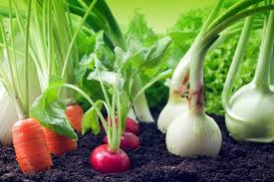
Biodiversity

Our overall aim for this Topic and Goal:

For children to become aware and care for living things.

Actions
- Encourage wider range of wildlife in our gardens (make habitats)
-Observe the life cycle of butterflies
- Nature walks through forestry programme
- Planting seeds and blubs
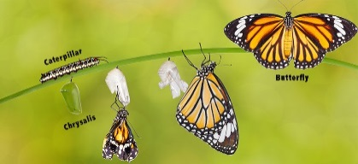
- Growing vegetables

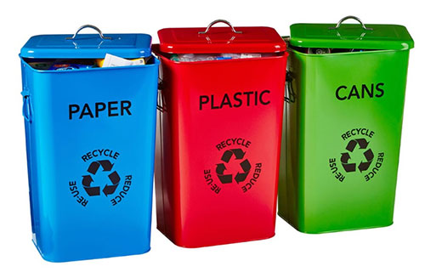
Litter

Our overall aim for this Topic and Goal:

To reduce litter in our local environment.

Actions
- Litter Walk, through Forestry Programme
- Encourage children to keep garden tidy, using litter bins.
- How to pick up litter appropriately
- Litter walks to develop awareness, using litter pickers.
- Purchase litter picker suitable for younger children.
- The Big Clean up

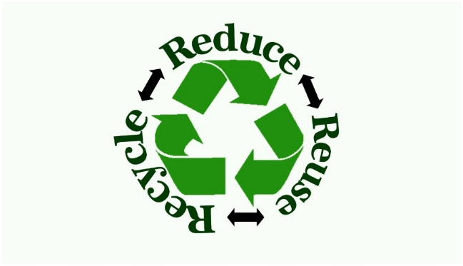

Waste Minimisation

Our overall aim for this Topic and Goal:

To reduce waste

Actions
- Introduce monitors for water, food and paper waste
- Recycling (eco-bags, recycling bins etc)
- Reuse (loose parts during play etc)
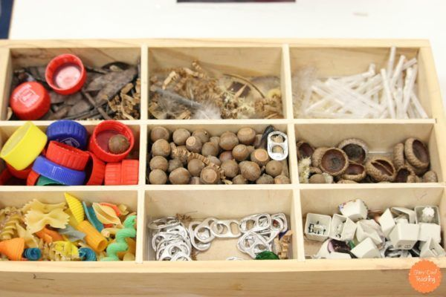
- Re-using materials during creative experiences

