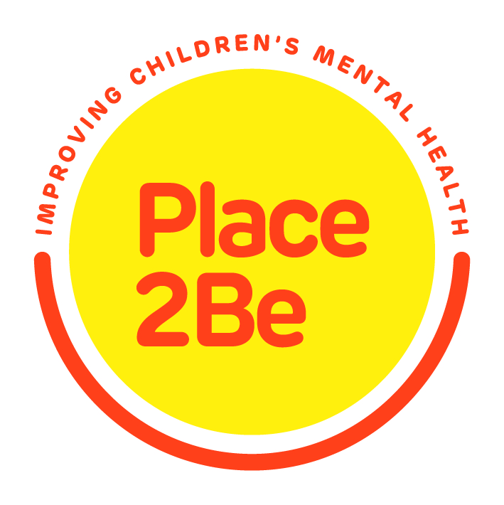
Dear Parents/Carers,

I am writing to let you know that West Johnstone Shared Campus will continue working with Place2Be, a national charity supporting schools to improve the confidence and wellbeing of children and young people.

Place2Be provides emotional and therapeutic support to pupils, families and staff in more than 250 schools nationwide. It gives pupils a space to express themselves through talking and creative work, and to think about any worries they might have. Place2Be also provides support for parents and staff too.

Place2Talk

One of the most popular aspects of this service is called ‘Place2Talk’. It’s open to all pupils, and they can make an appointment to spend 15 minutes with a trained counsellor, either by themselves or with a friend. On average, about a third of pupils in Place2Be’s schools take advantage of this service every year. Pupils often talk about friendships or any worries they may have.

Pupils will automatically be receiving this service, unless you choose to opt-out by signing the permission slip below or by contacting your school or Place2Be School Project Manager.

**** If YOU WANT your child to have access to this service then nothing needs to be done****

Place2Be will record your child’s name, date of birth, year group, gender, ethnicity, the broad topic of discussion and any actions taken as a result of the session. This information is stored securely. It is used in key coded form to evaluate Place2Be’s service and improve our work. Please see the information below, at the end of this letter, for more details on this.
If would like to find out more, please contact Claire Blaney (Place2Be School Project Manager) at gw21blaneyclaire@glow.sch.uk or your child’s Head Teacher who will be very happy to answer any questions.
Kind regards,
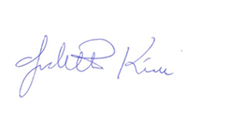


Mr. Graeme Mothersole Mrs Judith Kirk
Head Teacher, Cochrane Castle Head Teacher, St David’s

Place2Talk
I DO NOT want my child to be able to self-refer to the Place2Talk lunchtime program

Name of child/young person……………………...……… Class………………………

Name of parent/carer ……………………………….…………………………………………..

Signature …………………………………………………... Date ……………………..

Place2Talk
Frequently asked questions by parents and carers

1. What is Place2Talk?

One of the most popular aspects of Place2Be’s support in schools is called ‘Place2Talk’. It’s open to all pupils, and they can make an appointment to spend 15 minutes with a trained counsellor, either by themselves or with a friend. On average, about a third of pupils in Place2Be’s schools take advantage of this service every year. Pupils often talk about friendships or any worries they may have.

2. Who conducts the Place2Talk sessions?

Place2Be School Project Managers (SPM). Place2Be is an organisational member of the British Association of Counselling and Psychotherapy. This means our SPMs are committed to the highest standards of personal and professional practice and work in line with its Ethical Framework and Ethical Guidelines.

3. Who will SPMs talk to about the Place2Talk sessions?

Place2Be has a responsibility to keep children safe and follow safeguarding procedures as and when required, but otherwise we will never disclose your child's data to third parties.

4. What is Place2Be’s evaluation and why is it important?

Place2Be’s evaluation provides an overall picture of children we support – your child cannot be identified in any report. Place2Be collects information to evaluate our effectiveness and learn about how to give the best possible service to children and families. For Place2Be to work well, we need to find out how the support we provide helps children’s emotional wellbeing and their learning and academic progress and so we can learn and develop our service. Every year Place2Be reports on the numbers of children supported through its services, the needs of the children who come to Place2Be and the impact the service has made on children’s wellbeing and learning. These reports are published on our website: http://www.place2be.org.uk/impact-evidence/our-impact/

5. What information about your child is included in Place2Be’s evaluation?

Place2Be collects the following information from the school: child’s name, date of birth, year group, gender and ethnicity. We then record brief details of children's appointments and the matters discussed, as well as any action recommended as a result of the session. You can see full details of the sort of information we collect on our website https://www.place2be.org.uk/impact-evidence/how-we-measure-impact.aspx
We keep the information for 6 years and it is then destroyed.

6. Is your child’s information confidential?

Yes. Your child’s name will not be in our research data. Your child’s information will be stored securely.

7. What is the Data Protection Act 2018 (DPA) and the General Data Protection Regulation (GDPR)?

The General Data Protection Regulation (EU) 2016/679 and the Data Protection Act 2018 (DPA) give people control over their personal information (data) and requires organisations who have people’s personal information to act in a lawful and transparent way. Place2Be works within the GDPR and DPA 2018 to ensure that personal data, for example, name or date of birth, are lawfully collected, kept securely and not passed to other people or agencies without permission.

8. How do we safeguard your child’s information?

We care about protecting your child’s information. Our policies and systems make sure that the information cannot be accessed by anyone who should not see it. They also protect against loss or misuse of the information.
We are committed to taking all appropriate steps to protect the personal information that we hold. We do this by having in place a range of measures, including the information being held in a secure, password protected database that can only be accessed by those who need to see the information to deliver the service for your child.

9. Why haven’t we asked for consent to collect information about your child?

We aim to have a service that any child in the school can access when they wish. Place2Talk is a valuable self-referral support service that reduces stigma by being accessible. Any child whose parent/carer has agreed that their child can use Place2Talk can attend. In those circumstances, parental consent is not required to record or store or assess a child’s information, because other legal safeguards kick in to ensure the minimal information is collected and used in a way that respects and protects the children who use the service.

10. What is our legal basis for collecting information about your child?

Under the GDPR we are required to identify 1 of 6 legal bases for processing personal data. We have identified our legal basis as “Legitimate Interest” as explained below, accordingly we do not need to rely on consent (or parental consent) to process your child’s information, especially because we are offering counselling services direct to a child. This is in line with guidance from the Information Commissioner’s Office (ICO) who enforce the data protection legislation in the UK. It is also in line with guidance from the British Association of Counselling and Psychotherapy (BACP).
We record, store and assess information about your child if they come to counselling sessions for two reasons:
• we are protecting the interests of your child in accessing counselling support and only necessary information is collected (this is called the “Legitimate Interests” legal basis for processing personal information); and
• recording the information means your child can access a service for their Health and Social Care (this is a further lawful basis for any sensitive or “special category” personal information).
Place2Be is an organisational member of the BACP. This means our staff work in line with its Ethical Framework and Ethical Guidelines, so they will make sure your child’s information is confidential. In addition, we are also able to use some of your child’s information for research and statistical purposes, as we use pseudonymised (i.e. coded) information and remove your child’s name. We also use some of the information for equality of opportunity and monitoring their counselling.

11. Can you request that your child does not attend Place2Talk?

Yes. You can ask us not to see your child by completing and returning the slip that accompanies this information to the Place2Be School Project Manager.

You can withdraw your agreement at any time by speaking to the Place2Be School Project Manager, or by sending an email to privacy@place2be.org.uk . Once we receive your email, we will cease to carry out Place2Talk support.

12. Can you request for the information held about your child?

You may ask us to confirm what information we hold about your child at any time, and request us to modify, update or delete such information. This is known as a Subject Access Request.
It is important to note that even if a child is too young to understand the implications of subject access rights, data about them is still their personal data and does not belong to anyone else, such as a parent or guardian. In the case of young children these rights are likely to be exercised by those with parental responsibility for them. If you request your child’s data, proof of parental responsibility will be required.
We will consider whether the child is mature enough to understand their rights. If they are considered to be competent we will respond to or consult the child or seek the child’s consent for disclosure to you (with parental responsibility).

You can make a Subject Access Request by speaking with the Place2Be School Project Manager who will ask you to complete a form or by sending an email to Privacy@place2be.org.uk.

13. How long will we store your child’s information for?

We store your child’s information securely for 6 years, and then it is destroyed.

14. What can you do if you are unhappy with our service?

If you are unhappy with any aspect of our service, you can make a complaint in writing to the Chief Financial Officer at Enquiries@Place2be.org.uk. If you are unhappy with how your child’s data is handled, you may complain to the Data Protection Officer in the first instance by sending an email to privacy@place2be.org.uk.

If you remain unhappy, you can complain to the Information Commissioner at: The Information Commissioner's Office (ICO), Wycliffe House, Water Lane, Wilmslow, Cheshire, SK9 5AF (telephone: 0303 123 1113; website www.ico.org.uk).

We assume that parents/carers will discuss this letter with their children, so that they also understand how and why their information is being collected. Copies of this sheet will also be available to children at Place2Talk sessions.

