https://primarygames.co.uk/pg3/topspot/topadd.html play the game to practise.
Move the number to 20 then press begin. You need to add the two numbers beside each other and once you have the answer then press the digits and press ok and it will appear in the circle. Keep adding the numbers together and you will eventually reach the top.
E.g.
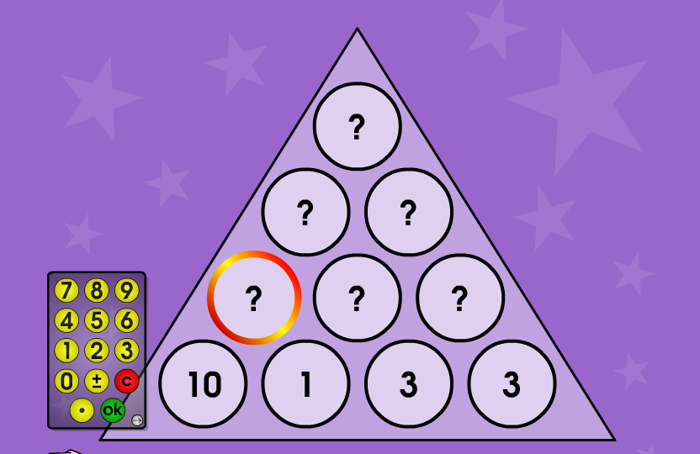
25
10
15
+
+
4
6
+
3+3
1+3
11
10+1
Now complete the worksheet.

