I have given you the three clues to help you solve this riddle. They are on the next page at the bottom.

Use column addition to work out the sums. Remember to put the decimal point in the answer too!

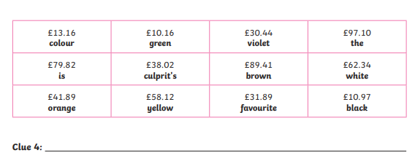

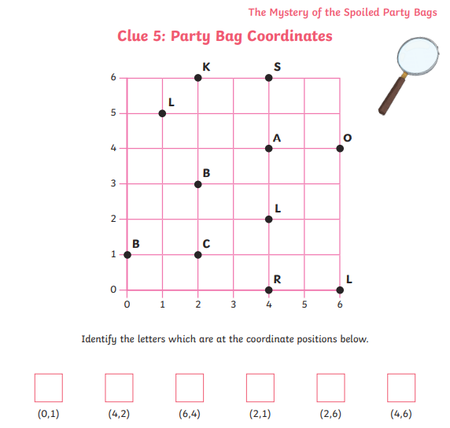
Remember to be able to read coordinates you go for a walk along then climb up the stairs!

