Tuesday 9/6/20
Maths Task
Triangles, Squares and Circles
- TeeJay Page 177 Q1-3.
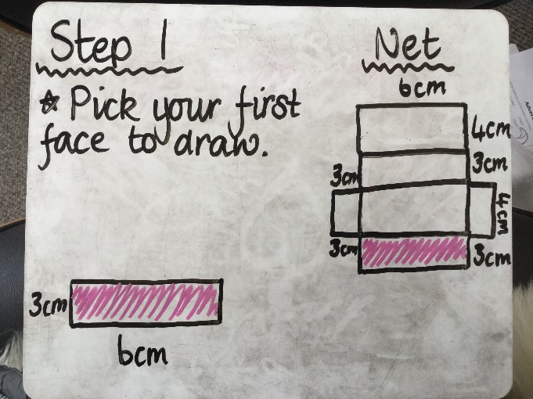
Today we are going to be continuing to learn about 3D shapes and their nets. Today’s work will be tricky as you are being asked to draw the 3D shape that matches each net. Use a ruler and take your time. Remember if you are unsure then just ask.

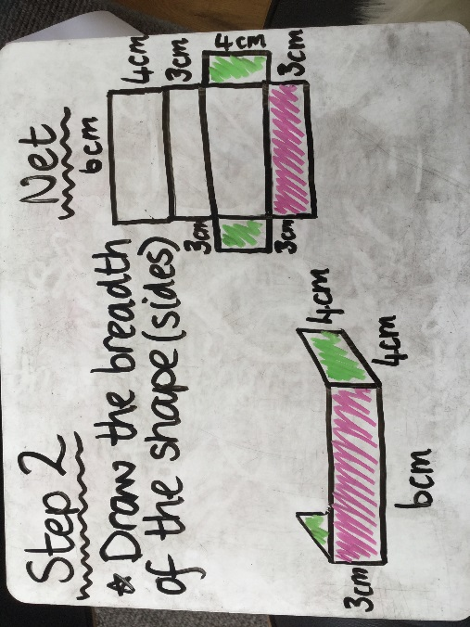

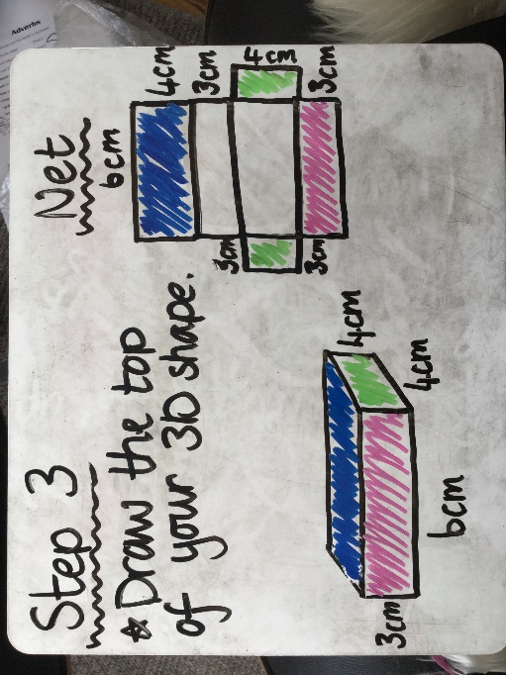

Literacy Task - Grammar
Complete Pg19 ‘Adverbs’ in the Grammar and Word Study Booklet. Today we are learning about adverbs.
Adverb – An adverb is used to describe a verb. It usually ends in ‘ly’. For example, The dog barked loudly. The boy quickly ran home. The mum waited patiently.
Watch the YouTube video for more information –
https://youtu.be/94aFcx6oliY

