Monday 8/6/20
Maths Task
Triangles, Squares and Circles
- Heinemann Page 99 Q1-2.
Today we are going to be continuing to look at 3D shapes and their properties (faces, edges and vertices). Last week we looked at the skeleton or 3D shapes and you all made some fantastic models… Well done! Today we are going to be looking at the net of a 3D shape.
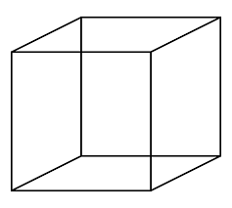
Net – The net is made up of flat 2D shapes which fold up to make the 3D shape. The net of a shape can look different depending on the shape. The hard part is trying to imagine how it could all fold up to form it’s 3D shape. For example the following are all nets for a cube.

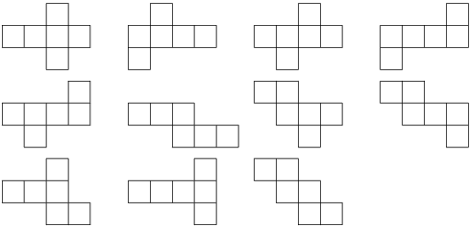

Watch the YouTube video for more information on nets
https://youtu.be/SwDjm6Ra1W4

Literacy Task – Spelling
Remember you should be practicing your spelling words every day, on your timetable you will see an example of how this may look.
Monday Task – Write sentences including your words.

Magic Writers
- Book 6 – Unit 25 (Focus: tricky words)
parliament
conscience
environment
temperature
bargain
vegetable
desperate
definite
average
government
Wicked Writers
- Book 5 – Unit 26 (Focus: e or no e)
shake
shaker
shaking
cure
curing
curable
close
closing
closed
Wonderful Writers
- Book 4 – Unit 26 (Focus: unstressed vowels)
family
different
factory
separate
listener
easily
lottery

