Have a listen to the story. Use the link below.
https://freestoriesforkids.com/audiostories/british-english/evil-millisphore-childrens-audio-story-narrated-british-english
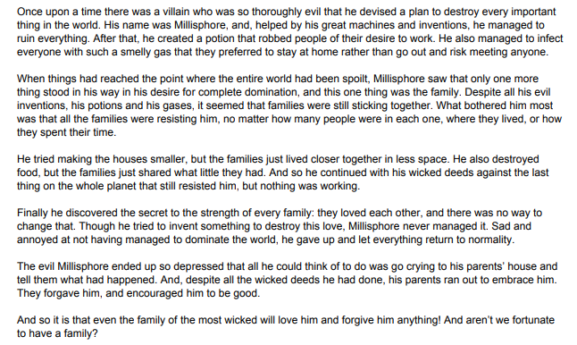

Now complete a wanted poster based on what you have heard about the evil Millisphore. Create a picture showing what you think he looks like. Now I want you to remember what evil things he did and have a chat with someone in your house about the crimes he committed.

