Read the story below. You can also listen to it while you read. Use the link below.
https://freestoriesforkids.com/audiostories/british-english/evil-millisphore-childrens-audio-story-narrated-british-english
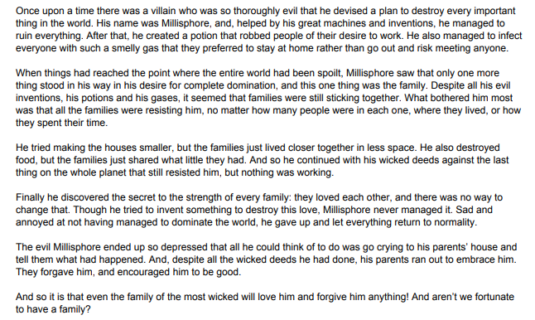

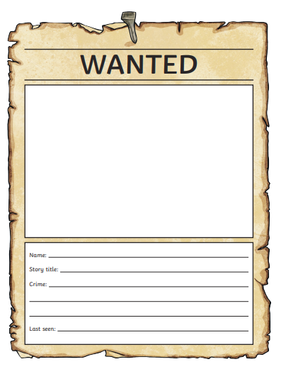
Now complete a wanted poster based on what you have read/heard about the evil Millisphore. Create a picture showing what you think he looks like. Then fill in the details of all his crimes and where he has last been seen.

