Thursday 23/4/20

Maths Task
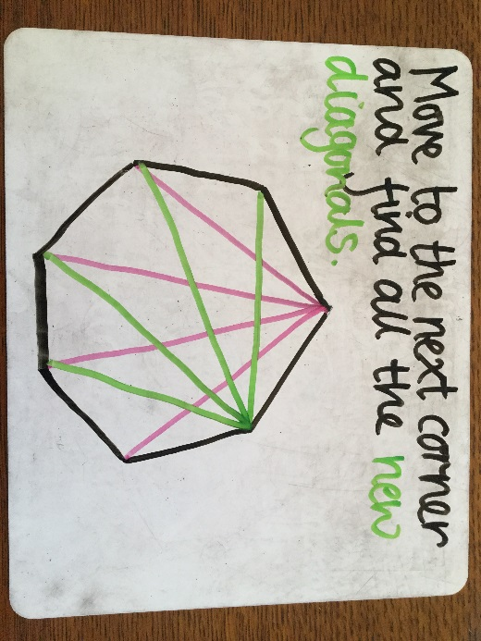
All of your work was fab on diagonals but most of us were a bit unsure when it got to the heptagon. Remember a diagonal line is a straight line that goes from one corner to another. This means that finding the total number of diagonals on shapes like heptagons can get a little messy! Have a look at the steps below, I’ve used a different colour for each corner to help you see each diagonal a little more clearly. I have set today’s task on SeeSaw. I’m not 100% how activities work on SeeSaw so this will be a little bit of trial and error for us all! You have to draw on all the diagonal lines for each shape.
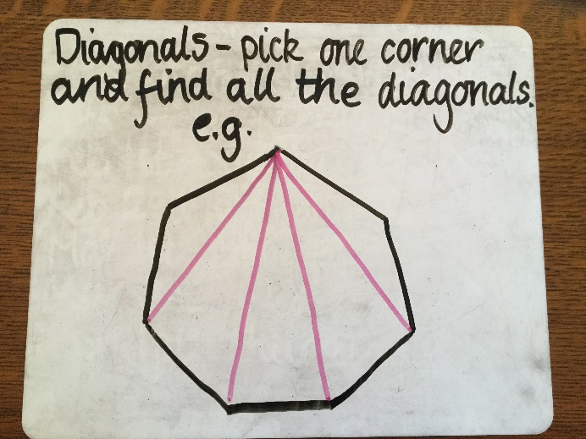

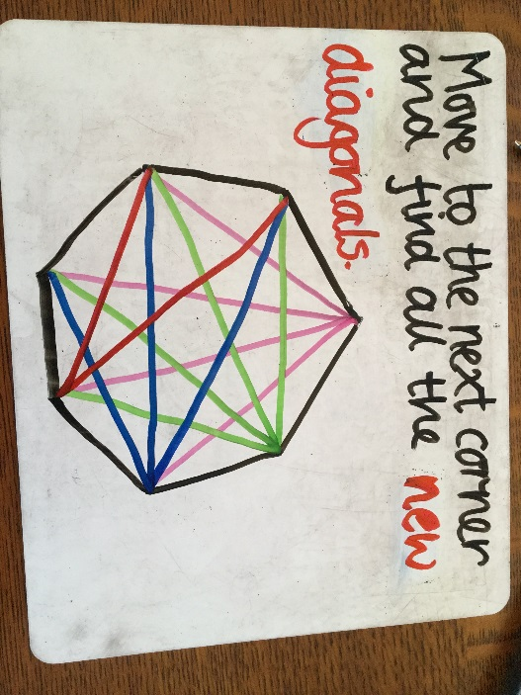
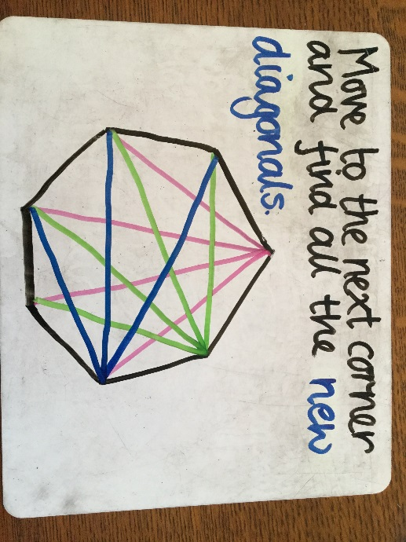

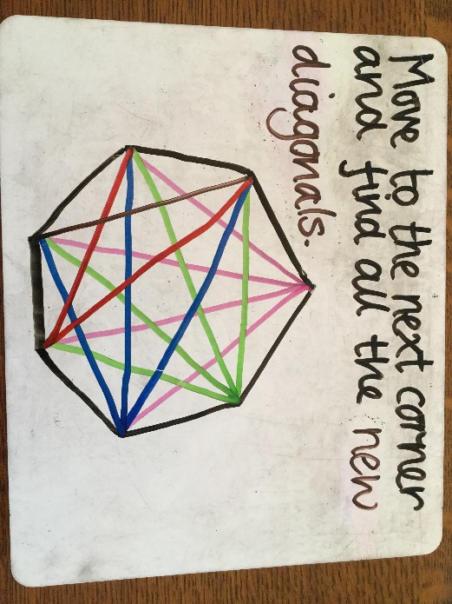
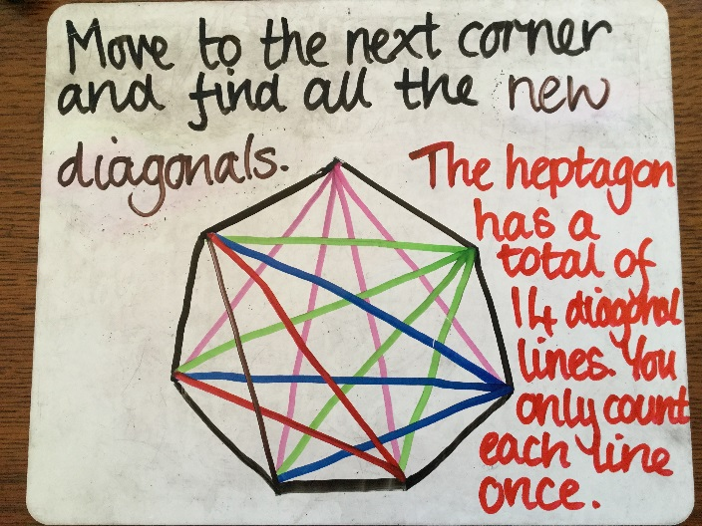

Literacy Task - Reading
Complete the second page of your Proofreading and Editing Skills booklet. Please use a coloured pen/pencil when editing the text so that I can easily see that changes you have made.
Rapid Readers
Guard the Treasure! (pg19)
Key Information –
- A hyphen is used in some words to connect smaller words, for example, happy-go-lucky, self-pity
- Subject and verb agreement – watch the YouTube video linked below. https://youtu.be/tySLFboxzyM
- Plural – more than one.
Rockstar Readers
The Egg and Bottle Experiment (pg23)
Key Information –
- Command verbs (also known as imperative verbs or bossy verbs) – a command verb is a doing word that gives a command. Watch the YouTube video linked below. https://youtu.be/_-YIKALwNwU
- Adjectives are words which are use to describe, for example, small, smaller, smallest.
Royal Readers
Let’s go Skateboarding (pg33)
Key Information –
- A verb is a doing word, for example, walking, jumping, yanking, skipping
- A past tense verb usually ends in ‘ed’, for example, walked, jumped, yanked, skipped
- Contractions are words made from joining two words together and shortening them by taking out letters and adding an apostrophe, for example, do not = don’t, can not = can’t, should not = shouldn’t. *Remember the apostrophe replaces the letter that has been removed.

