TASK 2: 3D SHAPES –We’re going on a shape hunt were going to find a big one!
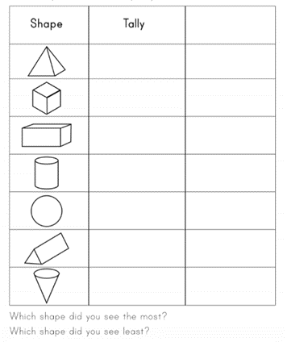
- How many 3D shapes can you name?
Watch this clip: https://www.bbc.co.uk/bitesize/topics/zjv39j6/articles/zcsjqty
- Look around your home or garden! Record how many different 3D shapes you can find on a table.

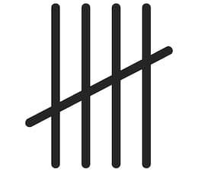
- Remember when we use a tally chart to record we must record our findings in multiples of 5 to make it easier for us to count the total/frequency.

- In your last column of your table record some of the 3D objects you found for each 3D shape.
Now watch this clip: https://www.bbc.co.uk/bitesize/topics/zjv39j6/articles/zgqpk2p
- Discuss with your adult the properties of some of the 3D shapes you have found in your home.
- Remember we use the words, edges, vertices and faces to describe 3D shapes!
Here are some more activities for you: https://whiterosemaths.com/homelearning/year-2/

