Wednesday 22/4/20

Maths Task
- Today we are going to be learning about the rigidity of a shape.
Rigidity – This means whether a shape is rigid or not rigid. A framework which cannot easily be pushed of shape is rigid. E.g.
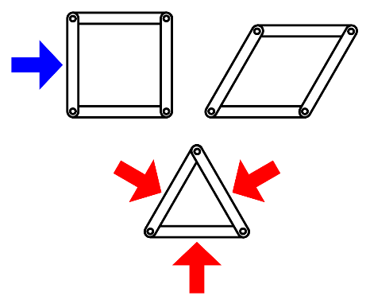
If you pushed the square framework it would
change shape, as shown in the picture.
Therefore it is not rigid.

However, if you pushed the triangle framework,
it’s shape would stay the same, therefor it is rigid.
Triangles, Squares and Circles
Today you are going to continue working on Heinemann 7 Page 103.
I would like you all to complete Q5,6 and 7. Triangles and Squares have a go at completing Q8.
When making the frameworks you may use whatever materials you have available, for example, paper strips, card strips, lollipop sticks, staws etc.

Literacy Task - Writing
Complete work on lined paper that was provided in pack.
Your writing task is to create a Lockdown Time Capsule. This will take us a few weeks to complete so please take your time with your writing.
I want you to imagine you are writing a letter for your time capsule that a stranger will find in 50 years time. You have to assume they know nothing about you or about Covid-19! This means you’re going to have to include detail, detail and (you guessed it) MORE DETAIL! The more information you can give the better.
This week you are going to be writing your introduction and first paragraph only.
Introduction (paragraph 1) – Introduce yourself (name, age, ect.) and the date. Try and engage your reader throughout. You could do this by asking questions, for example, “You have stumbled across Miss Monaghan’s time capsule. I wonder what the date is as you read this letter, and what the world is now like?”

Paragraph 2 – Explain to your reader that you are on lockdown, and why. Your reader should know that you are in the middle of a pandemic and what Covid-19 is. You should do a little research to make sure your information is correct. Here is a link for information on Covid-19 that will help you get started.
https://www.royalfree.nhs.uk/services/services-a-z/childrens-services/coronavirus-information-for-children/
Success Criteria –
I can –
- Write in paragraphs
- Include letter format (Address (make up a fake one), date and dear)
- Write an introduction
- Include information on Covid-19
- Include VCOP (Vocabulary, Connectives, Openers and Punctuation)

