Good Afternoon Everyone
Our Health and Well being focus for this week and next will be ‘Looking after Ourselves’
Our bodies are designed to look after us but there are things we can do to help our body out. Over this next two weeks, we will look at all the different ways we can help our body and look after ourselves.

Doing some exercise
It is important to exercise at least a few times a week because it makes your body fitter but also make your brain happier. There are many ways we can do exercise running, cycling, walking, swimming, dancing and many more. I like to go horse riding and do some yoga at home.
It is tricky at the moment to exercise as much as you want in the way you like best but I hope we are all trying some Joe Wicks, Go Noodle or one of Miss Harper’s fitness ideas every day.
Make a list of your favourite ways to exercise and share a photo of you doing one of your favourite types of exercise. If you have found a new way to exercise in the house, I would love to see it too.
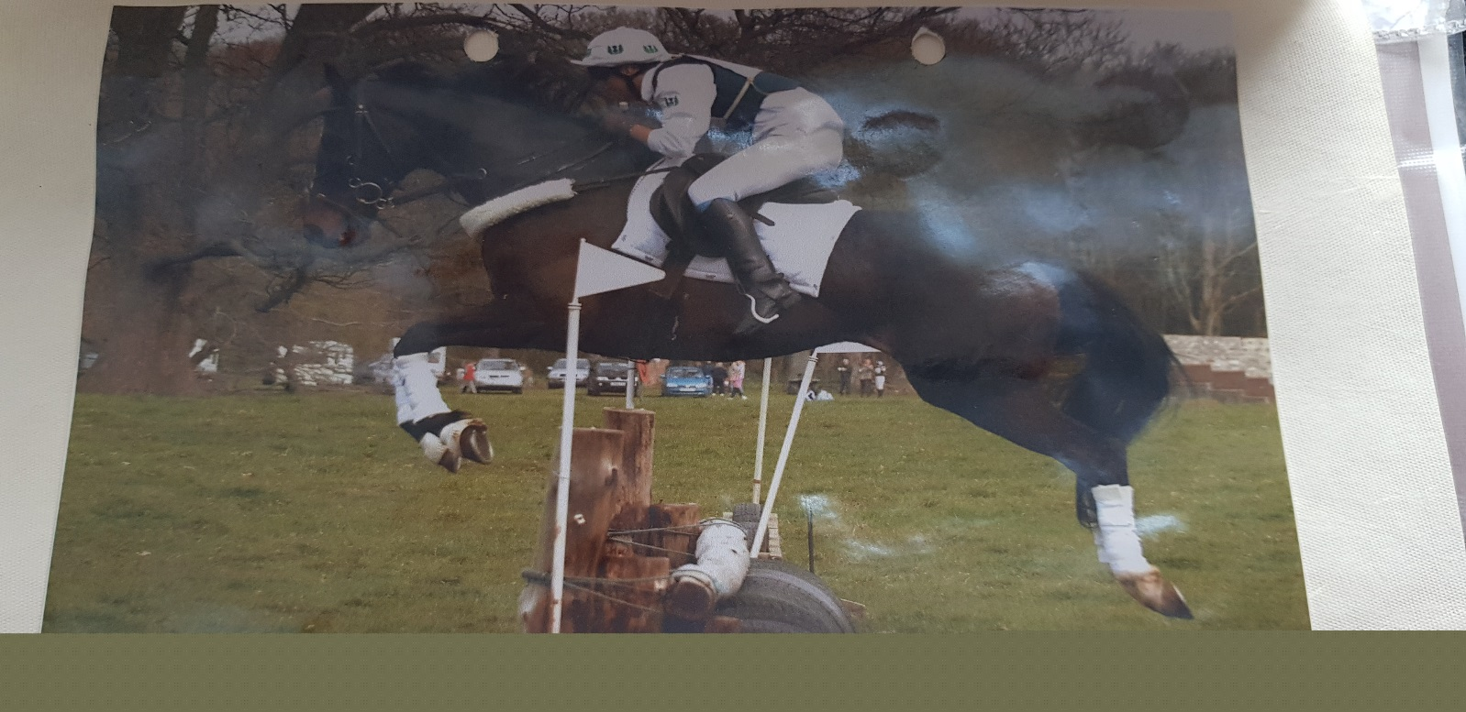

Having plenty of rest or sleep
If you listen to your body it will tell you when it needs to rest and when it needs to sleep.
If you are out playing, do you ever need to stop for a moment to catch your breath? Or, at night time do you ever feel your body getting heavy or your eyes wanting to close? This is your body telling you what it needs.
It is very important to get plenty sleep at night. When we sleep, our body uses the time to grow, do repairs and the brain sorts all the things we have learned that day into the right place.
A good sleep will make us feel better and if we do not get enough sleep, we feel grumpy and cannot concentrate to learn and play.
What do you do before you go to bed to help you sleep well? Do you like having a bedtime story?
Think of 3 things that help you to sleep well.
I like to
- read a book or hear one on Audible
- have a cup of tea before bed
- take a hot water bottle to keep me cosy
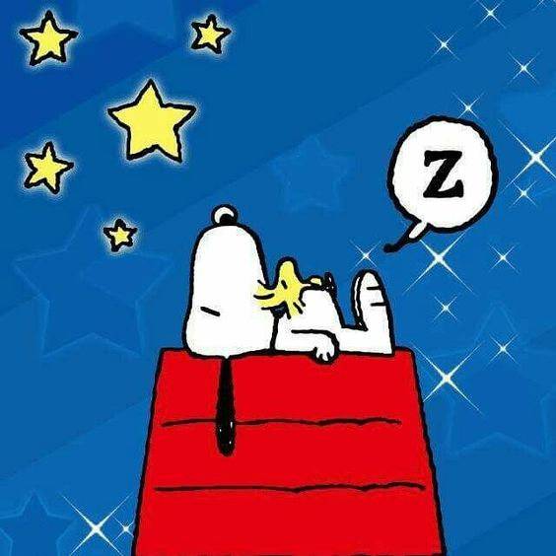

Eating a balanced diet
This means you should eat a variety of food and keep trying new things – you never know what you might like. You do not have to give up sweets or crisps but they should not be the only thing you eat. Your body needs fuel and it cannot get the right kind of fuel from eating only one kind of food. Everything is necessary at different times. The main food groups are
Protein, Fruit and Vegetables, Carbohydrates, Dairy and Alternatives, Oils and Spreads and Sugars
The power point shows you what a good balance of the different food groups is.
It is also very important to stay hydrated, which means drinking plenty of water. Other drinks count but water is the healthiest way to stay hydrated.

What are your favourite food and drinks? Have you tried anything new that you liked recently?

Some of my favourites are
A cup of tea and some Maltesers or poached egg and avocado on toast.
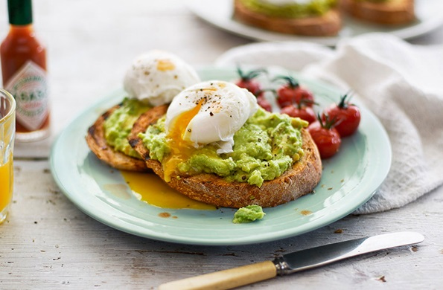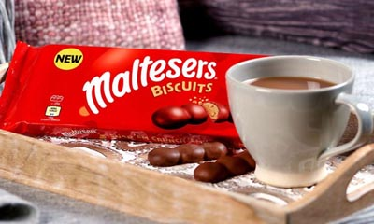
Take a picture of your favourites and post them on Dojo.

Looking after our personal hygiene
Looking after our personal hygiene means keeping ourselves clean and, at the moment, it is especially important.

We need to wash our hands lots of times throughout the day. Washing our hands after going to the toilet and before we have anything to eat and drink is particularly important. Don’t worry if your hands get dirty while you are playing, just give them a wash with some soap when you are finished.

It is also important to wash and have baths or showers to keep our bodies clean and wash our hair too, especially as we get older because our bodies change as we grow and we begin to sweat more. A bath is also a great way to relax if you have had a busy day and brushing your hair and styling it can be good fun.

Brushing your teeth is very important to make sure your teeth are clean and healthy. Remember to brush for 2minutes in the morning and before you go to bed.

Think of all the ways you take care of yourself.
Can you take a photo of you brushing your teeth, styling your hair or washing your hands?

