Name of Participant:
Class:
School:

I am taking part in a sponsored walk around Bishopton and Dargavel. It is a 4mile route shown below.
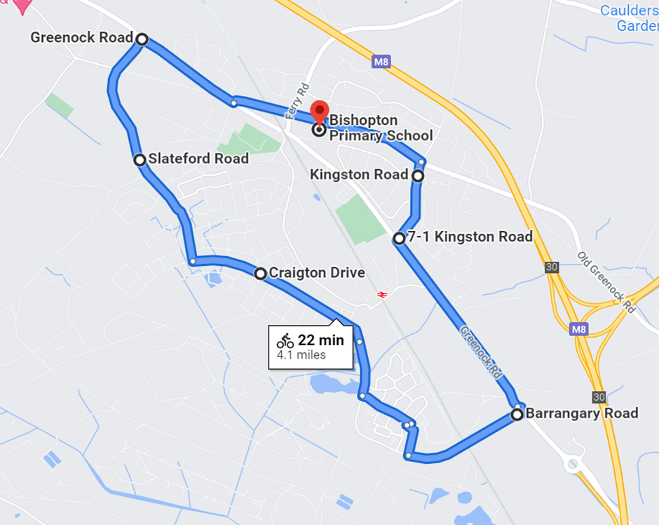

NAME | CONTACT DETAILS | AMOUNT

Thank you!

Please add any sponsor money into the designated area on parent pay. You can bring the slip below into school to let your teacher know how much you raised. This will help us to estimate a total on Friday 19th November.

----------------------------------------------------------------

Name:_____________________ Class:___________

I took part in Bishopton Primary Schools sponsored walk for Children in Need 2021 and raised _______________________.

